BRIDG Project
Release 1.0 Documentation Package
Biomedical Research Integrated Domain Group (BRIDG)

Authors
BRIDG Technical Harmonization Committee (THC)

Julie Evans (CDISC)
Doug Fridsma (University of Pittsburgh Medical Center/NCI)
Smita Hastak (ScenPro/NCI)
Charlie Mead (Booz Allen Hamilton/NCI/HL7 RCRIM)

https://cabig.nci.nih.gov/inventory/infrastructure/bridg/
19 June 2007

Revision History

Date | Version | Summary of Changes
18 June 2007 | 1.0 | Initial Documentation Package for BRIDG Release 1.

Table of Contents

Section 1. Guide to the Reader 4
Section 2. Executive Summary 4
Section 3. The BRIDG Project 4
3.1 History of the BRIDG Project 4
3.1.1 2003-2004: CDISC and HL7 RCRIM TC 4
3.1.2 2004-2005: The caBIG™ (and CDISC) Structured Protocol Representation (caSPR) Teams 4
3.1.3 2005-2006: Maturation of the BRIDG Project 4
3.2 Governance and Organization of the BRIDG project 4
3.2.1 The BRIDG Advisory Board (BAB) 4
3.2.2 The Technical Harmonization Committee (THC) 4
3.3 Contributing to the BRIDG Project/Model: How Does a Project Team Get Its Content Into the BRIDG Model? 4
3.4 The BRIDG PROJECT website at NCI 4
3.5 The BRIDG Model Release Schedule 4
3.6 The BRIDG Model as a “Standard” – Solicitation of Community Input on the BRIDG Model 4
Section 4. The BRIDG Model – General Considerations and Conventions 4
4.1 Computable Semantic Interoperability (CSI) 4
4.1.1 CSI Pillar #1: The BRIDG Model 4
4.1.2 CSI Pillar #2: Complex Data Types 4
4.1.3 CSI Pillar #3: Binding to Terminologies 4
4.2 The BRIDG Model: Instance of a Domain Analysis Model 4
4.2.1 The Domain-of-interest of the BRIDG model 4
4.2.2 The Scope of a DAM 4
4.3 UML: The BRIDG Model’s Representational Language 4
4.3.1 The Semantics of UML Class Diagrams 4
4.3.2 The Semantics of UML Instance Diagrams 4
4.4 Static Representations: Conventions and Guidelines 4
4.4.1 Explicit vs Implicit Representation 4
4.4.2 Empty Classes in the BRIDG Class Diagram 4
4.4.3 Placeholder Classes 4
4.4.4 Derived Values 4
4.4.5 Required vs Optional Attributes 4
4.4.6 BRIDG Mapping Documents 4
4.5 The BRIDG Backbone 4
4.5.1 ObservationResult vs Assessment 4
4.5.2 Minimum Attribute Set in ActivityRelationship Class 4
4.5.3 Activity.category 4
4.5.4 Where is “Analysis” and/or “Reporting” in the BRIDG Model? 4
4.6 Relationship of the BRIDG Model to the HL7 Reference Information Model (RIM) 4
4.6.1 Use of RIM Color-coding in the BRIDG model 4
4.6.2 The RIM Participation and BRIDG FunctionalRole Classes 4
4.6.3 The Absence of HL7 “Act.moodCode”: A Specific Example of RIM vs BRIDG Representational Choices 4
4.7 Representation of Dynamic Semantics 4
4.7.1 Activity Diagrams 4
4.7.2 State Diagrams 4
4.7.3 Sequence Diagrams 4
4.8 Navigating the BRIDG Model: Tools and Options 4
4.8.1 Text View: RTF 4
4.8.2 XML View: XMI 4
4.8.3 UML View: Single Model vs Multiple Views 4
4.8.4 BRIDG Model Navigation “How To” 4
Section 5. The BRIDG Model – Release 1.0 Content 4
5.1 View #1 – The BRIDG Domain: Focal Classes 4
5.2 View #2 –Planned Study 4
5.3 View #3 – Scheduled Study 4
5.4 View #4 – Performed Study 4
5.5 View #5 – BRIDG Backbone (Green, Yellow, Turquoise) 4
5.6 View #6 – BRIDG Backbone (Red and Pink only) 4
5.7 View #7 – BRIDG Static Content (classes only) 4
5.8 View #8 –BRIDG Static Content (classes + local attributes) 4
5.9 View #9 –BRIDG Static Content (full representation) 4
5.10 Complex Data Types in Release 1.0 4
5.10.1 Representing groups of recurring semantics across classes: A brief BRIDG history 4
5.10.2 “Flattening” of other CDTs in Release 1.0 4
5.11 What’s Next: A Look Forward at Trial Design and Adverse Event Semantics 4
5.11.1 Specification of BRIDG attributes using HL7 data types 4
5.11.2 Patient study calendar/trial design model harmonization 4
5.11.3 Adverse event reporting 4
5.12 4
Section 6. Glossary 4
Section 7. Appendix 4
7.1 Abstract and Complex Data Types 4
7.1.1 Temporal Grammar(s): HL7 V3 GTS Data Type 4
7.1.2 Coded Concepts: HL7 V3 CD Data Type 4
7.1.3 Collections: BAG, SET, and LIST 4
7.2 A Brief Explanation of the concept of “mood” 4
7.3 caBIG: Using the BRIDG Model: Application Development vs Message Specification 4
7.3.1 caBIG™ CTMS WS Silver Compatibility: An Instance of Application Development Processes Using the BRIDG Model 4
7.4 BRIDG Dynamic Semantics and Service Oriented Architectures (SOAs) 4
7.5 The Concepts of Visit and Event 4
7.6 Representing Case Report Form (CRF) Questions vs Answers, Models and Terminologies 4
7.7 Exemplar HL7 Values from Normative Edition (2005) 4
7.7.1 Act State Machine and Act.status values 4
7.7.2 Role State Machine and Role.status values 4
7.7.3 ActRelationship.typeCode 4
7.7.4 Act.moodCode 4

Guide to the Reader

The BRIDG Documentation Package consists of seven Sections:

Section 1.0 – Guide to the Reader (the present Section)

Section 2.0 – Executive Summary. This Section presents the working definition of the scope of the BRIDG model; enumerates the BRIDG Project’s stakeholder organizations; outlines the scope, organization, and content of the BRIDG Model Documentation Package; lists the projects which have, to date, collectively contributed static or dynamic content to the BRIDG Model; discusses the intended audience of the BRIDG Model and this associated Documentation Package; provides pointers to sites where additional information about the BRIDG Project and/or the BRIDG Model can be found; and enumerates a number of caveats and/or scope limitations to the overall content of the BRIDG Model Documentation Package.

Section 3.0 – The BRIDG Project. This section contains a brief history of the BRIDG Project, as well as a description of the organization and function of the two administrative groups that together are responsible for the continued definition, maintenance, and evolution of the BRIDG Model, i.e. the Technical Harmonization Committee (THC) and the BRIDG Advisory Board (BAB).

Section 4.0 – The BRIDG Model – General Considerations. This section describes the BRIDG model from a relatively content-independent perspective, i.e. from the perspective of topics such as general modeling conventions and representational guidelines utilized in the BRIDG Model; use of abstract or super-classes in class hierarchies; class and attribute naming conventions; relationship of the BRIDG Model to the HL7 Reference Information Model; representation of complex data types in the BRIDG Model, etc. Although this section – like all of the sections in the Documentation Package – will be updated as needed on a per-Release basis, it is expected that the content of this section will not change much from Release to Release.
Section 5.0 – The BRIDG Model -- Release 1.0 Content. This section describes the specific content of the current Release of the BRIDG Model including discussions about particular representational choices made by the Technical Harmonization Committee as those choices relate to specific content. It should be noted that representation of specific content can be expected to change over the course of the next several releases of the BRIDG model as domain-critical content scheduled for inclusion in the BRIDG Model over the next 3-9 months is analyzed and represented (e.g. Adverse Events, Trial Design, etc.)

Section 6.0 – Glossary. The Glossary contains a list of definitions of terms that may not be familiar to, or are prone to misunderstanding by, readers of the BRIDG Documentation Package, the stated definitions reflecting the use of the term in the context of the BRIDG Documentation Package. Throughout the BRIDG Documentation Package, terms which are defined in the Glossary are indicated by being underlined.

Section 7.0 – Appendix. This section contains material that may be of interest to some readers of the BRIDG Documentation Package, but which the Technical Harmonization Committee decided was not critical to overall understanding of the BRIDG Project or the BRIDG Model. Examples include exemplar enumerated value sets for a number of HL7 Version 3 attributes and a somewhat detailed discussion of Abstract/Complex Data Types.

Executive Summary

The BRIDG Project is a collaborative effort engaging stakeholders from four organizations:

- Clinical Data Interchange Standards Consortium (CDISC)

- HL7 Regulated Clinical Research Information Management Technical Committee (HL7 RCRIM TC)

- National Cancer Institute (NCI), including the Cancer Biomedical Informatics Grid (caBIG™) project

- Federal Drug Administration (FDA)

The goal of the BRIDG Project is to produce a shared view of the dynamic and static semantics of a common domain-of-interest, specifically the domain of protocol-driven research and its associated regulatory artifacts.
A shared semantic view is essential if the clinical research community – both in-and-of-itself and as part of the larger healthcare and life sciences communities – is to achieve computable semantic interoperability (CSI), i.e. the ability for information systems to exchange at a machine-to-machine level the meaning (rather than simply the structure) of data and/or to effectively combine functionality across machine/system boundaries. Stated another way, in order to realize the various data interchange and application interactions that are known by members of the BRIDG stakeholder organizations to be requirements for CSI, a shared view of dynamic and static semantics must be established.

Through the efforts of the BRIDG Project, this shared view is expressed as a collection of visual diagrams which are, in turn, expressed using the iconography and grammar of the Unified Modeling Language (UML). This set of visual diagrams plus the underlying inter-diagram relationships, definitions, explanations, and examples (instance diagrams which illustrate the semantics of the diagrams in more detail) are collectively referred to as the BRIDG Model.

The BRIDG Model is an instance of a construct often referred to as Domain Analysis Model (DAM) or “problem space model.” The term “analysis” refers to the fact that the model is specifically constructed to be implementation-independent, i.e. the semantics of the model are restricted to those that characterize the “problem domain” as described by domain experts. In particular, a DAM specifically excludes semantics that are introduced based on a particular “solution space” that can be built to solve the stated problem. Thus, one or more “solution space models” can be built to support all or part of a single problem space model. The term “domain” indicates that the semantics of the model-in-question are restricted to those that collectively define a clearly bounded domain-of-interest. In the case of the BRIDG Model, the domain-of-interest is formally defined as:

- Protocol-driven research and its associated regulatory artifacts, i.e. the data, organization, resources, rules, and processes involved in the formal assessment of the utility, impact, or other pharmacological, physiological, or psychological effects of a drug, procedure, process, or device on a human, animal, or other biologic subject or substance plus all associated regulatory artifacts required for or derived from this effort.

It should be noted that the semantics of the BRIDG Model, Release 1.0, are limited to human subjects of clinical trials, i.e. the semantics currently do not support pre-clinical trials on animals or other non-human biologic entities. Future releases of the BRIDG model are expected to include semantics for non-human subjects as that content is brought forward for harmonization.

As outlined in the Guide to the Reader, the content of the Documentation Package has three main purposes:

- Provide a brief historical background and administrative overview of the BRIDG Project, including how the BRIDG Model is maintained and evolved.
- Describe the framework of stylistic and representational guidelines and principles that have been used to develop the BRIDG Model, thereby providing those domain experts or technologists interested in reviewing the Model’s content a means for placing their particular perspective in the larger context of the BRIDG Model, as well as to realize that the representational choices made for a given semantic in the BRIDG Model simply represent just that: a representational choice, and that there are may be any number of other representation choices – at either the analysis or design level – of that semantic that could be made.
- Present and explain the content of Release 1.0 in the context of #1 and #2.
As of the release of the BRIDG Model, Release 1.0, the BRIDG Project will begin a regular schedule of releases throughout each calendar year. Specifically, releases will occur in January, April, July, and October with the January release nominally viewed as a “major point release” and the other three releases as “minor point releases.” Thus, Release 1.1 will occur in October, 2007, while Release 2.0 will be in January 2008, etc. The distinction between “major” and “minor” point releases will, in general, not be a reflection in different degrees of content – content being continuously added in an incremental fashion as new projects bring their harmonizable artifacts forward for inclusion in the BRIDG Model – but rather of temporality, all versions of the form 1.x having been issued in 2007, versions of the form 2.x in 2008, etc. From a content perspective, it is expected that Sections I, II, III, and IV of the BRIDG Documentation Package will remain relatively stable over multiple releases, whereas Section V will obviously contain different content for each release of the BRIDG Model.

The content of each release will include representations of both the static and dynamic semantics from the various projects within the BRIDG Project’s stakeholder organizations whose content has been harmonized into the BRIDG Model since that last release. Content is tagged with one of several tags, depending upon a whether the content is considered to have been vetted and harmonized and is therefore considered “final” in the context of the current release, or whether it represents one of several other categories depending on its current level of consideration in the harmonization process. Specifically, the tag set defined for BRIDG Model content is defined as follows:

- <<Release 1.0>>: content which has formally passed through the THC harmonization process described in section III. This content is considered to have been sufficient vetted to be considered as “final” in the context of the current Release. Subsequent Releases may, however, modify this content as the overall semantics of the BRIDG Model mature with the inclusion of other content critical to the overall definition of the BRIDG domain-of-interest.

- <<draft>>: content which has passed through formal harmonization but which is known to be dependent on content that is not yet fully harmonized in the BRIDG Model. For example, Release 1.0 of the BRIDG Model contains content developed by the NCI’s Patient Study Calendar application team in their Phase I development efforts. This content is tagged as <<draft>> rather than <<Release 1.0>> because it is known that the representation of this content will change substantially in Release 1.1 as it is itself harmonized with the content from the CDISC Trial Design team. Thus, the merger/harmonization of the PSC and TD content is expected to be collectively tagged as <<Release 1.1>> in the October, 2007 release of the BRIDG Model.

- <<placeholder>>: content which is scheduled to enter the BRIDG Model within the next two releases (i.e. 6 months) and of which the BRIDG Technical Harmonization Committee is aware and has reviewed and believes to be stable enough to warrant its inclusion as a “snapshot of things to come.” <<placeholder>> content is intentionally lacking in critical detail and is simply meant to encourage wider discussion of the content in anticipation of its planned inclusion. <<placeholder>> content is also known to be critical to overall domain understanding, e.g. the current model includes <<placeholder>> content around the concepts of Adverse Event.

- <<proposed>>: content is included to serve the purpose of providing exemplar structures and/or style guidance, and is not expected to progress to one of the other tags in the foreseeable future of BRIDG Model releases.

At present, all dynamic content in the BRIDG Model is tagged as <<proposed>>, whereas the static content has tags of <<Release 1.0>>, <<draft>>, or <<placeholder>> depending on its current place in the overall harmonization and vetting process described below.

For Release 1.0, the static content tagged as <<Release 1.0>> was taken from four projects:

- Study Data Tabulation Model (SDTM) – CDISC
- caXChange/LabHub (including Clinical Trial Periodic Update and Lab Model) -- NCI/HL7/RCRIM TC/CDISC
- Regulated Product Submission (RPS) -- HL7 RCRIM TC
- Cancer Trial Object Model (CTOM) – NCI

Content marked as <<draft>> was taken from a single project
- Patient Study Calendar, Phase I (PSC) – NCI

and was tagged as draft because of its deep dependency on Trial Design content which is currently in active harmonization for inclusion in Release 1.1

Finally, static content tagged as <<placeholder>> was taken from a single project
- Adverse Event definition project – NCI (including caBIG™ and CTEP), CDISC (SDTM), FDA (ICSR project) and the NIH (FAET project), which are currently developing content for inclusion in Release 1.1 or 1.2

The dynamic content in Release 1.0 is tagged as <<proposed>> in the BRIDG Model’s Activity, State, and Sequence Diagrams, and is included to provide exemplar content meant to serve as guidance as to the preferred representation and content requirements of BRIDG dynamic content planned for future releases. This content is not considered harmonized or community-vetted content in Release 1.0. The Activity and Sequence diagrams were taken from a single project:

- NCI caBIG™ Clinical Trial Management System Interoperability (CTMSi) project (currently being demonstrated throughout the NCI community)

The state diagrams are drawn for the HL7 Reference Information Model as a result of multiple discussions with various clinical trial stakeholders as the static semantics have been presented.

The target audience for the BRIDG Documentation Package is, first and foremost, anyone with an interest in learning more about the BRIDG Project in general, and specifically about Release 1.0 of the BRIDG Model. In particular, the BRIDG Technical Harmonization Committee – the authors of this document -- expect that the content of the Documentation Package will be of use to:

- domain experts working within the domain scoped by the BRIDG Model;
- analysts, architects, and developers working on defining specific data interchange semantics (e.g., message specifications) or application APIs; and

- terminologists/ontologists interested in augmenting current work involving building clinical trial ontologies.

The BRIDG model is represented using the Unified Modeling Language (UML). However, the model uses only the most obvious and easily understandable constructs of UML and, as a result, the THC believes that the model – in combination with the content of the Documentation Package – should be readily understandable by anyone with experience and expertise in the BRIDG domain-of-interest. The Technical Harmonization Committee believes that instance diagrams will aid those domain experts with no prior UML experience in reading, understanding, and validating, the content of the BRIDG Model, thereby adding the essential element of vetting by the larger community that is essential to the relevance – and therefore the success – of the BRIDG Project.

The latter point – large-scale validation/vetting of the content of the BRIDG Model – is of particular importance, since the overarching motivation of the BRIDG Project is to present to the clinical- and pre-clinical-trial community a valid representation of the shared meaning of various concepts, relationships, and processes that collectively define the domain of protocol-driven research. In the end, the value of the BRIDG Project and the BRIDG Model that it produces are directly related to the degree to which that representation is both valid and relevant to the community. If the BRIDG Model provides a correct and complete view of shared meanings (semantics) of the BRIDG domain in a form that is both understandable to domain experts and robust enough to be utilized by various technology teams charged with building solutions required by those domain experts, the BRIDG Project will be a resounding success. It is to that goal that all those involved in the BRIDG Project are continually striving.

It is not the purpose of the Documentation Package to give detailed instructions as to how a given application development or message specification team can contribute to and/or work with the BRIDG model.

The BRIDG Project
The BRIDG Project is a collaborative effort engaging stakeholders from the Clinical Data Interchange Standards Consortium (CDISC), the HL7 Regulated Clinical Research Information Management Technical Committee (RCRIM TC), the National Cancer Institute (NCI) and its Cancer Biomedical Informatics Grid (caBIG™), and the US Food and Drug Administration (FDA). The goal of the BRIDG Project is to developed a shared view of the data, relationships, and processes which collectively define the domain of “protocol-driven research and its associated regulatory artifacts.” Specifically, the formal definition of the domain-of-interest for the BRIDG Project stakeholders is:

- Protocol-driven research and its associated regulatory artifacts, i.e. the data, organization, resources, rules, and processes involved in the formal assessment of the utility, impact, or other pharmacological, physiological, or psychological effects of a drug, procedure, process, or device on a human, animal, or other biologic subject or substance plus all associated regulatory artifacts required for or derived from this effort.

A shared view of the various structures and processes that define the BRIDG domain is essential in achieving the larger goal of computable semantic interoperability (CSI) both among people and systems within the domain as well as between those working within and those working outside the domain (e.g. healthcare institutions.)

The BRIDG Project is focused on producing the required shared view as a series of graphical “views” expressed in the Unified Modeling Language (UML) which collectively form the BRIDG Model. In particular, the collective semantics (aka “meaning”) of the BRIDG domain means that the BRIDG Model is gathering and documenting the various business processes (dynamic semantics) and data structures and relationships (static semantics) that collectively are required to support CSI. Although the BRIDG Model itself is the primary artifact that is being incrementally assembled by the BRIDG Project, there are several additional artifacts of interest including Project Mapping Documents and associated educational materials describing in some detail how a specific project team can utilize the BRIDG Model in its efforts to build message structures of applications that support CSI. Details of these various artifacts are available within the BRIDG Release 1.0 Documentation Package.

History of the BRIDG Project

2003-2004: CDISC and HL7 RCRIM TC
The idea of building a domain analysis model of the protocol-driven-research domain emerged from a September, 2003 dialogue between the Board of Directors (BoD) of the Clinical Data Interchange Standards Consortium (CDISC) and one of the authors of the BRIDG Documentation Package (CM), then a member of the HL7 BoD. The dialogue was, in turn, in response to a request from CDISC leadership to HL7 leadership that the two organizations renew a then 2-year-old Memorandum of Understanding (MoU) to work collaboratively on data exchange standards in domains deemed to be of interest to both organizations. In the context of the renewal of the MoU, CDISC requested HL7 provide an educational session for the CDISC BoD that would provide them with a better understanding of HL7’s model-based approach to message specification, a process that CDISC had attempted to embrace in the context of the HL7 Regulated Clinical Research Information Management (RCRIM) Technical Committee with somewhat limited success.

Figure 1 shows an overview of the motivation for initiating the modeling efforts as the concept was presented to the CDISC BoD in January, 2004.

CDISC XML
(e.g., Operational Data Model (ODM))
HL7 XML
(e.g. Periodic Lab Update)
CDISC Implementation Specification
HL7 Implementation Specification
Implementation-Independent Representation
HL7 RIM → RCRIM DMIM
Domain Analysis Model
(BRIDG)
Design-level representation of multiple domains-of-interest
Requirements
Design
Implementation

Figure 1: Modeling Implementation-Independent Semantics. Representation of implementation semantics in a Domain Analysis Model (DAM) facilitates the mapping of those semantics to more than one implementation model, thereby facilitating interoperability between applications or message specification built from either model. The BRIDG model is a DAM and therefore presents only the implementation-independent semantics of a domain-of-interest. The HL7 Reference Information Model (RIM) and its derived, domain-specific artifacts are, strictly speaking, implementation-independent. However, they are not “domain-friendly” because the semantics are represented using cross-domain, often-design-level abstractions that are unfamiliar to domain experts. Finally, XML is a particular implementation representation. Representation of the semantics of a domain-of-interest in a separate model from the design or implementation models of those semantics facilitates automated transformations between the various implementations, e.g. between CDISC XML and HL7 XML.

Following a discussion of the risks and effort involved in pursuing such the path of building a DAM, the CDISC BoD elected to begin funding the development of a CDISC DAM. The process officially started with a scope definition meeting in March, 2004, the resulting DAM ultimately becoming the BRIDG model. The current scope definition of the BRIDG domain is essentially the same as was defined at this initial meeting, i.e. protocol-driven research plus its associated regulatory artifacts.

2004-2005: The caBIG™ (and CDISC) Structured Protocol Representation (caSPR) Teams

In February 2004, The National Cancer Institute (NCI) began a project to develop a structured model of a clinical trial protocol as part of the caBIG™ project, awarding a grant to the University of Pittsburgh Medical Center (UPMC) to form the Cancer Structured Protocol Representation (caSPR) Team to focus on identifying a set of data elements suitable for a computational representation of structured protocols. Rather than create “yet another standard,” the caSPR Team began to seek out other groups interested in standardizing the exchange of information related to clinical trials research with whom they might collaborate. The search naturally lead to interactions with representatives from both CDISC and the HL7 Regulated Clinical Research Information Management Technical Committee (RCRIM TC). An outgrowth of this collaboration was the inclusion of the caPSR Team – and thus the NCI and caBIG™ – in the building of the still-to-be-named “CDISC Domain Analysis Model project.” The first joint modeling sessions involving both members of the CDISC DAM team and the caSPR team were held in the late fall of 2004, with the meetings continuing over the next 9 months. This initial effort, in combination with the preceding work that CDISC had done during the first 6-8 months of their Domain Analysis Model building project, resulted in the first Domain Analysis Model of the domain of protocol-driven research, now referred to by many as the “CDISC Problem Space Model.”

2005-2006: Maturation of the BRIDG Project
In the summer of 2005, the project was renamed the BRIDG project. Motivation for the naming effort was, in part, to prevent organization-specific monikers, e.g. CDISC Problem Space Model, HL7 RCRIM Domain Analysis Model, NCI caSPR Model. The acronym “BRIDG” – which technically stands for “Biomedical Research Integrated Domain Group” – was chosen to reflect the project’s contribution to building “bridges” between the various stakeholder organizations.

With the inclusion of multiple stakeholders, it became apparent that a more formal organizational governance structure must be defined if the effort was going to succeed in the long-term. Several of the individuals involved in the BRIDG project felt that the project could productively take guidance from the experience on consensus building and management of diverse, distributed content from various standards organization such as HL7, W3C and OASIS, and on the management and evolution of shared content from the open-source community in the form of projects such as Linux, Firefox, and Mozilla.

In concert with beginning to articulate the governance of the BRIDG Project, the ever-expanding model was ported from Rational Rose to Enterprise Architect (EA) in the Spring of 2005, in part because of the higher cost without higher (relevant) functionality of the former application, but in larger part to allow the dissemination of the model to a larger community using the free model reader available from Sparx Systems, the makers of EA (www.Sparxsystems.com). In addition, the model itself was moved from residence on a single laptop to a GForge site -- initially hosted by UPMC but now hosted by NCI – to take advantage of a number of GForge capabilities such as version control, document management, and bug tracking.

An early version of the BRIDG Model was presented to the HL7 RCRIM TC in late 2005/early 2006 and was subsequently accepted as the single Domain Analysis Model for use by the RCRIM TC in support of their compliance with the HL7 Development Framework (HDF) and its increased focus on robust representation of implementation-independent requirements. This commitment meant that not only would the RCRIM TC use the BRIDG model going forward for all of its message specification efforts, but that it would also commit to reverse engineer all of the implementation-independent semantics from existing RCRIM TC specifications (e.g. Regulated Product Submission, Structured Product Labeling, etc.) into the BRIDG Model, a commitment which is in part manifest in the content of Release 1.0 of the BRIDG Model. At approximately the same time, the CDISC BoD committed to reverse engineering all existing CDISC specifications (e.g. SDTM, OMD, etc.) into the BRIDG model, a commitment also partially manifest in Release 1.0.

Amidst these activities, it became clear to the stakeholders of the project that additional strategic oversight was needed within the BRIDG project. As a result, the BRIDG advisory Board (BAB) was created in August 2005 with representation from each of the four BRIDG Project stakeholder organizations: HL7, NCI, CDISC, and the FDA. The BAB was charged with identifying, securing, and allocating resources to support the modeling effort, establishing priorities for modeling and harmonization efforts, and managing the vetting and review of the evolving model within their stakeholder organizations.

Similar to other open source or standards development organizations as mentioned above, it was also decided that a “Technical Harmonization Committee” (THC) needed to be established to manage the operational details of the model construction, harmonization, maintenance, and dissemination. The THC was tasked with defining and executing the harmonization activities that would result in the representation of project-specific semantics in the larger context of the complete BRIDG Model, i.e. in assembling the various building blocks of the BRIDG Model into a coherent form as they were incrementally presented over time by various stakeholder project teams The THC’s responsibilities were defined/restricted to making representational rather than semantic changes in the overall BRIDG model, as well as to ensure that ambiguous semantics across the various projects contributing to the BRIDG Model were effectively normalized (different terms for the same concept mapped to that concept) or harmonized (same term for different concepts disambiguated through the creation of an appropriate number of newly-named concepts). Like the BAB, the THC has representatives from the four stakeholder organizations with specific modeling and/or associated domain-centric informatics skills. Both the THC and the BAB are discussed in more detail below.

Governance and Organization of the BRIDG project
The term “BRIDG Project” (or sometimes simply “BRIDG”) is used to refer to both the UML model whose semantics are collectively defined by its various contributors, as well as the organizational governance and model management, maintenance, and evolution processes defined and executed by various members of the four BRIDG stakeholder organizations. From a strictly governance perspective, there are two groups which operate in the overarching context of the BRIDG Project to oversee the ongoing evolution of the BRIDG Model: the BRIDG Advisory Board (BAB), and the Technical Harmonization Committee (THC). Following is a brief description of each group’s organization and responsibilities in the context of the overall BRIDG model.

The BRIDG Advisory Board (BAB)
As mentioned above, the scope, content, organization, and processes of the BRIDG Project are currently defined by four stakeholder organizations: HL7 RCRIM TC, NCI caBIG™, CDISC, and FDA. The BAB was established to provide the four stakeholder organizations with a semi-formal mechanism to direct and monitor the content and evolution of the BRIDG Model. The BAB meets monthly, and is charged with both the general governance of the BRIDG Project, and the prioritization and scheduling of content submitted to the Technical Harmonization Committee (THC) for inclusion in the BRIDG Model. In establishing priorities and schedules for harmonization of specific content, the BAB strives to maintain an overall balance of perspective in the BRIDG Model, ideally allowing no single stakeholder organization to dominate the harmonization schedule to the exclusion of the others. Operationally, prioritization decisions are made based on consideration of a number of factors including stakeholder balance, overall semantic content balance of the BRIDG Model, state of the project’s “harmonizable artifacts” (see below), and an overview of the entire project execution space to make sure complimentary or possibly redundant project content is scheduled concurrently or sequentially whenever possible. In addition to prioritizing project harmonization schedules, the BAB is also available to solve any stakeholder-to-stakeholder issues that may arise, as well as to serve as the public face of the BRIDG project.

In addition to the just-mentioned responsibilities, the BAB has defined four collections of tasks – aka “task sets” -- that are required for the ongoing maintenance and evolution of the BRIDG model. The BAB monitors resource allocation in each of these areas and targets funding and resource assignments to the BRIDG Project so as to ensure that critical activities in each of the task sets are being appropriately resourced and supported. The four task sets are:

- Infrastructure management – the design and maintenance of the BRIDG web site as well as the necessary infrastructure (GForge) support. These tasks are currently executed by NCI infrastructure personnel.

- Model Maintenance – the updating, formatting, and packaging of the various BRIDG Model elements including views, instance diagrams, definitions, etc. These tasks are currently done by an NCI-funded contractor.

- Education and Training – the generation of appropriate education and training materials about the BRIDG model including how to work with the BRIDG model in a particular project setting. These tasks are currently executed by funded or volunteer resources from each of the four stakeholder organizations on an as-needed basis.

- Model Harmonization – the task set that is the responsibility of the Technical Harmonization Committee.

The Technical Harmonization Committee (THC)
Although the BAB defines the overall prioritization and scheduling decisions as to which content will be moved into the BRIDG Model when, the actual process of transferring content from a given project to the BRIDG Model, i.e. the specific representational decisions regarding how a given project’s static or dynamic content are represented in the BRIDG Model, is executed by the Technical Harmonization Committee (THC). Specifically, each project brings to a scheduled THC meetings its harmonizable artifacts, i.e. UML Class and Instance Diagrams documenting the project’s static content, and UML Activity, State, or Sequence Diagrams documenting the project’s dynamic content, for inclusion (“harmonization”) into the existing BRIDG Model.

Members of the THC have experience and expertise in clinical trial content and process, standards development, and knowledge acquisition and representation (“modeling”). The THC meets monthly for three days to work on the harmonization into the BRIDG Model of static and/or dynamic content, i.e. the “BRIDG Harmonizable Artifacts,” from one or more projects which have been previously scheduled based on BAB priorities. As of Release 1.0 of the BRIDG Model, the THC plans to have eight harmonization meetings each year, reserving every third month’s meeting for preparation for the next release (i.e. addressing of comments, updating of release artifacts, etc.

Harmonizable static artifacts include fully documented class diagrams (and instance diagrams as necessary); harmonizable dynamic artifacts include fully documented activity diagrams with swim lanes, state diagrams, and/or sequence diagrams. Experience has shown the wisdom of the THC having two or three “reality checks” with a given project team over the lifecycle of the project and prior to the team’s formal submission of its artifacts to the THC to ensure that the project team is creating analysis level artifacts suitable for BRIDG harmonization, as well as to ensure that they are applying good UML modeling and documentation practices to their analysis model artifacts. An Activity Diagram showing a draft version the basic flow of the process as it is being adopted within the NCI’s caBIG™ is shown below.
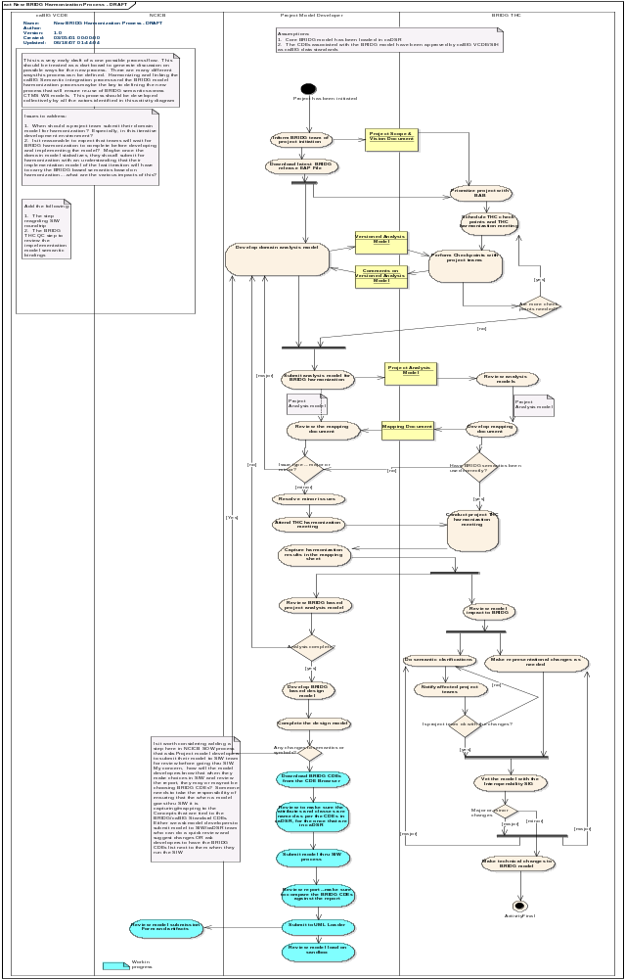
FIGURE LEGEND: The Activity Diagram (above) defines a draft process currently being adopted (and possibly modified based on experience) by the NCI/caBIG™ program within the Clinical Trial Management System Work Space (CTMS WS) to ensure coordination between application teams and the BRIDG THC as the various teams – each working on a particular aspect of the overall functionality necessary to support cancer clinical trials – define and submit BRIDG harmonizable artifacts which will ultimately be registered in the NCI’s caDSR (Data Standards Repository), to run-time mediator of computable semantic interoperability. This diagram is included as exemplar content and is not meant to define an exclusive process for interacting with the BRIDG Project or Model.

When a project team comes to a THC meeting for harmonization of their content, they are required to bring a “Mapping Document” which specifies how the project team believes that each of the elements in their static model maps to the current BRIDG Model. (NOTE: at present, no attempts are being made to harmonize dynamic content. However, such harmonization will almost certainly occur in the future in the context of Service Oriented Architecture (SOA)-based service specifications.) The Mapping Document facilitates the team-THC harmonization discussions by (ideally) decoupling the potentially different representational choices made for the same semantics between the two teams. The Mapping Document is also used as a working reference during the THC meeting to facilitate BRIDG Model representational choices. Over the course of a single 3-day harmonization meeting, it is not uncommon for the BRIDG Model to change both its structure and content as new concepts are included, existing concepts are disambiguated based on the submitting team’s additional perspectives, etc. Over time as more projects are harmonized into the BRIDG Model, the THC expects that the magnitude of changes to the BRIDG Model as a result of a single harmonization session with be relatively small, much as has been the case with the HL7 Reference Information Model as it matured and stabilized.

The size of the THC has been kept small to ensure its effectiveness when making representational choices regarding BRIDG Model content. The THC assumes that the larger community has participated in vetting the various harmonizable artifacts that are presented to the THC and/or that the community will respond to the various published Releases of the BRIDG model with appropriate feedback which will, in turn, drive the content of future BRIDG releases. The BRIDG model only succeeds if the community interested in its semantics utilizes it as a DAM and informs the THC of its errors of omission and commission, errors which the THC is committed to promptly addressing in future releases. Project teams define domain semantics; the THC makes representational choices about these semantics; the community validates both that the semantics were initially stated correctly and completely and that the THC represented those semantics correctly and completely (realizing that there may be more than one valid representation of a given semantic.)

Over the course of the BRIDG Project’s existence, a number of projects had portions of their content harmonized into various evolving versions of the BRIDG model. Over the past nine months, the model has gained enough stability and the processes for model maintenance, management, and evolution enough maturity that the Clinical Trial Management System Work Space (CTMS WS) of the caBIG™ project has decided that all applications built under NCI funding for use in the CTMS WS must utilize the BRIDG model as the starting point for application analysis activities and requirements specification and, as part of the final application deployment process, harmonize their application semantics with the BRIDG model so that interoperability in the CTMS WS will be based on exposed BRIDG Application Program Interfaces (APIs). In combination with the reverse engineering of the CDISC and HL7 RCRIM specifications in the BRIDG Model, this effort marks the movement of the BRIDG Project and its associated Model “from pilot to enterprise.” It should be noted that although each of the various efforts to add semantics to the BRIDG model has resulted in clearer definitions and representations of the semantics represented in the model, the definition/boundary of the BRIDG model has not changed from its original definition:

- Protocol-driven research and its associated regulatory artifacts, i.e. the data, organization, resources, rules, and processes involved in the formal assessment of the utility, impact, or other pharmacological, physiological, or psychological effects of a drug, procedure, process, or device on a human, animal, or other biologic subject or substance plus all associated regulatory artifacts required for or derived from this effort.

Differences in Meaning vs Differences in Representation: Normalization, Harmonization, Localization and a Note on the Challenges of building a Domain Analysis Model
The process of building a DAM in a domain-of-interest is a process of knowledge extraction and establishing common, non-ambiguous representations across and among various stakeholder groups. The term “harmonization” was taken from the HL7 V3 process, where it is used to refer to the process whereby multiple perspectives on a given problem are presented to an informed, neutral group who must decide if the various perspectives represent the same or different semantic content, i.e. the process of harmonization is focused on distinguishing true differences in meaning from representational or naming differences, a process that is, at times, straightforward, while at other times quite complicated and time-consuming. When a difference in naming or meaning is encountered, the choices are, at least in theory, fairly limited:

- on the one hand, the difference is real so that the two concepts need to be appropriately defined, separated, and granulated; or, alternatively

- the concepts are virtually identical and appropriate naming decisions and definitions (including examples of naming choices) must be made.

The operational difficulties in building a DAM arise when seemingly “simple” differences (or agreements) are examined more closely and reveal intricacies in meaning that may be contextual, cultural, or otherwise.

Technically speaking, the process of disambiguation and concept granulation known as “harmonization” can be distinguished from the process of “normalization,” where one concept name is assumed to subsume another equivalent concept’s name. Likewise, harmonization and normalization are distinguished from “localization”, a process whereby a concept that is known to be non-interoperable is allowed to persist in a model, often because “that’s the way things are done” at a local level. The THC’s job as its sorts through a new set of harmonization artifacts presented for inclusion in the BRIDG model is to determine whether conflicts in concepts represent one of the following situations:

- naming issues, which are solved through normalization with the choice of a single name assigned to both concepts;

- definitional issues, which are solved by appropriate harmonization techniques such as concept splitting; or

- localization, which need to be either excluded from the model or included as appropriately tagged exemplar content.

Thus, an expected outcome of a THC meeting is that new names are selected for overloaded terms (i.e. situations where the same term is used to mean several things), ambiguous/overlapping concepts are granulated to express their meaning with appropriate semantic clarity, and, if necessary, a certain amount of the content is deemed as localizable or outside the scope of interoperability concerns.

It should be noted that one of the realities of a shared DAM such as BRIDG is the phenomena of “my words aren’t in the model” or “that term is used more broadly than I use it.” The pragmatics of building a shared model mean that not everyone’s particular labels (words) for naming concepts will be seen in the model. It is the job of the THC, rather, to make sure that words with conflicting or overlapping semantics are disambiguated. Sometimes, this is accomplished by using new words to point to specific, rigorously defined concepts. For example, the symbol Protocol” is used to mean both “a particular kind of documentation, i.e. one that specifies all of the rules, regulations, assumptions, etc. that define a clinical study set up to answer a specific question/address a specific hypothesis,” as well as “the collection of the defined set of activities one plans or, in fact, accomplished, in the course of a given study.” Pursuing the word “Protocol” a bit further, one realizes that there are actually two distinct concepts lurking behind a single term and that using the symbols “Study Protocol” and “Process Protocol” resolves the ambiguity by restricting the latter term to refer to the definition and specification of the steps to accomplish a goal, while the former includes not only the “rules,” but also expands the meaning of the original overloaded symbol to include the overarching semantics of hypothesis evaluation. In such cases, inclusion of a concrete example is often deemed necessary to fully define the new terms: For example, a Study Protocol would be “Protocol XYZ to evaluate the therapeutic effectiveness of drug ABC in treating disease JHK,” while an example of a Process Protocol would be “To draw a CBC, execute the following sequence of steps and rules.”

In the case of a word/symbol being used more broadly than a particular local usage of the word, the guidance of the THC is for the local application to be aware of the restricted usage and the possible larger interoperability issues that may result from systems with the restricted usage trying to interoperate with systems with the broader usage. If significant interoperability issues arise and find their way back to the THC, new symbols may have to be defined for a future version of the BRIDG model and appropriate transformations applied to the involved applications based on earlier versions of the BRIDG model. In other words, the BRIDG Model and the underlying THC processes are expected to play a critical role in the overall process of message specification/application development and as such, specification/application implementations much be designed with the appropriate processes/procedures/infrastructure in place to allow smooth migration and version management going forward. Change is a given. Architecting and planning for change is essential.

Contributing to the BRIDG Project/Model: How Does a Project Team Get Its Content Into the BRIDG Model?
The short answer is that any project team working in a domain whose semantics are within – or partially overlap with – the semantics defined by the BRIDG model (see Section 1.0) is encouraged to contribute their semantics to the BRIDG model via the Harmonization Process. The only requirement for participating in this process is the preparation by the interested team of BRIDG harmonizable artifacts, i.e. the set of Class, Instance, Activity, State, and/or Sequence Diagrams which collectively define the project team’s specific semantics and which the team and the THC will collectively harmonize into the larger BRIDG model.

Project teams wishing to contribute to the BRIDG model are urged to contact one of the members of the THC (the authors of this document) either directly or through https://cabig.nci.nih.gov/inventory/infrastructure/bridg/ to discuss the logistics of discussing their project and being scheduled – through a discussion with the BAB – for a future harmonization session.

The BRIDG PROJECT website at NCI

The BRIDG project page can be found at

https://cabig.nci.nih.gov/inventory/infrastructure/bridg/.

Interested individuals can download the Release package from the BRIDG GForge site which can be accessed from the NCI BRIDG project site.

The BRIDG Model Release Schedule
With the release of BRIDG 1.0, the BRIDG THC and BAB are announcing a general Release Schedule. There will be one “major point” release per calendar year, i.e. 1.0, 2.0, etc. There will be quarterly “minor point” releases, i.e. 1.1, 1.2, etc. This notation system is being adopted based on a convenient method of time-stamping a given release to a given year (e.g. all 1.x releases will have been released during 2007, all 2.x releases in 2008, etc.) rather than to denote any significant focus or content differences between major vs minor point releases.

The THC anticipates that the major point release will occur in January of each year with the minor point releases in April, July, and October. In 2007, there will be one additional release (1.1) in October. Release 2.0 is planned for January, 2008, Release 2.1 for April, 2008, etc.

All releases will be posted for download at

https://cabig.nci.nih.gov/inventory/infrastructure/bridg/

with associated updated Documentation Package including itemized bug fixes (corrections of errors of commission), technical corrections (corrections which do not change the semantics of the corrected item), and content additions and modifications. The web site will also be updated as needed with associated supporting documentation including education material, relevant presentations, etc.

The BRIDG Model as a “Standard” – Solicitation of Community Input on the BRIDG Model
In the sense that the BRIDG Project does not operate under the umbrella of a formal standards organization such as HL7 (an ANSI-certified Standards Development Organization (SDO)), the BRIDG Model does not represent a formal standard. As such, there are no voting or formal content approval procedures associated with a given release of the BRIDG model. However, because BRIDG Model content that is tagged as “RELEASE X.Y” is content that has been developed by a project team which is expected to have solicited some degree of consensus among its immediate stakeholders and then harmonized into BRIDG Model via the formal THC harmonization processes, the THC and BAB feel comfortable in making the assumption that the content has had a reasonable opportunity to be vetted by a representative cross section of the BRIDG community.

Nevertheless, realizing that as broad a perspective on BRIDG content as can be gained benefits both the model and the community it serves, the THC plans to keep an ongoing comments and issue logging infrastructure active at all times. Users and interested parties are encouraged to download the BRIDG Model R1.0 and its associated documentation and respond openly, critically, and constructively to any issues that they might find, be they errors of omission or commission. The THC plans to address each bug/technical correction submitted to the web site between Release X.Y and X.Y+1. It also plans to publish a monthly “BRIDG Newsletter” updating the BRIDG community as to when expected content can be expected to appear in the BRIDG Model as well as to update the community on various applications of the BRIDG Model and the Lessons Learned from those projects. In addition, the THC and the BAB will maintain an ongoing dialogue to determine if any specific issues should result in a re-prioritization of THC schedules or changes in the governance of the BRIDG Project.

The URL https://cabig.nci.nih.gov/inventory/infrastructure/bridg/ contains a BRIDG_Users listserv link through which anyone may contact the THC with suggestions, comments, criticisms, corrections, etc. relative to the posted BRIDG Model, associated Documentation Package, or other BRIDG-related materials. The THC will attempt to address all issues submitted through this main BRIDG Project URL

The BRIDG Model – General Considerations and Conventions
This section describes the general principles and representational guidelines used in constructing the BRIDG Model as well as specific information on the model’s current structure and therefore how one can effectively navigate the model. Discussions regarding content-specific issues (e.g. representational choices involving specific content) can be found in Section V.

Computable Semantic Interoperability (CSI)
It is important to note that the overarching, primary use case for the BRIDG Model is the need to achieve computable semantic interoperability (CSI) both within the domain of protocol-driven research as well as between this domain and others that may intersect with it at the interoperability level, e.g. with Public Health around Adverse Events, or with general healthcare and the Electronic Health Record with respect to “single source” data capture and reuse. It is beyond the scope of this BRIDG Documentation Package to discuss the details of CSI A summary of the minimum – that is, necessary but not sufficient – requirements needed to achieve CSI – the so-called Pillars of Computable Semantic Interoperability -- can be stated as follows:

- Pillar #1: Common model across the domains/sub-domains-of-interest

- Pillar #2: Computationally robust datatype specification

- Pillar #3: Framework for binding context-specific terminologies to model elements

- Pillar #4: Methodology for constructing interoperability “building blocks” (e.g. data interchange structures or application service specifications) that utilizes the output of the first three requirements

CSI Pillar #1: The BRIDG Model
The BRIDG Model is an instance of Pillar #1. Future releases will increasingly embrace Pillar #2 through the specification of each BRIDG Model attribute using the HL7 Version 3 Datatype Specification and are therefore discussed in some detail below. Although Pillar #3 is currently not addressed directly in the BRIDG Model, it will increasingly become part of future releases as the BRIDG Model is used to more directly influence specific project goals and is therefore discussed in some detail below. Processes adopted by the various stakeholder organizations (e.g. application of the HL7 Version 3 Development Framework (HDF) or Health Services Specification Project (HSSP) can be expected to address Pillar #4.

It should be noted that it is the express purpose of the BRIDG Model to inform both data interchange/message specification and application development. Thus, the BRIDG Model defines -- and graphically represents -- both dynamic information (business process activity flows and interactions) and static information (the concepts, attributes, and relationships) that together define the semantics of the BRIDG domain.. Both aspects of semantic clarity are essential if one is to achieve CSI to the degree deemed necessary by the BRIDG stakeholders. However, in the context of CSI, it should be noted that although the static semantics of the BRIDG Model could be used as input into formal inference engines, it is not the primary purpose of the BRIDG Model to function in this manner.

It is also beyond the scope of this document to describe the similarities and differences between the BRIDG Model and traditional purely static structures such as ontologies, although one of the members of the THC (DF) is actively involved in developing the necessary transformations to move between BRIDG and OWL representations of BRIDG Model content.

CSI Pillar #2: Complex Data Types
Within the context of BRIDG, the concepts of Abstract Data Type and Complex Data Type are closely linked. While a discussion of Abstract and/or Complex Data Types is beyond the scope of this documentation, several aspects of the current and planned use of Complex Data Types (CDTs) in the BRIDG Model is necessary to understand the current and planned semantics of the BRIDG Model’s static content.

Over the next several Releases of the BRIDG Model, the THC will increasingly bind each attribute in the static class diagram to an appropriate HL7 Version 3 data type. This strategy is a reflection of the THC’s assessment of the maturity and degree of adoption of the V3 Data Type Specification (e.g. it is now an ANSI standard and relevant portions are moving to be adopted by ISO) in combination with the THC’s view that all of the semantics of complex data types of interest to the THC and the BRIDG Model are currently represented in HL7’s (abstract) Data Type Specification. As such, for the purposes of this discussion, the term “complex data type” will be used exclusively. Readers interested in more information on abstract data types (ADTs) in healthcare, clinical research, and the life sciences are encouraged to use the HL7 V3 Data Type Specification as a reference document and/or to see the extended discussion of the topic in the Documentation Package Section VII, Appendix. (NOTE: the HL7 Version 3 Data Type Specification is available through HL7.org.)

Assignment of BRIDG attributes to specific HL7 data types will be an incremental and iterative process that will take place over several releases of the BRIDG model. Release 1.0 utilizes two of the HL7 V3 data types: Instance Identifier (II) and Concept Descriptor (CD). In addition, the THC has identified several additional collections of attributes which ultimately will be represented as HL7 V3 data types, for example those describing various absolute and relative timing specifications which are consistent with the semantics of the HL7 V3 GTS (General Timing Specification) data type. For Release 1.0, these attributes have been “flattened” and appear as individual attributes within their relevant classes (e.g. CalendarTS). In future Releases, these attribute collections will be “rolled up” into a single attribute of data type GTS and additional notes will be given to show users of the BRIDG Model exactly how the semantics of the HL7 V3 data type are being utilized in the BRIDG Model.

CSI Pillar #3: Binding to Terminologies
The BRIDG Model – and in particular, this paragraph speaks most immediately and directly of the static content, i.e. classes, attributes, and relationships of the BRIDG Model -- provides an important component necessary to achieve CSI, i.e. it supports CSI Pillar #1. However, there are other components as well, e.g. Pillar #3. The binding of attributes in the BRIDG Model to specific terms within locally or globally specified terminologies – a process which occurs in the context of a run-time instance of BRIDG Model concepts -- has not historically been part of the BRIDG Model’s collective content. However, the binding of well-defined standardized vocabulary/terminology concepts to agreed-upon semantics (e.g. BRIDG Model attributes) is fundamental to achieving CSI (e.g. the CSI between a Patient Study Calendar application within caBIG™ and an application from an external application that sends (or receives) a CDISC-compliant SDTM message) and must therefore be addressed at some point in the evolution of the BRIDG Model.

Thus, on the one hand, the BRIDG Model, as an implementation-independent representation of domain semantics applicable to a number of design/implementation solutions. However, each of these designs/implementations must, at some point in their lifecycle, specify appropriate terminology bindings as part of the computational-level semantic definitions of attributes. In order to achieve CSI, the BRIDG Model can – and must – specify these bindings if the semantics of the BRIDG Model are truly to be “shared.” The specification of terminology bindings does not make the BRIDG Model implementation-dependent. Rather, it specifies the shared semantics at a deeper/more comprehensive level than is possible without these bindings. In other words, the BRIDG Model can be “implementation independent” in the sense that it should not specify structures like primary or foreign database keys, but it cannot remain implementation independent in the sense of ignoring run-time terminology bindings. The recent decision of the NCI to register BRIDG Model static elements in the caBIG™ Cancer Data Standards Repository (caDSR) guarantees that attribute-specific terminology bindings will become increasingly prevalent in future releases of the BRIDG Model. In addition, ongoing work by CDISC to define specific terminology bindings will mesh with BRIDG Model binding specifications. Users of the BRIDG Model can expect to see terminology bindings as part of the BRIDG Model in future releases. Bindings are not, however, specified in Release 1.0.

The BRIDG Model: Instance of a Domain Analysis Model
The BRIDG model – which includes both static and dynamic representations of concepts, attributes, relationships, and processes of the protocol-driven research domain – is the most obvious and visible artifact produced by the BRIDG Project. More formally, the BRIDG model is a domain-specific instance of a Domain Analysis Model (DAM). A further discussion of the term Domain Analysis Model can be found in the Glossary of the Documentation Package.

The Domain-of-interest of the BRIDG model
The BRIDG model defines the static and dynamic semantics of a domain-of-interest. Specifically, the domain of the BRIDG model is formally defined by the BRIDG Advisory Board as:

- Protocol-driven research and its associated regulatory artifacts, i.e. the data, organization, resources, rules, and processes involved in the formal assessment of the utility, impact, or other pharmacological, physiological, or psychological effects of a drug, procedure, process, or device on a human, animal, or other biologic subject or substance plus all associated regulatory artifacts required for or derived from this effort.

The graphical overview of the domain of the BRIDG Model is shown in Figure 2.

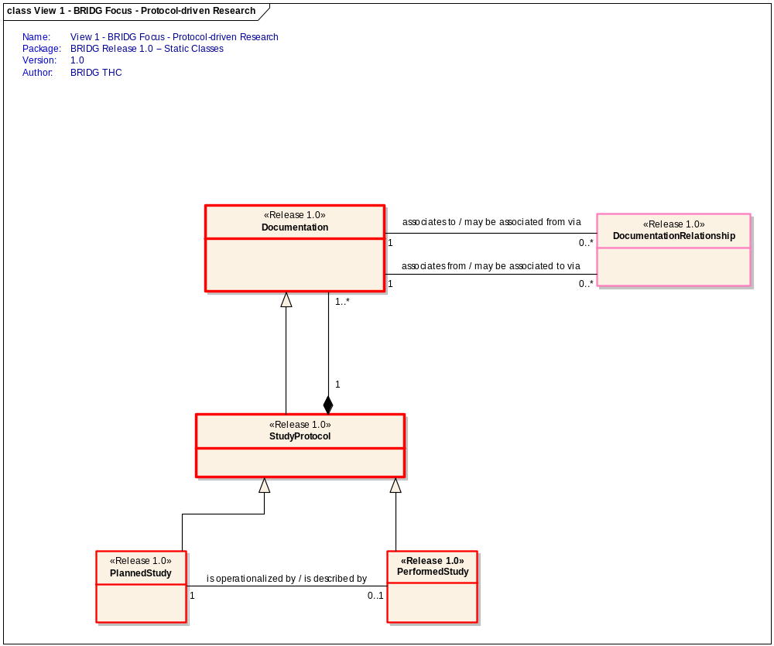
Figure 2 The Scope of the BRIDG model. This figure depicts the bi-directional (compositional and generalization/specialization) relationship between two of the classes which form the focal point of the BRIDG domain: Protocol-driven research (represented here as the ‘StudyProtocol’ class) and Documentation. The concept “DocumentationRelationship” indicates the fact that documents (containing documentation) can be linked together in arbitrarily complex ways including relationships such as “Containment,” “Subsumption,” “Replacement,” etc.) See the definition of StudyProtocol in the BRIDG Model for a further explication of the dual role of this concept as both a type of documentation and a collector of planned or performed Activities. Also note that the Planned or Performed Activities, although not explicitly shown in this graphic, are contained in the two subtypes of StudyProtocol, i.e. PlannedStudy and PerformedStudy.

The Scope of a DAM
When working with DAMs, one assumes that a given application, service, or data interchange specification (“message,” “procedure call,” etc.) may involve multiple overlapping/intersecting domains, i.e. domains that share common dynamic or static semantics. The occurrence of overlapping scope between two or more DAMs is not necessarily an indication that a given DAM’s scope is too narrow, but rather simply an indication that the two domains have some common semantics. In such cases – for example, there are overlapping static semantics around the concept “adverse event” between the BRIDG domain and the Public Health domain – the most expeditious approach often is not to expand a particular DAM, but rather to harmonize the overlapping semantics of the two domains. The concept of harmonization is conceptually depicted in Figure 3.

BRIDG Domain

Public Health
Domain
Common
Domain
(e.g., Adverse
Events domain)
Figure 3 Overlapping Domains-of-Interest. Semantics from intersecting/overlapping domains-of-interest (e.g. ‘adverse event’ in the Public Health and BRIDG domains) are “harmonized” so that computable semantic interoperability (CSI) is possible between the domains. Note that the notion of harmonization at domain-to-domain “touch points” (“intersections”) is not limited to static data, but may also involve interoperability/share semantics regarding dynamic behavior.

As mentioned in the discussion of the genesis of the BRIDG Model (Section III), a DAM is useful in separating domain-specific (implementation-independent) semantics from implementation-dependent semantics and is therefore helpful in identifying true cross-domain intersection points that may need to be harmonized. The following figure shows how the BRIDG Model was initially envisioned to resolve questions of interoperability between the cross-domain HL7 Reference Information Model (RIM) and several of CDISC’s domain-specific implementations.

CDISC XML
(e.g., Operational Data Model (ODM))
HL7 XML
(e.g. Periodic Lab Update)
CDISC Implementation Specification
HL7 Implementation Specification
Implementation-Independent Representation
HL7 RIM → RCRIM DMIM
Domain Analysis Model
(BRIDG)
Design-level representation of multiple domains-of-interest
Requirements
Design
Implementation

The BRIDG model is a DAM and therefore presents only the implementation-independent semantics of a domain-of-interest. The HL7 Reference Information Model (RIM) and its derived, domain-specific artifacts are, strictly speaking, implementation-independent. However, they are not “domain-friendly” because the semantics are represented using cross-domain, often-design-level abstractions that are unfamiliar to domain experts. Finally, XML is a particular implementation representation. Representation of the semantics of a domain-of-interest in a separate model from the design or implementation models of those semantics facilitates automated transformations between the various implementations, e.g. between CDISC XML and HL7 XML.

UML: The BRIDG Model’s Representational Language
The graphical lingua franca of the BRIDG Model is the industry standard Unified Modeling Language (UML). To date, the iconography and underlying language grammar of UML V1.5 have been sufficient to express all of the semantics of both the dynamic and static views of the domain of the BRIDG Model. In particular, because the BRIDG Model is an instance of a DAM, it must first and foremost be comprehensible to domain experts. This means that extended UML functionality such as Object Constraint Language constructs that facilitate automated code generation or support executable models have not been employed in constructing the BRIDG Model simply because they have not, as of yet, been required to express the semantics that have been codified from the various domain experts that have contributed to the content of the BRIDG Model. The BRIDG THC will continue to utilize the minimum amount of modeling language complexity necessary to represent the BRIDG domain semantics in a way that is clearly understandable and readily accessible to the BRIDG domain Subject Matter Experts while at the same time robust enough to support CSI-based data interchange specifications and application coordination scenarios. To date, UML V1.5 has proven capable of supporting these requirements.

At present, no language other than UML (and English, for all definitions and occasional notes attached to objects in views) has been used to express BRIDG domain semantics. In particular, to date the THC has not employed any one of a number of formal ontology languages (e.g., OWL), nor has it specified any business rules using a computable constraint language such as Object Constraint Language (OCL). The THC has instead chosen to attach UML Notes to certain classes in the UML class diagrams to denote specific constraints, assumptions, and business-level requirements. As the acceptance and penetration of OCL increases, future versions of BRIDG may begin to utilize OCL as the lingua franca for formally expressing business rules and other constraints. With respect to OWL, the BRIDG THC does plan to provide an OWL representation of the static semantics of the BRIDG model at some point in the future. In particular, as mentioned above, one of the THC members (DF) is actively involved in developing examples of the transformations that are semantically possible between a UML/BRIDG representation of domain semantics and the identical semantics in an alternative, OWL-based representation.

The BRIDG Model uses two UML diagrams to represent the static semantics of the BRIDG domain: Class Diagrams and Instance Diagrams. Each type of static diagram is described below, with the majority of the discussion being devoted to Class Diagrams as the predominant expression of BRIDG static semantics. Note that it is beyond the scope of this documentation to provide instruction on the UML class or instance diagram grammar or a discussion of UML iconography. A number of excellent on-line and print references are available at varying levels of detail and specificity. However, a brief overview is provided here with the hope that it is of sufficient depth to enable domain experts not familiar with UML to be able to understand the static data diagrams in the BRIDG Model.

The Semantics of UML Class Diagrams
The essential semantic components of UML Class Diagrams as used in a DAM are:

- class – a concept of primary importance the domain-of-interest, depicted as a rectangle labeled with the concept’s name
- attribute (including datatype specification) – a descriptive feature of a class, depicted as being contained within the class
- relationship – one of several types of “lines” between classes
- method/operation – not utilized to date in the BRIDG Model

The definition of each of these components is as follows:

Class (concept): In the BRIDG Model, a UML class is a concept of importance to domain experts with knowledge in the BRIDG domain. Domain experts need to “see the things that they know are important.” Therefore, the BRIDG Model intentionally contains, whenever possible, words that are known through the BRIDG domain (see the discussion on Normalization, Harmonization, and Localization in Section III.)

Attribute (property of a Class): Class attributes “describe” various static characteristics of a class. Ultimately, they must be assigned a single data type such as integer, character, or string (so-called “simple” or “atomic” data types), or, alternatively, a “complex” data type such as “date-time,” “physical quantity,” “coded concept.” See the Appendix for a more detailed discussion of the concept of Complex Data Types, and Section V for a discussion of data types in the BRIDG Model.

Relationship: A syntactic (structural) and semantic (meaning) between two classes. In particular two classes may be related in one of three general ways:

- generalization/specialization (inheritance – a subtype class “is-a-kind-of” type of its super-type, e.g. “the subclass bear is-a-kind-of super class animal”)

- composition/aggregation (whole/part – the whole class “is-a-part-of” class that is part of its overall makeup, e.g. “the class called anchor is-a-part-of the class boat). NOTE: the BRIDG Model utilizes “composition” rather than “aggregation” semantics of UML (“strong aggregation” or “the black diamond”) as a matter of convention in its class diagrams and does not, at this time, formally distinguish between the two semantics because Use Cases presented to the THC have, to date, not required the distinction.

- a general syntactic “is associated with” relationship which can be further qualified (semantically qualified) through the use of Roles, Cardinalities, and Association Names (e.g. the Person class is associated with the Company class and can be qualified as “A Person in the role of Worker is employed by zero-to-many Companies; A Company in the role of Employer hires one-to-many Persons.”)

Method/Operation: A “responsibility” of a given class, this construct is not currently utilized in the BRIDG Class Diagram. However, it may be used in future releases as emphasis is placed on application interactions in addition to static data exchange (“message specification.”)

The Semantics of UML Instance Diagrams
Class Diagrams are the lingua franca for representing the concepts, attributes, and relationships that define the static semantics of the domain of the BRIDG Model. Instance Diagrams are used to illustrate specific representational constructs, particularly in three situations:

- Domain application of the concepts shown in the class diagram involves constructs assembled from multiple instances of several classes related to each other in arbitrarily complex ways, e.g. Schedule of Activities in a Study Calendar; symptom constellations which may be classified by one observer as an Adverse Event of certain causality and by another as either not an Adverse Event or as one having different causality, etc.

- Domain experts agree on the semantics of a given set of concepts and concept relationships, but not on the names of the concepts. In this case, an Instance Diagram is used to demonstrate the use of the BRIDG terms (concepts) and definitions with the added explanation that one is free to attach alternative, domain-instance-friendly names to concepts as long as those names do not change the underlying concept semantics (including the relationships of a given concept).
- More than one representation (and possibly implementation) of a set of BRIDG domain concepts is known to exist and clarity as to the CSI relationship between the various representations can be gained by illustrating the BRIDG representation in an instance diagram.

Exemplary Instance Diagrams are included in Section V of the Documentation Package as part of the explination of Release 1.0 static content. Future Releases of the BRIDG Model are expected to contain increasing numbers of Instance Diagrams in addition to “project-specific” Class Diagram representations of a specific project’s view of their piece of the BRIDG domain (e.g., SDTM view, Patient Study Calendar view, Trial Design view, Adverse Event view, etc.) Although the concept of project-specific “views” and Instance Diagrams are related, they are distinctly different in their semantics and the reader is cautioned to be clear as to their respective differences and uses.

Static Representations: Conventions and Guidelines
Following is a discussion of several specific representational conventions and/or guidelines followed by the THC in representing the static content of the BRIDG Model.

Explicit vs Implicit Representation
The THC is very sensitive to the use of abstraction and generalization in the BRIDG model. Although often quite elegant from an information modeling perspective, overuse of generalization and abstraction often hides information that domain experts see as critical in one or more layers of a hierarchy. The THC believes that although appropriate in a design model, excessive information layering and hiding is contrary to the expressed purpose of a DAM, i.e. to be domain-friendly as well as solution-robust (yet remain implementation independent). To this end, the THC has adopted a general stylistic approach of limiting the use of abstraction and generalization, always aiming to err on the side of using domain-friendly explicit terms whenever possible, i.e. terms that can easily be recognized by domain experts as possible, rather than hiding the semantics of these terms (concepts) in the deeper layers of the model. The commitment to explicit rather than implicit representation is most obviously manifest in the main BRIDG Class Diagram in two structural aspects of the diagram:

- limited use of UML Abstract or Super-type Classes (An abstract class serves as a ‘collector’ for the common attributes (and methods) of its specializations and is thus, in some sense, a ‘macro’ that is used to make sub-type/sub-class definition more efficient and error-free. There are no special semantics associated with BRIDG Abstract Classes, i.e. they are used exactly as defined in UML.)
- when either abstract or super-classes exist in the BRIDG Model, there is limited grouping of common attributes in these “parent” classes

The latter guideline is particularly important to avoid subtle semantic overloading of attributes – and thus the blurring of their respective value sets – when the attributes are inherited by the super-class’ various subclasses. In particular, the THC adopted the representational convention of pushing potentially common attributes that could be modeled as part of a super-class down into sibling sub-classes. The motivation for this decision was two-fold:

- The THC wanted to allow the specific visualization of domain-friendly concepts at the level at which domain experts were used to seeing them applied rather than forcing domain experts not overly familiar with UML notation and the concept of inheritance to mentally map the attributes of the ancestor class into the class-of-interest (e.g., instead of having the super-class Role contain the attribute “RoleID,” the THC has defined “healthcareSiteIdentifier,” and “providerIdentifier” as specific attributes in the HealthcareSite, and HealcareProvider)
- In many cases the attributes had subtle semantic differences when applied in the context of one sibling class verses another. This stylistic approach naturally leads to more attributes at the sub-class level than one might see in a more “pure UML” class diagram. However, the tradeoff of increased recognition from domain experts was deemed to worth the price of a “leaf-heavy” class diagram.

Empty Classes in the BRIDG Class Diagram
Those familiar with UML will note the occurrence of several classes with no attributes in the main BRIDG Class Diagram. The presence of what appears to be a flagrant violation of UML modeling style if not semantics (“all classes should have at least one unique attribute”) is another manifestation of the THC’s decision to err on the side of explicit rather than implicit representation as a statement of the commitment of making the BRIDG model domain-expert friendly. Classes are created in the BRIDG model for one of three reasons:

- The class represents a unique concept that is considered essential to be seen by domain experts reviewing the BRIDG Model for correctness or completeness
- The class has a unique collection of attributes
- The class has one or more unique relationships

It is the third of these reasons that results in empty classes that result in the presence of empty classes in the BRIDG Model, i.e. the concept represented by the class is deemed of sufficient importance to the domain-of-interest that it needs to be explicitly shown in the Class Diagram and, in fact, its importance in the domain-of-interest can then be visually appreciated to be based not on any unique attributes it has, but rather on its unique relationships.

Placeholder Classes
As previously mentioned, each static element in the BRIDG Model can have one of three possible tags attached to it:

<<Release 1.0>>
<<draft>>
<<placeholder>>

Placeholder classes are included to give users of the BRIDG Model a “hint” of the content that is being worked on by various project teams and which can be expected to appear in the BRIDG Model in the near future. The specifics of the <<placeholder>> classes in the Release 1.0 BRIDG Model class diagram are discussed in Section V.

Derived Values
The degree to which a Class Diagram utilizes (or does not utilize) derived values is another way in which the commitment to explicit vs implicit representational choices is manifest. In keeping with the choice to be more explicit than implicit, the THC has, in general, avoided the use of derived values, preferring instead to explicitly define attributes that could easily be represented in a design or implementation model (as opposed the analysis model that BRIDG is) as derived attributes. There are, however, a few exceptions where the THC views the derivations as transparent and has therefore chosen not to define specific attributes. Examples include “AgeAtEnrollment” and “SubjectAgeAtCollection,” as well as a number of boolean “indicator” attributes which are common to implementation specifications such as CDISC’s SDTM model (e.g. the TRUE/FALSE value of the attribute “missedReasonIndicator” can be derived from the presence or absence of text in the “missedReason” attribute, as is the case with the “performedAsScheduled” indicator whose TRUE/FALSE status can be derived from a comparison of the date-time stamp of the ScheduledActivity instance vs the corresponding stamp of the PerformedActivity instance. Finally, a third type of derived value is specifically represented by the absence of attributes commonly used to classify events that occur in a given clinical trial as “scheduled” vs “unscheduled.” The status of this indicator is derivable from a comparison of the PerformedActivity’s ID with the list of all ScheduledActivities (or PlannedActivities, depending on the application’s definition of “scheduled.”)

Required vs Optional Attributes
In the BRIDG model, there are no semantics specifying whether an attribute is required or optional. Thus, one can infer that all attributes in the BRIDG model are optional. However, the THC expects in future releases to fully specify each attribute as required or optional and, if appropriate, also specify default values and/or other restrictions on the attributes cardinality when specific use cases are presented to the THC.

BRIDG Mapping Documents
A Mapping Document is, at present, an Excel spreadsheet that shows the specific relationship between each static attribute (or group of attributes, depending on the semantics involved) in a project’s existing analysis model, and one or more static elements in a specific release of the BRIDG model. It should be noted that the relationships shown in a given entry in a Mapping Document are often not one-to-one and often not at the same level of abstraction between the two models. Rather than cite specific examples in the text, the THC has included the Mapping Documents for the static elements of each of the five projects contributing static semantics to the current release. The THC publishes the Mapping Documents generated in the process of harmonizing all static semantics introduced into the BRIDG model since the last release. The THC believes that the Mapping Documents will form an essential part of the BRIDG knowledge base that project teams will use as they both begin new projects and extend existing ones. In the future, the THC plans to place the relationships contained in each mapping document in an accessible and downloadable database. Timing of this addition to the BRIDG release content is, at present, uncertain.

The BRIDG Backbone
The following classes have been identified as the BRIDG backbone classes as of Release 1.0 that support the clinical research domain:

- Person
- Organization
- Material
- StudyProtocol
- Documentation
- Activity
- ActivityRelationship
- ObservationResult
- ObservationResultRelationship
- Assessment

In the static views of the BRIDG model, the borders of these classes shown with black bullets (above) are thicker than the other classes to denote their function as part of the BRIDG Backbone. The BRIDG Backbone classes are named (and notated) as such because they appear in virtually every project’s content as it is harmonized with the BRIDG Model.

Also considered part of the “fundamental building blocks” of the BRIDG Model (not currently shown with thicker borders, however) are the three subtypes of the Activity class, i.e.

- PlannedActivity
- ScheduledActivity
- PerformedActivity

(NOTE: The THC has harmonized use cases that require the class PerformedActivityObservationResult. In Release 1.1, there will also be a class called PlannedActivityObservationResult as an outcome of the Trial Design harmonization that is currently underway.)

ObservationResult vs Assessment
The BRIDG Model distinguishes the concept of an Observation from an Assessment, the former being a single data acquisition event by a person or system and the latter being a meta-observation, i.e. a judgment made on the basis of one or more observation Results. Thus, for example, the Activity sub-class LabTest could produce three separate PerformedObservationResults (e.g. Na++ = 160 mEq/l, K+ = 3.1 mEq/l, BUN = 45 mEq/l) which might lead one clinician to make the assessment “Patient is dehydrated” while another, looking at the same observation results might conclude “Patient is in renal failure.”

Minimum Attribute Set in ActivityRelationship Class
In the BRIDG Model 1.0, the THC has an abstract class for all relationship classes in the model, i.e. ActivityRelationship. At present, the ActivityRelationship class has three substantive attributes – type, priorityNumer, and sequenceNumber -- the minimal number being driven by the scope of Release 1.0, i.e. by the specific Use Cases that the THC has reviewed from the project teams whose content is included in this release. The THC anticipates that it will increasingly include additional attributes from the RIM ActRelationship class as the need to express more complex relationships between activities that are common in protocols and trial designs are brought forward for harmonization.
In general, there are three types of relationships that can exist between any two activities:
- Composition
- Judgment
- Rules
Although each type of relationship has deeply different semantics, all constitute a “link” between two instances of (a type of) Activity. However, given the importance of linkages based on rules in the design (and execution) of a protocol, the THC may, at some future point, separate the notions of “relationships of composition” from “relationships of judgment” from “relationships of rules.”

Activity.category
The attribute Activity.category is included in the BRIDG model as a result of harmonization discussions which occurred with several of the application development teams, most notably the Patient Study Calendar (PSC) team. A requirement for grouping various types of activities according to one or more local business rules was clearly expressed. Although it was initially thought that the grouping would fit neatly within the Activity sub-type hierarchy of the BRIDG model, it was soon realized that local decisions regarding the enumerated list that populated an “Activity Type” drop-down list in an instance of the application could be at variance with the BRIDG model’s strict sub-type portioning. The Activity.category attribute is included to address this issue, at least for the context of Release 1.0. It is used in the BRIDG model in a manner similar to the use of Act.classCode in the HL7 RIM, i.e. as either a type discriminator (i.e. which sub-type of Activity is being referenced) or an alias (i.e. it may point to a locally defined concept not named in the Activity sub-type hierarchy. It is important to note that use of the attribute as an alias does not violate the semantics of the Activity sub-type hierarchy, but rather simply denotes that the local application has need to reference a collection of attributes identical to one of the Activity sub-types but named differently. If this practice is found to be wide-spread, the THC will need to publish an Activity.category enumerated value set similar to the Act.classCode value set published by HL7.

Where is “Analysis” and/or “Reporting” in the BRIDG Model?
As a follow-on to the discussion about the BRIDG representation of the various phases of a business process using explicit rather than implicit techniques (e.g. explicit phase-named classes such as “PlannedCalendar” and “ScheduledCalendar”) rather than a single attribute in a common class in the style of the HL7 Act class, a person familiar with the clinical trial process might legitimately ask the question of the BRIDG Model 1.0: “I see the phases of ‘planning,’ ‘scheduling,’ and ‘performing.’ Where are ‘analyzing’ and ‘reporting?’

With respect to the concept of “analysis,” the THC has not yet been presented with specific Use Cases and harmonizable artifacts that have resulted in the need to have these specific concepts represented in the BRIDG model. It is a virtual certainty that the concept of ‘analysis will emerge in the very near future in the context of Trial Design. In recognition of that fact, Release 1.0 of the BRIDG Model includes a note in the Class Diagram to remind readers of the model that this topic will be covered in future releases. The THC chose not to include a <<placeholder>> class called “Analysis Activity” because there is not yet a high-level agreement as to the semantics of this concept. With respect to the concept of “report”, it will most likely not occur as a general concept in the BRIDG Model since a report should be simply a collection of specific data/information (or derived data/information). (The notable exception to this statement is the case of Adverse Event or Regulated Product Submission “reports,” each of which collect data in known formats. If a DAM attempts to explicitly represent each individual report by type and attribute collection, one quickly degenerates into an intractable model that, on the one hand, purports to be a class diagram but is, on the other, an ever-expanding instance diagram.

Relationship of the BRIDG Model to the HL7 Reference Information Model (RIM)

The HL7 RIM is a cross-domain model that is distinctly not domain-expert friendly because it is designed to abstract the static semantics common to multiple domains into a single representational view. The domains-of-interest to the RIM include, but are not limited to:

- clinical care (inpatient and outpatient)
- healthcare administration
- reimbursement
- community care
- veterinary care
- genomics
- imaging

Although the RIM is, for the most part, relatively free of implementation details, it is not a DAM because, as just mentioned, it is not readily understandable by domain experts in any one of the listed domains (e.g, “Where are vaccinations in the RIM?” “How do I represent a provider credential?” “Where is a SNP found?”, etc.), a fact that arises from the requirement that the RIM abstract cross-domain semantics. However, because it is important to the BRIDG stakeholders that BRIDG semantics be expressible in HL7 XML, the THC is responsible for ensuring that BRIDG semantics can be represented in RIM structures. If this is not the case, the THC works with project teams to bring their specific semantics to HL7 for harmonization of the RIM, i.e. expansion of RIM semantics. To date, only a handful of such instances have been identified and have, in fact, been included in the current RIM. (NOTE: Saying that BRIDG semantics are mappable to the HL7 RIM does not mean that the mappings are one-to-one, e.g. attribute to attribute. In fact, they are most often not of that nature., i.e. a BRIDG class doesn’t often map to a RIM class (exceptions being concepts like “Person” or “Role” and, likewise, a single attribute in the BRIDG model may map to a combination of RIM attributes or a collection of RIM data type properties. The details of the mapping are not important. Semantic equivalence is the critical issue.)

In the context of ensuring that BRIDG to RIM mappings can be built by interested project teams in the course of either message or application development, the THC follows a general guideline of using RIM-like structures whenever such use can be done without obscuring the required domain friendliness of the BRIDG representations. So, for example, the BRIDG Model, like the RIM, is able (when necessary) to distinguish the notion of a “static role” (role played by an organization, person, or material) from a “dynamic role” (role assumed in the context of an activity), but when such a distinction is necessary, uses a different, more domain-friendly term for the latter concept (FunctionalRole rather than Participation.) Also, as previously discussed, the THC consistently chooses explicit rather than RIM-flavored implicit representations of concepts to ensure whenever possible that the BRIDG model will be readily understandable by domain experts familiar with the concepts, attributes, and relationships in the BRIDG model’s domain-of-interest. Sometimes these choices are readily mappable to the HL7 RIM. At other times, the mapping, while still possible, may be somewhat opaque when simply viewing the BRIDG Model’s class diagram.

Use of RIM Color-coding in the BRIDG model
One area of relative strong commonality with the RIM is the use of color coding in the static views of the BRIDG model. The RIM derived its inspiration for using color codes from an important book by Peter Coad et al entitled “Java Modeling in Color with UML.” Coad argues that there are certain “archetypes” present in virtually all static models, e.g. Parties (Persons or Organizations) acting in Roles (time-limited Capabilities, Capacities, or Competencies) participating in Events. He also states that there are often “libraries” or “repositories” of static information that are utilized in various ways by the Parties, Roles, or Events. For each of these archetypes, he assigns a color: Green (Party), Yellow (Role), Red (Event), and Blue (Library). He then observes the existence of a number of simple “visual rules” which are true for all grammatically correct models, e.g. “green must have yellow between it and red,” thereby allowing a model to be grammatically validated “from across the room.”

Because the early builders of the HL7 RIM felt that this approach had significant merit, it was adopted with some necessary modifications. In particular, the HL7 RIM adopted verbatim Green for its Entity class hierarchy (Party was abstracted to Entity to allow for the inclusion of animals, tissues, and materials/devices), Yellow for the Role hierarchy, and Red for the Act hierarchy (Event was abstracted to Act and a rich sub-class hierarchy was created to cover the specific semantics of a number of cross-domain Acts such as Substance Administration, Observation, etc.). The RIM then added three additional colors for its three “relationship” classes: the Participation class -- Role in the context of an Act -- which relates static Role instances to dynamic Act instances was assigned turquoise (to distinguish it from Coad’s blue); the ActRelationship class which specifies the semantics linking two instances of the Act class was assigned light red (pink in the BRIDG model); and the RoleLink class specifying the semantics of complex role-to-role relationships was assigned light yellow (NOTE: to date, the semantics of the RoleLink class have not appeared in BRIDG domain modeling sessions although they can be expected to at some point in time in the future.)

Whenever it presents an advantage of clarity to BRIDG domain experts, the THC has adopted the RIM color conventions. However, the BRIDG Model does not enforce the RIM color grammar unless that grammar is domain friendly. Thus, for example, BRIDG domain experts talk about “ManufacturedMaterial (green) in role of Specimen being collected during a SpecimenCollection (red) activity,” notably leaving out the superfluous (in this case” turquoise class “specimenTarget.” Thus, in summary, those familiar with the RIM color grammar will find some similarities in the BRIDG Model, but will find, on close examination, that the BRIDG Model does not strictly enforce that grammar.

The RIM Participation and BRIDG FunctionalRole Classes
There are essential differences in the semantics of the concept of Role class, i.e. a static, time-scoped capability, capacity, or competency vs FunctionalRole (not explicitly shown as a class in the BRIDG class diagram, but a concept that is discussed in the context of the BRIDG Model as equivalent to HL7’s Participation), i.e. Role in the context of an Activity. The motivation for the use of the name FunctionalRole in BRIDG vs Participation in the RIM was simply one of clarity and domain-friendliness, resulting in large part from the common domain usage of the term participant to refer to the role of a patient that is, at some point, enrolled as a StudySubject in a particular clinical trial. The THC felt that the use of the term “participant” as a Role would be confusing in if a “StudySubject” were then represented as a type of Participation. Future releases of the BRIDG model are expected to expand considerably on the explicit representation of the semantics of a number of trial-specific “roles” which will be, by virtue of their association with the Activity of a trial, be represented as (implicit or explicit) subtypes of the turquoise class FunctionalRole.

In the HL7 RIM, there are actually two Participation classes: the supertype Participation and its sub-type ManagedParticipation, the latter adding the two attributes necessary to track state – ID and status – to the attribute set of its parent. Discussion of the reasons for this separation in HL7’s RIM is beyond the scope of this document. However, because there are specific use cases in the BRIDG domain supporting the concept of ManagedParticipation (e.g. supervised vs unsupervised procedure execution), the BRIDG model places all attributes of the two RIM classes in the various (turquoise) classes as needed.

The Absence of HL7 “Act.moodCode”: A Specific Example of RIM vs BRIDG Representational Choices

Readers familiar with the HL7 RIM will immediately recognize the BRIDG explicit representation of Planned, Scheduled, and Performed Activities and Calendars as explicit representations of a concept that HL7 refers to as mood. The THC has chosen to use an explicit representation of these three major business process phases of a clinical trial (as well as anticipating a fourth “phase” of activities in the <<placeholder>> class AnalysisActivity) rather than hide the semantics in a value of an attribute such as Activity.businessProcessCode¸ whose value set would presumably be PLANNED/SCHEDULED/PERFORMED/etc. At present, it has been consistently stated by domain experts in the context of harmonization meetings that this explicit representational choice was far more user friendly than the latter, more RIM-centric representation. Going forward, if the domain community that is represented by the BRIDG model becomes sufficiently comfortable with the folding of the model’s current explicit representation of these well-known phases of a study/protocol/trial into a single multi-valued attribute similar to the HL7 mood attribute, the THC will make the appropriate representational changes in the model. At present, the important fact is that BRIDG model semantics around the RIM concept of Act.moodCode remain mappable between the BRIDG model and the RIM.

Representation of Dynamic Semantics
As mentioned previously, the BRIDG model currently uses three UML diagram types to represent the dynamic semantics of the BRIDG domain:

- Activity Diagrams to document process flow;

- State Diagrams to demonstrate the life cycle of a concept;

- Sequence Diagrams to detail at an instance level how various BRIDG concepts interact in a particular process flow.

Activity Diagrams
Responsibility-based Activity Diagrams are the most commonly used dynamic representation view in the BRIDG model as they have proven to be excellent vehicles for providing semantically robust documentation of domain-expert-generated storyboards. In particular, they provide a link between dynamic processes (e.g. business scenarios) and static structures (data elements passed between systems) by allowing the sequential control-flow nature of an Activity Diagram’s process flow to be augmented with the representation of static structures that are passed between sequential or non-sequential Activities and which are, by definition, required input for the execution of the receiving Activity.

The essential semantics of a UML Activity Diagram are:

- Responsibility Partition (swim lane)
- Responsible Entity (swim lane owner)
- Activity
- Guard (TRUE/FALSE)
- Decision Point (multiple branches possible)
- Forks (division into parallel control flow)
- Joins (synchronization of parallel control flow)
- Static Structures passed between Activities (datagrams/objects with state)
- Signals (Sent and Received)

Several examples of BRIDG-compliant Activity Diagrams (and their original textual Storyboards) are shown below.
Storyboard “Enroll Subjects”:

- CRA verifies that the patient meets eligibility criteria and if so, registers the patient to the study. Once they are registered/enrolled to a study, notification needs to go out to multiple systems (SC, CDMS). The message needs to indicate that the registration date needs to be the first date of the treatment epoch. CRA will review the Study Calendar and schedule the next visit and associated activities for that patient.

Activity Diagram “Enroll Subjects”:

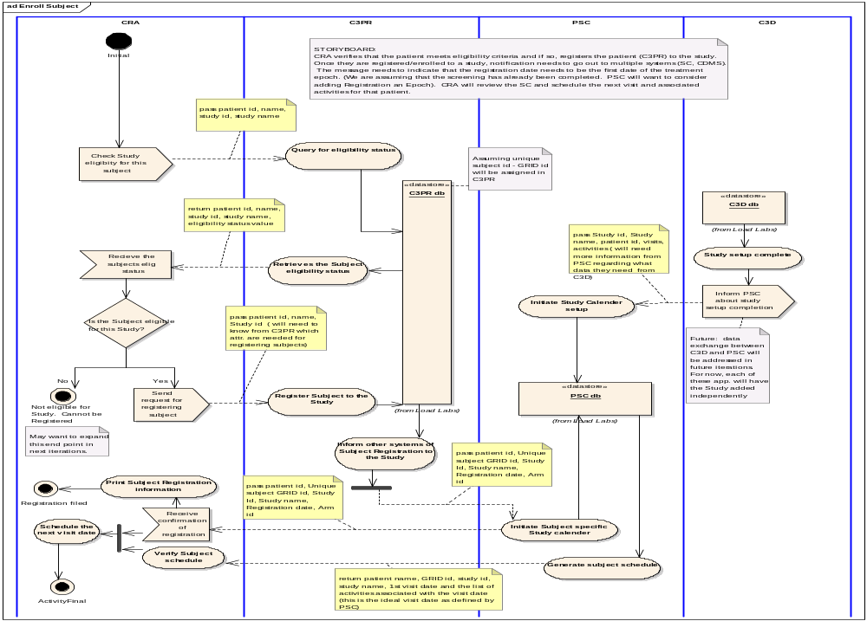
Storyboard “Load Lab Data

- CRA looks at the schedule of a given patient on a study for a specific visit. She/he identifies all the lab tests that should have been scheduled/ completed for that visit. CRA would need all the lab values in a given timeframe that would fall within the timeframe of the visit. CRA then reviews the lab tests/values and identifies which ones are relevant to be loaded into the CTMS (for example, a diabetic pt may have also had a A1C – in this case, this values would not be stored in the CTMS).

Activity Diagram “Load Lab Data”

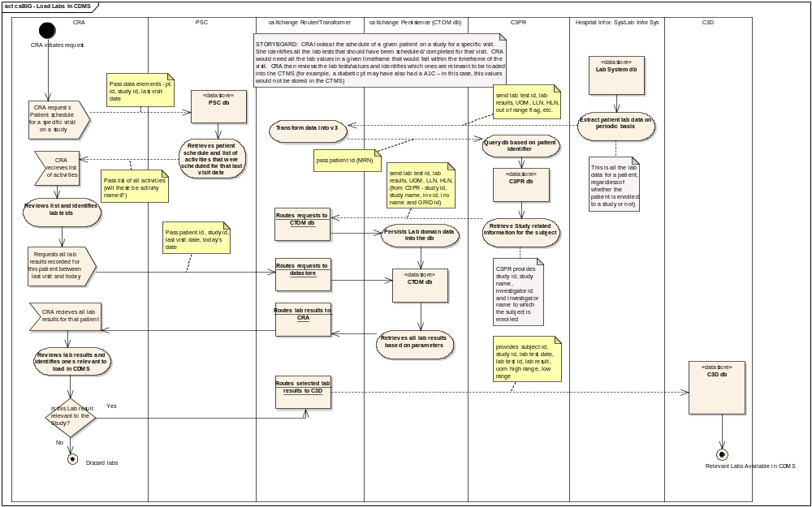
STORYBOARD – “AE-triggered Protocol Schedule Modification”:
- Patient has a lab-based AE which has been entered into caAERS. This event would trigger caAERS to send a notification to study calendar that there maybe a change in patient schedule due to an AE-caused treatment delay. A CRA who uses the PSC application may notice an alert when she tries to schedule this patient for the next treatment. She will then have to take an action to ensure that the AE has been resolved before continuing treatment. Then, if required, the patient’s schedule will be modified.

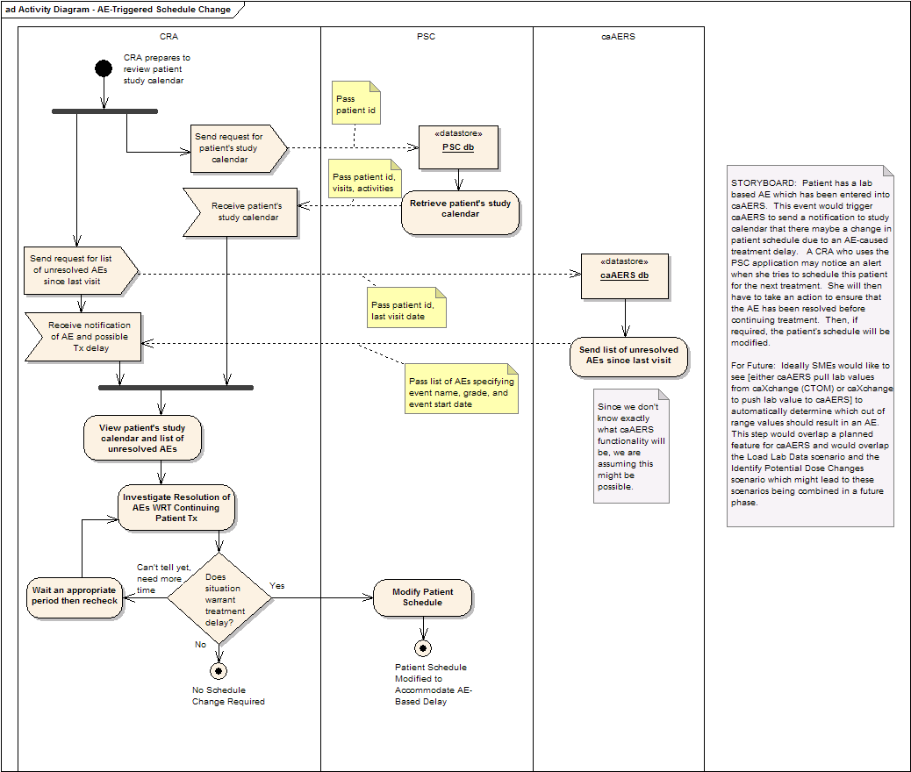

State Diagrams
State Diagrams depict the possible life cycle stages and legal transitions that an instance of a given concept may undergo during its existence and are associated with a small percentage of BRIDG static concepts/classes. In common modeling practice, approximately 10% of classes in a given class diagram have sufficiently interesting life cycles to warrant an associated State Diagram. All classes for whom state is of interest carry an obligatory “status” attribute.

The essential semantics of a UML State Diagram are:

- State (including StartState and EndState)
- Transition
- Guard
- Intra-state Activities (not currently used in BRIDG)

At present, the BRIDG model has three such classes: StudyProtocol, Activity, FunctionalRole, and Role. Currently, the THC is using the working assumption that the State Diagram for each of these three classes will map to a corresponding HL7 Reference Information Model State Diagram, specifically Role (BRIDG) → Role (HL7); Activity (BRIDG) and StudyProtocol (BRIDG) → Act (HL7), and FunctionalRole (BRIDG) → ManagedParticipation (HL7). The state diagrams for each of the HL7 classes are shown in Figures 23, 22 , and 24 respectively.

With respect to the StudySubject (BRIDG) State Diagram, it will be immediately clear to readers of this document that the HL7 Managed Participation class does not contain as many states as does the BRIDG StudySubject State Diagram. The latter was developed early in the history of the BRIDG Project and is included (as previously stated) as exemplar but not necessarily vetted dynamic content. The THC will, in the near future, do a more careful analysis and vetting of the StudySubject state diagram to determine if a) additional state semantics need to be submitted to HL7 to expand its Participation class state machine; or b) the BRIDG StudySubject state diagram can be mapped to the HL7 Participation class state machine (including collapsing and states when necessary but without loss of critical, domain-specific semantics). Full documentation of the StudySubject State Diagram is contained in the BRIDG Release 1.0 EA file for inspection and comment. Documentation of the RIM state diagrams can be found in the HL7 Reference Information Model documentation.

Sequence Diagrams
Sequence Diagrams are used to visualize specific interactions that occur between named instances of classes from a model’s Class Diagram in the context of a particular process or scenario. A Sequence Diagram is conceptually similar to an Activity Diagram in depicting flow, but differs somewhat in its iconography and more specific focus on the use of class instances (rather than the more general Responsible Party of an Activity Diagram) and explicit use of instance-to-instance messages.

The essential semantics of a UML Sequence Diagram are:

- Active Lane
- Active Instance (Active Lane owner)
- Lifeline (vertical)
- Instance-to-Instance Communication Path (horizontal)
- Message (associated with a Communication Path)
- Notes

Further discussion of the specific semantics and uses of Sequence Diagrams is beyond the scope of this document. An example of a sequence diagram is shown here. This is from NCI’s CTMS I project.

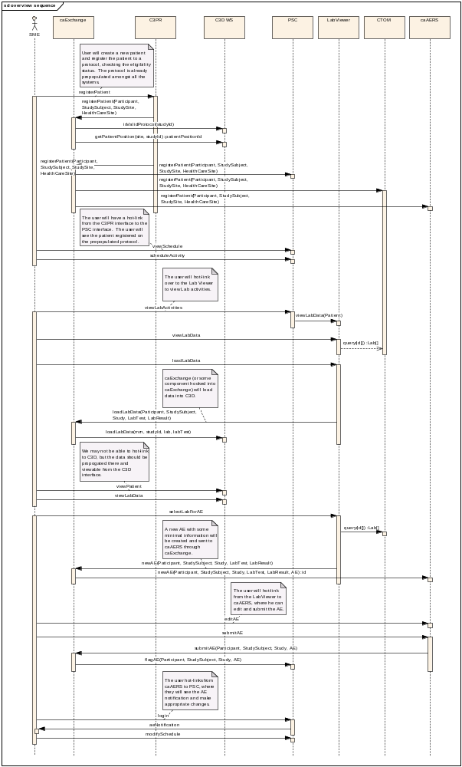

Navigating the BRIDG Model: Tools and Options

Text View: RTF
The Release package also consists of an RTF report for all the static elements in the BRIDG model. This was generated from the Enterprise Architect file. Users and interested parties can generate similar RTF reports for other packages by following the steps listed below:

- Highlight the desired package in the Project Browser.
- Right click on the package and select Documentation -> Rich Text Format (RTF) Report.
- Click Switch Generator
- For Output Filename, click the browse (…) button to locate the location in which you wish to save the RTF report
- Select the desired items you wish to appear in the RTF report from the “For each Object Include” section
- To include the diagrams in the RTF report, click the “Embed Diagrams in Document” box under “Options”.
- Select the desired “Diagram format” from the radio buttons
- Click Create under the “Document” section.
- A success message will appear when generation is complete

XML View: XMI
Readers interested in a serialized, non-graphical version of the model can use the xmi file that is part of the BRIDG Release package. It is the representation of the model that is generated by the Enterprise Architect tool as using the somewhat-less-than-standard XML Model Interchange (XMI) format. Note that there are known problems with this format and, as such, the XMI version of the BRIDG Model 1.0 is not considered by the THC to be canonical.

UML View: Single Model vs Multiple Views
A UML modeling tool such as Enterprise Architect supports the development of a single definition of a model as a collection of dynamic and static semantics which are represented and presented in multiple views (e.g. Class, Instance, Activity, State, and Sequence Diagrams as discussed earlier in Section 3.)

The ability of a modeling tool such as Enterprise Architect to present a number of “nearly independent views of a single model” is the reason that the THC has chosen to represent BRIDG semantics using UML and an associated modeling tool rather than simply presenting a number of diagrams in a drawing tool such as Visio. In a modeling tool, changes of the attributes, relationships, etc. of a particular element in one view results in automatic, tool-mediated changes of the element in all other views in which the element occurs, a fact that is a reflection of the underlying representation of a single model in the tool’s persistence layer (database). Support for “one model, multiple views” is essential in a domain of the complexity of the BRIDG model domain.

BRIDG Model Navigation “How To”
The UML representation of the BRIDG model is represented in Enterprise Architect from Sparx Systems. A viewer which enables full traversal and inspection of the complete BRIDG model (which is an .EAP file) can be downloaded from the Sparx Systems website -- http://www.sparxsystems.com.au/.

Navigation through the BRIDG file is best done by using the Project Browser window of EA. It enables you to navigate through the Enterprise Architect project space. It displays Packages, Diagrams, Elements and element properties. The original structure of the elements present is EA have been kept in BRIDG file. Only those elements that have BRIDG content have been renamed to say so. Only two of the elements have BRIDG content – the BRIDG Business Process Model and the BRIDG Domain Model. Users should click on the first element in Project Browser called the BRIDG Start Here. It will provide an overview of BRIDG project. Two components have BRIDG content in them in Release 1.0. They are

1. BRIDG Business Process Model -- Shows the draft dynamic content of BRIDG v 1.0.

- BRIDG Activity Diagrams -- these are exemplar diagrams from the NCI/caBIG CTMS I Project.
- BRIDG State Diagrams - these are also exemplar diagrams. They are drawn for the HL7 RIM (Activity State Diagram), and as a result of multiple discussions with various clinical trial stakeholders (Subject State Diagram).
- BRIDG Sequence Diagram - example - this is an exemplar sequence diagram from the NCI/caBIG CTMS I project.

2. BRIDG Domain Model
Shows the static elements of the BRIDG model. This package has the UML class diagram of BRIDG v 1.0. There are multiple views that have been built to help with reviewing the model in parts and pieces. For the complete UML class diagram, open View 9, named -- Complete BRIDG View - Classes, Attributes, Inheritance

The BRIDG Model – Release 1.0 Content
In future releases of the BRIDG Model, this Section will discuss in detail the content of the BRIDG Model that has been added since the previous Release. However, for this first release, the content of this Section will be somewhat different than what can be expected in future versions of this section, both in its level of detail and mode of presentation.

In particular, when one reviews the content of the BRIDG Model Release 1.0, it is apparent that although there is now considerable “scaffolding” in place (e.g. the BRIDG Backbone, the various “Green/Yellow/Turquoise” classes and relationships, the beginning of the elaboration of the Activity hierarchy, etc.), there are still some significant “holes” in the content of the model both in terms of areas-of-interest and level-of-detail. In fact, one might argue that the model is “close but not yet there” in terms of its readiness for Release 1.0. The THC believes that there is sufficient content to warrant a release because a release is valuable in and of itself (assuming it is grounded in reasonable quality and reproducibility, which the THC has made every effort to define and guarantee) since it is through a formal release and the comments that it will stimulate from the community that the BRIDG Model and BRIDG Project mature. The THC wants readers to recognize that although there is valid, harmonized content in Release 1.0, the main motivation for pushing Release 1.0 out the door rather than waiting for a future point in time when the model would have more detailed, semantically richer content, is to openly and explicitly define for the community the direction, governance, and anticipated near-future content of the BRIDG Model so that the community can become even more involved than it has over the first three years of the BRIDG Project’s existence is the adoption of and contribution to the BRIDG Model.

In particular, those reviewing the content of BRIDG Release 1.0 should view the content with perspective of near-future content that can be expected to significantly influence the semantic richness of the BRIDG Model in the next one or two releases, i.e. by the end of 2007. In particular, four near-future projects will be harmonized into the BRIDG Model over the next 3-6 months:

- Trial Design (started the week before the release date of Release 1.0)
- Adverse Event semantics (started 2 weeks prior to Release 1.0),
- remaining ~50% of CDISC’s SDTM specification (scheduled in July/Aug)
- remaining ~50% of NCI’s CTOM (scheduled concurrently with SDTM)

With respect to Trial Design and Adverse Event semantics, the former focuses on the planning of and relationships between the various activities of a trial and will thus both expand the semantics of the BRIDG Model per se, but will also be integrated with the scheduling and execution of actual activities – the Patient Study Calendar perspective -- some of which were planned, some of which were contingency-planned, and some of which were not planned. Among the “unplanned” activities are the Adverse Events that may occur in the course of a given trial. Semantics from both sub-domains-of-interest in the BRIDG Model are critical to the overall relevance of the BRIDG Model.

Although approximately 50% of both the SDTM and CTOM models have already been harmonized into the BRIDG Model, the remaining semantics from these two models will add considerable detail to the “Performed Activity” portion of the model, including not only activity-based semantics, but also the classes and relationships involved in fully specifying the semantics of these two mature models.

In summary, Release 1.0 should be viewed as the first step in a short-term, two- or three-step process (i.e. spanning Release 1.1 and possibly Release 2.0) that will lead to an order-of-magnitude increase in the semantic richness of the BRIDG Model.

With the preceding comments as a backdrop and framework, the content of Release 1.0 (from a static perspective – recall that all dynamic content in Release 1.0 is considered to be exemplar in nature) is discussed below through the presentation of a set of nine “views,” i.e. selective “cross-sections” of the complete BRIDG Model 1.0 class diagram. The views are constructed so as to walk the reader through the class diagram by adding increasing levels of detail. Note that the several of the views are at the “class only” level. This method is utilized to emphasize the core BRIDG (static) Model concepts and their relationships rather than the details of the classes involved in the view.

The THC is considering generating “project-specific” Views in future releases of the BRIDG Model. The THC appreciates any comments readers of this Section might have on the content or perspectives involved in developing Release 1.0 and/or this “view-based” approach to content exposition. (NOTE: detailed definitions of each class shown in the various views can be found in the .EAP file which contains the entire model including the Views discussed below.

View #1 – The BRIDG Domain: Focal Classes

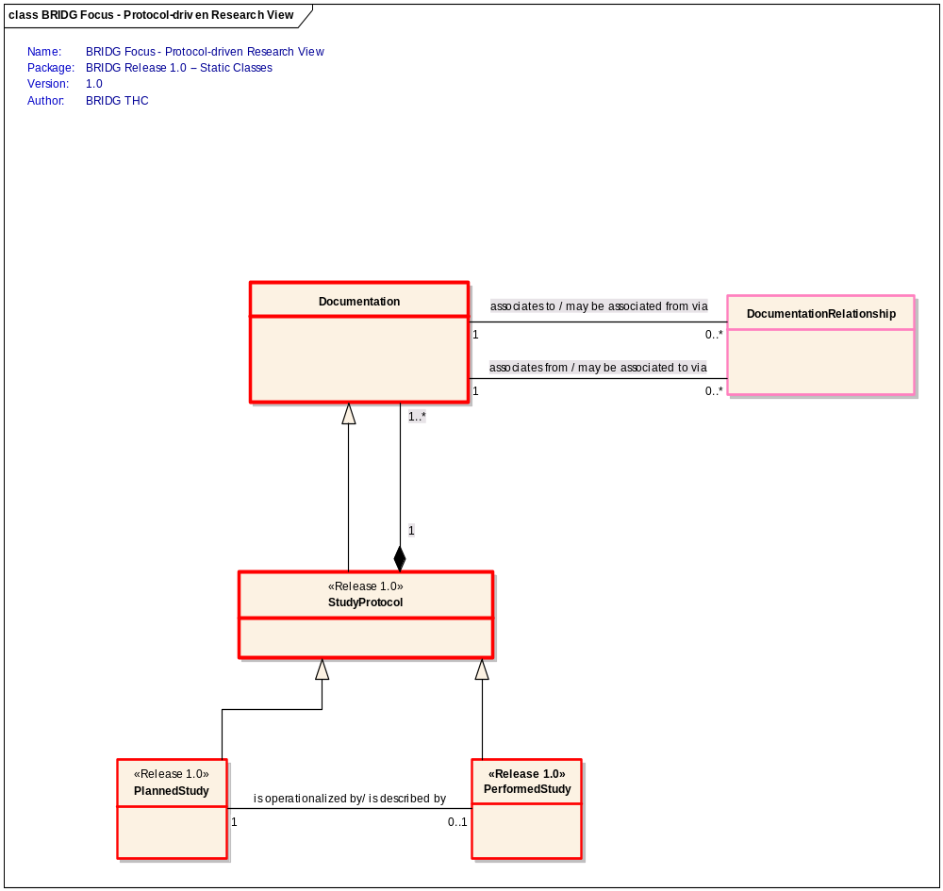

This View shows the core classes that collectively define the domain scoped/defined by the BRIDG model, i.e.,

Protocol-driven research, i.e. the data, organization, resources, and processes involving the assessment of the utility, impact, or other pharmacological, physiological, or psychological effects of a drug, procedure, process, or device on a human, animal, or other biologic subject or substance plus all associated regulatory artifacts required or derived from said research.

Note that the THC has chosen to disambiguate the term “Protocol” (and its various overloaded terms including “Trial” and “Study” by defining a core class called StudyProtocol whose semantics include, both “collection” semantics which enable a StudyProtocol to “contain” all of the various documents that collectively define the protocol and to act as a “super-type/sub-type” class, thereby enabling StudyProtocol to define the semantics (attributes and relationships) that are common to both PlannedStudy and PerformedStudy. Finally, the class DocumentationRelationship enables the documents collected in the course of a Protocol’s life cycle (i.e. from Planning to Performing and beyond) to be related to each other with relationship types such as “Updates,” “Replaces,” “is a part of,” etc.

View #2 –Planned Study

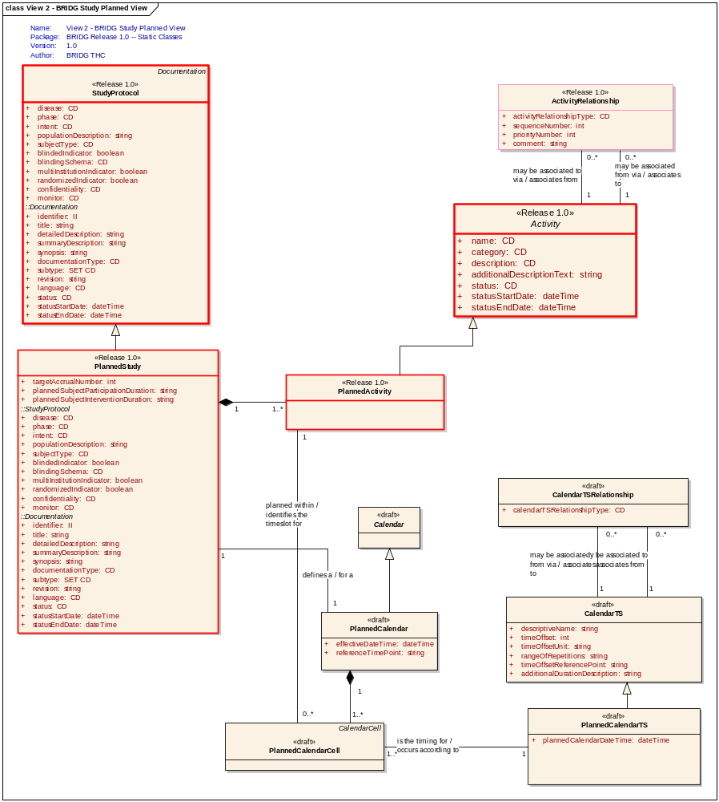

This View focuses on one of five classes from the previous View, i.e. Planned Study, and shows both this class’ attribute set (defined in detail in the .EAP file) and its relationships to other classes in the BRIDG Model Release 1.0. In particular, the relationship to the Planned Activity class (and its associated inherited ActivityReleationships class) provides semantics critical to an interoperable definition of a Planned Study. Note that there are several classes having to do with “calendars” which are tagged as being <<draft>> in Release 1.0. These classes, attributes, and relationships collectively represent the perspective of the Patient Study Calendar Phase One project. They have been stereotyped as <<draft>> to indicate that as the just-received content from the Trial Design project is harmonized into the BRIDG Model, it will impact the representation and possibly the semantics of the “calendar-based view of the world” that is characteristic of a scheduling application. It is important to note that the THC does not believe that the two projects have contradictory or incompatible views. It is simply a case of need to integrate two particular perspectives on the planning and scheduling of a Study into a single representation, something that the THC expects will be complete by Release 1.1 of the BRIDG Model.

View #3 – Scheduled Study

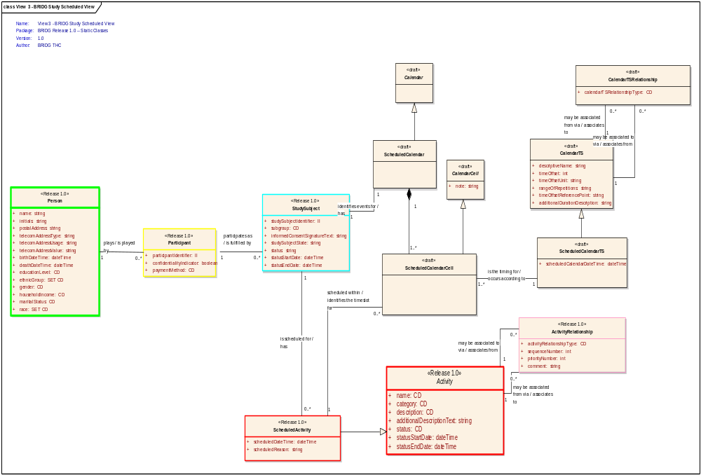

This View depicts the current semantics of Scheduled Study, i.e. one that has been planned and has now moved into the first phase of its execution, i.e. the scheduling of Research Subjects who have been enrolled in the Study. Note the relationship – as in the Planned Study View – to the Activity super-class and the consequent inheritance of the Activity Relationship class for linking Scheduled Activities in arbitrarily complex ways including composition, judgment, and inter-activity rules. Also, note the presence of a number of classes stereotyped as <<draft>>. As in the previous View, this is content from the Patient Study Calendar Phase One project which is expected to change to some degree following its integration with the Trial Design content. Finally, note that, in contrast to the Planned Study View, the Scheduled Study View contains Green, Yellow, and Turquoise classes. This is reflection of the fact that when the Patient Study Calendar Phase One project’s semantics were harmonized into the BRIDG Model, their “activity” semantics including the type of “contextual attribution” that is carried by the Green/Yellow/Turquoise classes. The harmonization of the Trial Design content will similarly bring a planning-specific set of attribution semantics into the BRIDG Model.

View #4 – Performed Study

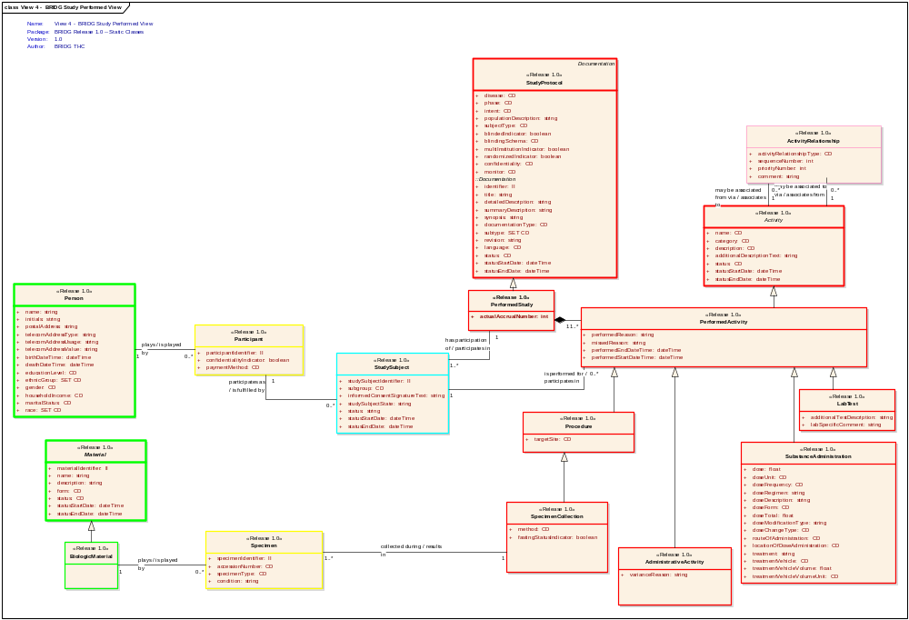

This View provides a view of a study from the perspective of the PerformedActivities. At present, a number of these types of activities have been identified, including LabTest, Procedure, SubstanceAdministration, and AdministrativeActivity. As is the case with the two preceding Views, note the inheritance from the PerformedActivity of the ActivityRelationship class. Note the presence of the BiologicMaterial in the role (yellow) of Specimen associated with a SpecimenCollection (sub-type of) Procedure, and the Person in the role (yellow) of Participant who then becomes a StudySubject (turquoise) in a study and, as a consequence, is the focus of a PerformedActivity. The absence of <<draft>> classes in this View is a reflection that that content came from the NCI’s CTOM and caXChange (formerly LabHub) projects and from CDISC’s Lab Model and SDTM specification, all of which have a focus on the activities and associated data collected during the “execution” phase of a particular trial/study.

View #5 – BRIDG Backbone (Green, Yellow, Turquoise)

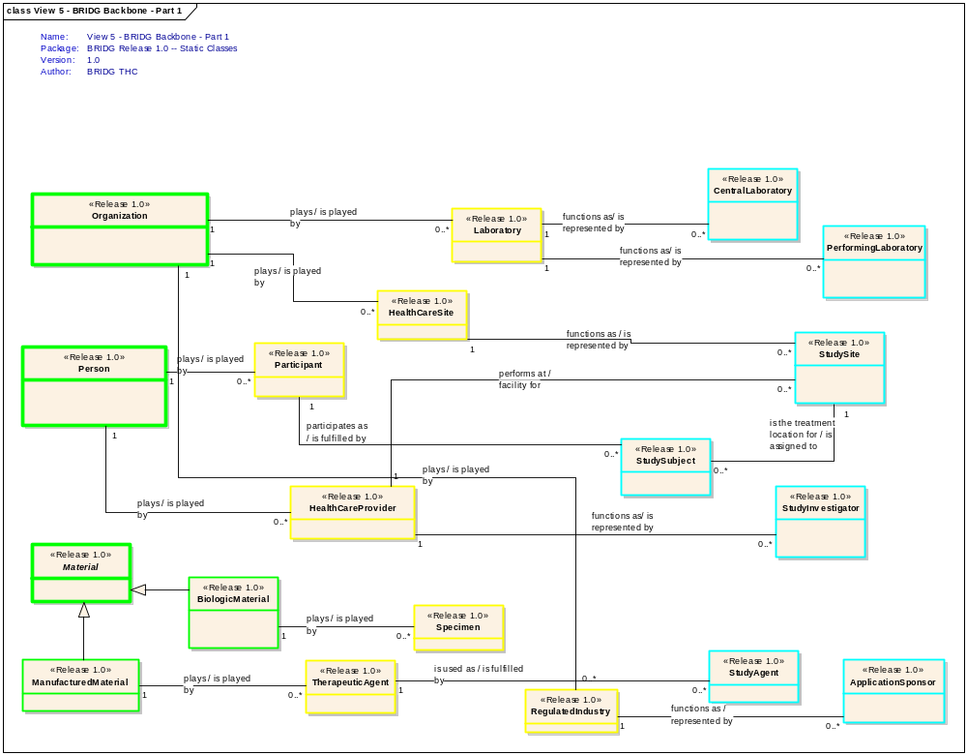

This View shows all of the “non-Red” classes in the BRIDG Model Release 1.0, in particular the three green classes (“Entity” in the HL7 RIM) of Organization, Person, and Material (with its two sub-types Biologic Material and Manufactured Material), their various associated yellow classes (“Role” in the HL7 RIM), the notion of role denoting a “domain-relevant capability, capacity, or competency, usually time based and authorized, certified, or otherwise verified by an entity separate from the one playing the role”), and, in turn, their associated turquoise classes (“Participation” in the HL7 RIM), internally referred to as “Functional Role” instances in the BRIDG Model even though there is – in Release 1.0 – no explicit super-type class called FunctionalRole because of the absence of common attributes in the various identified turquoise/functional role classes shown in the View. It is expected that as the Adverse Event and Trial Design contents are harmonized into the BRIDG Model over the next two releases, this View will become increasingly dense and rich in semantics as the explicit definitions (and representations) of the various green-yellow-turquoise “tuples” (or their simplified green-turquoise, green-yellow, or yellow-turquoise domain-friendly representations).

View #6 – BRIDG Backbone (Red and Pink only)

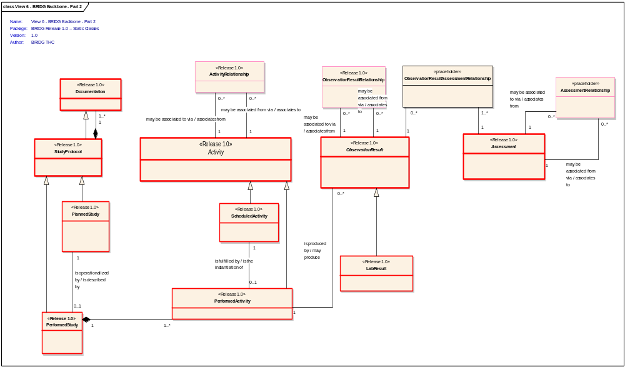

This View contains many classes seen in previous Views, e.g. StudyProtocol and Documentation, as well as the StudyProtocol and Activity Planned, Scheduled, and (in the case of Activity) Performed hierarchies. Note also the presence of ActivityRelationship, a class previously discussed. The important concepts not discussed in previous views include Observation and Assessment and the two relationship classes: ObservationRelationship and ObservationAssessmentRelationship. First note that there is a zero-to-many relationship between PerformedActivity and ObservationResult, i.e. an instance of a PerformedActivity may produce zero-to-many ObservationResults, a fact that simply says “some PerformedActivities have results, some do not, and the ones that do are referred to (in the BRIDG Model) as Observations. The distinction between an Observation and an Assessment is one of judgment, i.e. an Assessment is not a “primary” piece of data, but rather a “secondary” one, an “observation about an observation.” This distinction is observed by both the CTOM and SDTM models and is turning out to be very helpful in the modeling of Adverse Events, where the identification (aka assessment aka judgment) that a particular ObservationResult is, in fact, an AE, is a type of Assessment, as the judgment (aka Assessment) that a given PerformedActivity is the cause of a given AE. Finally, given that “an instance of an ObservationResult may be associated with one-to-many Assessments, and that an instance of an Assessment can involve one-to-many ObservationResults,” the model contains a class to disambiguate the many-to-many relationship, i.e. ObservationResultAssessmentRelationship. Future releases of the BRIDG Model can be expected to substantially enrich this View of the BRIDG Model.

View #7 – BRIDG Static Content (classes only)
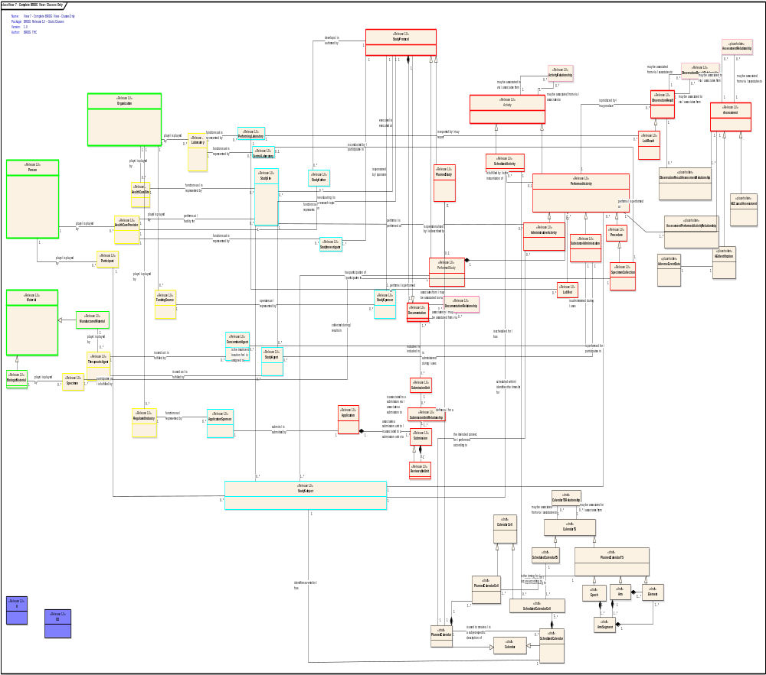

This View shows the complete BRIDG Model Release 1.0 at a “class-only” level to give the reader a overview of the composite semantics of the preceding 7 Views. Note the <<draft>> (PSC Phase One) and <<placeholder>> (AE) classes in the context of the larger View.

View #8 –BRIDG Static Content (classes + local attributes)

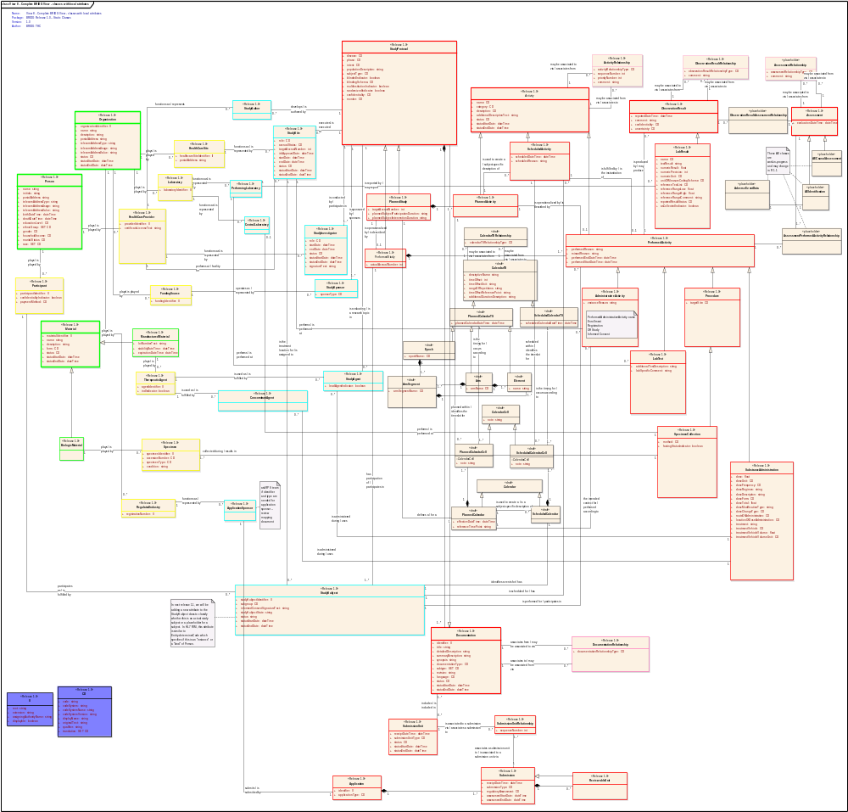

This View shows the complete BRIDG Model Release 1.0 and adds the class-specific attributes for each class to give the reader a more detailed overview of the composite semantics of the preceding 7 Views.

View #9 –BRIDG Static Content (full representation)

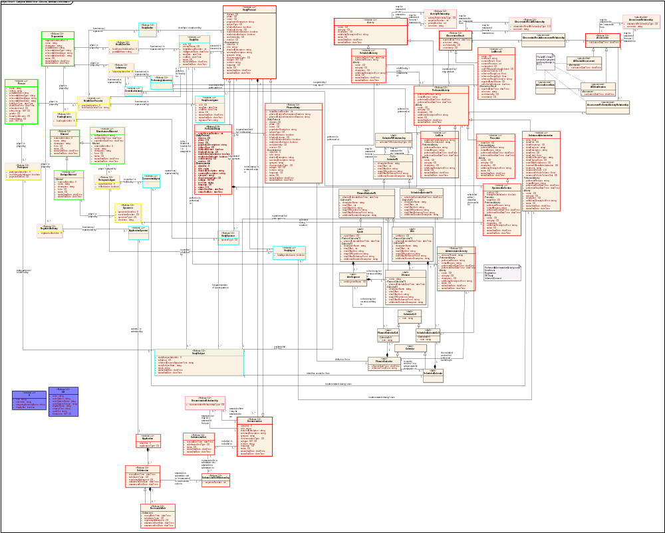

This View shows the complete BRIDG Model Release 1.0 and specifically shows, for each class where it’s applicable, the complete set of attributes for the class, partitioning the attributes as to whether they are “local” to the class or inherited from the class’ super-type (and, in some cases, from the super-type’s super-type.)

Complex Data Types in Release 1.0
Because of their critical role in computable semantic interoperability, Complex Data Types (CDTs) will play an increasingly substantive role in the BRIDG Model. A “look ahead” to the THC’s plans to bind each attribute of each class in the BRIDG Model is presented in the next section (5.11). The purpose of this section is to give the reader an understanding of the strategies that the THC has utilized in Release 1.0 for representing the semantics of CDTs without formally binding – in Release 1.0 – attributes to HL V3 CDTs.

Representing groups of recurring semantics across classes: A brief BRIDG history
It became clear very early in the process of building the BRIDG Model that, as is virtually the case in every model of any sophistication, that there were sets of attributes that, like a class, collectively specified semantics that could be bound to a specific attribute. In the preparation for Release 1.0 of the BRIDG Model, the THC identified the following candidate CDTs:

- BRIDGID (BRIDG concept ID)
- BRIDGCodedConcept(BRIDGcodedconcept)
- BRIDGTS (BRIDG Timing Specification)
- BRIDGIntervalTS (BRIDG Interval Timing Specification)
- BRIDGRelativeTS (BRIDG Relative Timing Specification)
- BRIDGDocumentDescription
- BRIDGStatus

Initial planning for Release 1.0 of the BRIDG Model called for these CDTs to be used as needed throughout the BRIDG Model. However, as discussions about the long-term implications of using BRIDG-derived CDTs – which, given the increasing maturity and world-wide industry traction of the HL7 V3 Abstract Data Type Specification – would most likely ultimately be mapped to HL7 V3 CDTs, it was decided that the BRIDG Model would – with the exception of the first two in the above list (separated from the remaining DTs for the convenience of this discussion) -- ,in the short term, “unfold” the various CDTs listed as separate attributes in the classes where they were needed, with the clearly stated commitment to, over the course of subsequence releases of the BRIDG Model, move to a position where each BRIDG Model attribute was bound to a “computable” data type which would be, in virtually all cases, drawn from the HL7 V3 Abstract Data Type Specification.

Thus, in summary, Release 1.0 of the BRIDG Model utilizes only two CDTS – Instance Identifier (II) and Concept Descriptor (CD) – both of whose name and semantics are taken directly from the HL7 V3 Abstract Data Type Specification (www.hl7.org ).

“Flattening” of other CDTs in Release 1.0
Having formally adopted the HL7 V3 II and CD CDTs, the THC then “flattened” the semantics of the remaining CDTs by moving their respective collections of attributes into classes requiring the CDTs collective semantics, assigning each attribute a “primitive” data types to each attribute as follows:

- BRIDGTS (BRIDG Timing Specification)
dateTime
- BRIDGIntervalTS (BRIDG Interval Timing Specification)
startDate
endDate

- BRIDGRelativeTS (BRIDG Relative Timing Specification)
timeOffset
timeOffsetReferencePoint
timeOffsetUnit
- BRIDGDocumentDescription
detailedDescription
summaryDescription
synopsis
- BRIDGTelecomAddress
usage
type
value

- BRIDGContactAddress
postalAddress

- BRIDGStatus
startDate
endDate
value

What’s Next: A Look Forward at Trial Design and Adverse Event Semantics
This section describes some of the known ongoing and future initiatives that will expand the semantics and the BRIDG model.

Specification of BRIDG attributes using HL7 data types
As mentioned in the previous section, complex data types (CDTs) are important to the BRIDG model for two reasons:

- When viewed as collections of attributes similar to those found in a UML class, CDTs prove to be a useful and efficient way to describe the semantics of their domain. For example, the collection of attributes that describes an interval of time (start time, end time, length, units) is such a collection, useful in describing a number of “complex” attributes such as “length of infusion;” the collection of attributes necessary to fully specify a coded value (code, code system, version, etc.)

- CDTs bridge the gap between analysis models and run-time implementations because of the critical computational nature of the semantics of the data types themselves, i.e. regardless of the level of semantic agreement that may exist “above” the data type, two machines cannot be semantically interoperable until there is a machine-level agreement as to the semantics of the data types to which the exchanged attributes are bound.

As discussed above, Release 1.0 of the BRIDG Model has utilized on two CDTs from the HL7 Version 3 Data Type Specification, i.e. II and CD. However, the combination of the need to bind BRIDG attributes to CDTs coupled with the breadth and maturity of the HL7 V3 Data Types Specification have resulted in a commitment to standardize the BRIDG Model around HL7 V3 Data Types. To this end, the THC will be including increasing numbers of V3 CDTs in future releases of the BRIDG Model. In the near future, users of the BRIDG Model can expect to see V3 representations of time (in the context of harmonizing the CDISC Trial Design Model (TDM) and the additional content added by the Patient Study Calendar Phase Two) and physical quantity (in the context of various lab test results). This movement to HL7 V3 CDTs will change some of the representations within the BRIDG Model (most notably in the “rolling up” of various attribute collections in the current model). It should not, however, change the underlying semantics. Rather, it will define them more clearly and non-ambiguously.

Patient study calendar/trial design model harmonization
The semantics from the Patient Study Calendar (Phase One) are included within the BRIDG Model, Release 1.0. Recently, the THC began to harmonize the CDISC Trial Design Model (TDM) with the Patient Study Calendar (PSC) project (Phase One). It is on the basis of this work that the semantics from the PSC project have been tagged as <<draft>> in Release 1.0 of the BRIDG Model, i.e. the THC believes that as these two views of a protocol – the TDM view being predominantly a “planning- and analysis-based view” and the PSC view being predominantly a “scheduling- and execution-based view,” the existing PSC semantics (and their corresponding representation in the BRIDG Model) will undergo some non-trivial changes, changes which the THC plans will be reflected in Release 1.1 (October, 2007) of the BRIDG Model.

In particular, the core use cases around which the Patient Study Calendar were specifically focused on building an application which could support daily scheduling in a cancer clinical trial setting. In contrast, the TDM provides a more general view of the constructs that define a protocol in virtually any context.
Specifically, the harmonization of the TDM model (now nearly complete but not available for inclusion in Release 1.0) has surfaced several core features of the general concept of a protocol which will be included in Release 1.1 of the BRIDG Model in a representation that links them with PSC (Phase One and Phase Two) :

- The concepts Epoch, Arm, and Element describe a protocol design from a state-based perspective useful in planning and analysis. (Note that Elements contain Activities.) In contrast, the concepts Activity and Contact describe a protocol design from a "control thread" or “process flow” point of view, a view that is useful in the operational scheduling and execution of a protocol. (Note that the terms Activity and Contact form the “rows” and “columns” in a traditional Schedule of Activities (SoA)).

- The two views are isomorphic (equivalent), “intersect” around the concept of Activity, and are both built based on arbitrarily complex Rules. Rules, in turn, are instances of a particular type of Relationship (the other types being “judgment” and “collection”).

- Within a given protocol, instances of Activity function, in their role as the "pivot" between the state-based and the control-thread views of the trial/protocol, mark the state transitions, either from Epoch -to-Epoch or Element-to-Element.

- When planning a given trial – i.e. when “designing” a protocol – one talks about a “subjects” but is actually referring to “potential subjects” whose specific identity is not yet manifest because subjects have yet to be recruited into the trial. When the trial/protocol moves from the Planning phase to the Scheduling or Execution phase, “actual” subjects may be referenced. These facts about the semantics of a protocol require that the BRIDG Model represent both “potential” and “actual” subjects (note that the same characteristic may be true of other “potential participants” in a given trial. These semantics are dealt with in the HL7 RIM and will be represented in the BRIDG Model, Release 1.1.

Adverse event reporting
There is ongoing work to harmonize into the BRIDG Model the semantics of adverse events (AEs), including identification and reporting, in several organizations including:

- the FDA, where the HL7 V3 Individual Case Safety Report (ICSR) is being utilized to collect adverse event data for post-marketing safety analysis;

- across several federal agencies including the FDA and NIH, where the Federal Adverse Event Taskforce (FAET) has been given the responsibility of harmonizing all of the data elements related to adverse events across the various federal agencies;

- the NCI, including participants from both the caBIG™ program and Cancer Trial Evaluation Program (CTEP) office; and

- CDISC, whose Study Data Tabulation Model (SDTM) specifies a certain amount of AE data.

The work has focused on identifying the core concepts, attributes, and relationships involved in AE identification (“the patient’s low white count is considered to be an AE in this context”) and causal assessment (“the patient’s low white count was caused by the administration of drug X”). The work assumes that harmonization of these core structures across multiple stakeholder organizations is possible. Likewise, it also assumes that it is probably not possible to harmonize the various business processes that identify, classify, and/or report on AEs. However, this does not appear to be a significant negative since the bulk of the known interoperability requirements around AEs have to do with exchange of identified or otherwise classified AEs. The work is not yet ready for formal BRIDG harmonization. However, the THC recognizes the importance of the topic of AEs in the BRIDG domain and therefore wanted the BRIDG community to get a “preview glimpse” of the semantics and structures that are emerging from the AE harmonization efforts. To this end, the THC included several AE-related classes, each tagged as <<placeholder>> to indicate that they are still early in the discovery process, but mature enough from a consensus basis to be put on the table. Comments from the community on this critically important topic are welcome and encouraged.

Glossary
Domain analysis model: The term “domain analysis model” (DAM) has at least two distinct meanings in the literature. Consistent across both definitions (which are essentially differences in content and scope of included domain information) is the notion that a DAM is implementation independent, i.e. it restricts itself to describing the “what” of the domain-of-interest, specifically excluding any representation of the various aspects of the “how.” This distinction results in a representation that is “domain friendly,” i.e. the terms and constructs used in a DAM can easily be understood by domain experts. (NOTE: A DAM is vettable by domain experts because it is expressed in terms familiar to those domain experts rather than in “techno-speak.” The latter is the appropriate language of a design and/or implementation-specific model. It should be noted that a single DAM can give rise to multiple design models, each a specific set of measured compromises on the original DAM semantics”). A DAM can be vetted by domain experts while simultaneously providing sufficient rigor for “downstream” design and implementation activities. This is a critical, essential defining feature of a DAM, and results in the fact that a single DAM can give rise to N-number of compliant implementations that vary in everything from UI to persistence schema, but remain computationally semantically interoperable by virtue of their implementation of various semantic constructs of the DAM on which they are based. As discussed in the text, the BRIDG model – itself an instance of a DAM – was begun to provide an implementation-independent view of the static and dynamic semantics of a domain-of-interest that could be shared initially by HL7 and CDISC and more recently by HL7, CDISC, NCI, and FDA.
The two meanings of the term DAM are: 1) Static content only. The more restrictive meaning of the term defines the scope of a DAM to be the definition, explication, and inclusion of the static structures-of-interest in the domain-of-interest. No dynamic content is included. Thus, if the DAM is represented using the iconography of the Unified Modeling Language (UML) -- the representational language of the BRIDG domain analysis model -- the restrictive use of the term means “the semantics specified by the collection of classes, instances, attributes, and relationships that collectively define the domain-of-interest.” 2) Dynamic and static content. The more inclusive use of the term DAM – and the one that defines the scope of the BRIDG model – allows for a DAM focused on a specific domain-of-interest to include both static and dynamic content, i.e. to be an “analysis-level architectural representation of the domain-of-interest.” Again, referring to the use of UML, a “type 2 DAM” would include all of the static content of a “type 1 DAM” plus the additional semantics of various dynamic aspects of the domain-of-interest expressed as Activity Diagrams of various granularities, State (lifecycle diagrams), and Sequence Diagrams.) By far the most common of these three dynamic views are Activity Diagrams. State Diagrams are usually required for < 10% of the classes in the static class diagram view, and Sequence Diagrams are usually restricted to understanding specific “interoperability scenarios” at an <<instance>> rather than “responsible party” level common to Activity Diagrams. NOTE: In both usages, the term “domain analysis model” is also synonymous with the term “Problem Space model.”

RCRIM TC: The Regulated Clinical Research Information Management Technical Committee (RCRIM TC) was established within HL7 as a multi-stakeholder TC with three CoChairs, one representing CDISC, one the FDA, and one HL7. The TC’s initial focus was message specification in the clinical trial/drug development (“big pharma”) business context. Early efforts produced an initial Version 3 HL7 standard (Periodic Reporting of Clinical Trials Laboratory Results) whose content was heavily influenced by the previously developed CDISC Lab Mode. However, the two organizations technical and domain experts had been unable to reach agreement on other critical issues including trial data organization and reporting, protocol representation, etc. The reasons for this roadblock were assessed -- in the context of the above-mentioned CDISC BoD presentation – to be linked in large part to debates of implementation details (HL7 XML vs CDISC XML) rather than core semantics. The development of a DAM, i.e. the BRIDG model, was proposed to the CDISC BoD as a methodology for defining shared semantics which could then be expressed in a particular implementation technology, i.e. HL7 XML vs CDISC XML.

semantics vs syntax: The term “semantics” is used as a formal synonym for “meaning” as opposed to the term “syntax” which means “structure.” Thus, the two sentences “The dog eats red meat” and “The dog drinks blue sky” have the same syntax but very different semantics (one be sensible, the other being nonsense.) In contrast, the two sentences “The patient took medication for pain” and “Pain medication was taken by the patient” have the same semantics but markedly different syntax. DAMs focus on the semantics (dynamic and/or static) of the domain-of-interest and as such, there may be more than one syntax/syntactic representation (i.e. modeling construct) for the same semantic content. A given DAM will pick one of several syntactic representations of a given set of semantics. (See further discussion of this topic in text.)

Appendix

Abstract and Complex Data Types
Definition of abstract data type (from Wikipedia): “In computing, an abstract data type (ADT) is a specification of a set of data and the set of operations that can be performed on the data. Such a data type is abstract in the sense that it is independent of various concrete implementations. The definition can be mathematical, or it can be programmed as an interface. The interface provides a constructor, which returns an abstract handle to new data, and several operations, which are functions accepting the abstract handle as an argument.”

Virtually everyone is familiar with the concepts of integer and character. Most people have little trouble moving from a single character to the concept of a string of characters. Integer, character, and string are often referred to a simple or primitive data types. In contrast, complex data types combine primitives (and other complex data types) to express increasingly complex semantics, e.g. notions of date and time, physical quantities, names, etc. In a computationally tractable model, each attribute in a Class Diagram must be of a single data type, be it complex or primitive.

Analysis models, being implementation-independent, are often not concerned with specifying a particular data type for a given attribute of an analysis-level class. Reasons for not specifying data types vary from not knowing enough about the implementation specifics of a given attribute to reliably specify a data type with any real accuracy, fear of confusing domain experts with notions of computational concerns that are outside of their realm-of-interest, and/or lack of a common data type standard that can be reliably applied to a given domain. However, there are certain times when it becomes necessary to define analysis-level complex data types to capture the semantics of a particular domain concept. The two most common reasons for defining a complex data type in the context of a given analysis model are:

- a set of attributes that have inter-relationships (e.g. a Value and a Unit for a given measurement such as 8 inches vs 8 days)
- a set of attributes that is used as an attribute in multiple classes (e.g. a DateTime stamp)
In the case of the BRIDG Model Release 1.0 (and beyond), the THC has decided that to support the multi-stakeholder requirements for cross-organizational computable semantic interoperability around which the BRIDG Project was initiated -- and given the existence of the HL7 V3 Abstract Data Type Specification, an ANSI-approved data type specification specifically developed for the domains of healthcare, clinical research, and life sciences – the BRIDG model should move to a point where each attribute in the static representation (Class Diagram) will be assigned to a specific HL7 V3 data type. The THC has made this commitment for several reasons:

- The need for complex data types in the BRIDG model (e.g. for coded concepts and various complex timing specifications) is becoming ever more clear;
- The increasing emphasis of BRIDG as a key component in application development (where data type definition is critical to final interoperability requirements);
- The viability and world-wide vetting of the HL7 V3 Abstract Data Type Specification has made it a natural choice for a DAM that lives within the composite domains-of-interest of HL7 (which BRIDG clearly does);
- The THC’s belief that, to domain experts, the concept of an Abstract Data Type is either interesting and understandable, or uninteresting and unimportant, but in neither case distracting to the overarching problem of robustly defining domain knowledge using UML/BRIDG constructs.

Temporal Grammar(s): HL7 V3 GTS Data Type
The inherent temporal complexity of a clinical trial – that is, the importance of expressing complex timing relationships between planned, scheduled, and performed activities as well as activities and events that occurred as either outside the scope of the trial or as unplanned or out of sequence within the context of the trial – requires that complex temporal semantics be captured from domain experts. From a computational perspective, this requirement is best stated by saying that the model requires a temporal grammar. To date, the HL7 complex data type General Timing Specification meets most (if not all) of the requirements for such a grammar. As such, the THC plans to include increasingly large portions of that data type’s semantics in future releases of the BRIDG model. At present, the BRIDG complex data types BRIDGTS, BRIDGRelativeTS, and BRIDGIntervalTS capture the minimum of temporal semantics necessary to represent initial calendar and Schedule of Activity constructs common in virtually all protocol-driven research.

Coded Concepts: HL7 V3 CD Data Type
The THC has liberally used the BRIDGCodedConcept complex data type through the model to emphasize the consistent message from domain experts of the importance of the use of coded concepts rather than free text in capturing critical clinical trial information for computational analysis (e.g. reporting, cross-trial data pooling, etc.). It should be emphasized that the assignment of a given BRIDG attribute to the BRIDGCodedConcept complex data types does not mean that the THC believes that a standardized set of coded concepts exist. Rather, the use of coded concepts most often begins with a locally-defined set of concept codes which, over time, is harmonized with other locally-defined sets of concept codes for similar purposes to eventually produce a standardized set of codes that can be used by all systems collecting data in a given context. At the point where a single set of coded concepts for a given concept exists, true computational semantic interoperability is realized.

Collections: BAG, SET, and LIST
Computational representations of collections of things recognize three types of collections with differing semantics:

- BAG – a collection of elements in which redundancy/non-uniqueness of elements may occur (for example, the set of all names of all persons participating in a specific clinical trial)
- SET – a collection of elements without order but with a guarantee of element uniqueness (e.g. the set of all participants in a given clinical trial)
- LIST – a collection of elements with both guaranteed uniqueness and a pre-determined order (e.g. an ordered set of steps defining a procedure)

The THC has utilized these SET specification of collection semantics as needed throughout the BRIDG model.

A Brief Explanation of the concept of “mood”
One of the most significant knowledge representation decisions made so far in the course of the BRIDG Project has been around the representational choices used to capture the well-known but not standardized representation of a somewhat obtuse concept that HL7 has named mood (manifest in the value of the moodCode attribute of the RIM class Act and its various subtypes.) The name of the concept comes from the world of grammar:

In linguistics, many grammars have the concept of grammatical mood (or mode), which describes the relationship of a verb with reality and intent. (WikiPedia)

The term is used in HL7 to distinguish “phases of a business process through which multiple instances of a concept can pass” from “state: the named phases of the life cycle of an instance of a concept.” If one studies this definition carefully, one realizes that the concepts of state and mood are orthogonal, i.e. they each describe different perspectives on complex business processes and workflow, the former (state) describing phases of the lifecycle of a single instance of the concept, while the latter (mood) describes the phases of the business process itself, through which multiple instances – each in a different mood -- may pass. It is beyond the scope of this document to explain or explicate the notions of mood and state in more detail. However, for reference, we have included the list of values that the moodCode attribute of the Act class (see Appendix) may assume (one value per instance for its entire existence), in contrast to the values of the status (i.e. state) attribute (see Appendix) that an instance may assume during its life cycle and that are exactly equivalent to the named states in the Act State Machine diagram included in the .EAP file.

In the domain of BRIDG, there are several well-known (if not completely robustly delineated) phases of the clinical trial business process, e.g. Plan, Schedule, Execute/Perform, Analyze, Report. In HL7 terms, these would be values of the moodCode of the various ‘Act instances’ that occurred during this ‘business lifecycle’ of a clinical trial (e.g in terms of the BRIDG Backbone, the various instances of Documentation, Activity, ObservationResult, and Assessment that were collected within an instance of a particular Study Protocol.) As is the case in many domains besides BRIDG, one finds that at the analysis level, there are many common structures (i.e. classes and attributes) shared across business process phases. However, one also quickly discovers that there are small but essential differences, e.g. a scheduled Calendar is associated with a specific Study Subject whereas a Planned Calendar is not even though the two calendars contain virtually identical information with the exception that the Scheduled Calendar uses absolute dates and the Planned Calendar uses relative dates. (A similar difference in “mood-based attributes” is found in clinical care when an order for a specific test does not contain a result value and contains somewhat different details of time specification, in many ways similar to the timing differences between a Planned Calendar and a Scheduled Calendar.)
Early versions of the BRIDG model attempted to use a single attribute called businessProcessMode which was modeled directly off of the HL7 attribute Act.moodCode to simplify the model by allowing reuse of classes (with the caveat that there needed to be mood-specific restrictions on attribute usage). This approach was found to be too confusing and obfuscating to domain experts. As a result, the composite BRIDG model contains explicit structural manifestations of each ‘mood’ of a clinical trial. Specifically present in Release 1.0 are the ‘moods’ of “Planned,” “Scheduled,” and “Performed.” To emphasize the differences (and similarities) of these three business process phases (aka ‘moods’), we present each in a separate view (FIGURES 6-8.) Future versions of the BRIDG model may, in fact, adopt a representation strategy that collapses the static structures in a manner similar to that used by HL7. As has been stated previously in this document, the choice of representational style has been – and will continue to be – driven by the overarching requirement that the BRIDG model be easily comprehensible to domain experts familiar with and working in the domain spanned by the BRIDG model.

caBIG: Using the BRIDG Model: Application Development vs Message Specification
Throughout the course of the BRIDG Project’s 3-year history, there has been speculation that the perspectives of the stakeholders interested in message specification (i.e. HL7, CDISC, and FDA) would have different requirements or expectations of a DAM compared to those of stakeholders concerned with application development (i.e. NCI). To date, that has not been the case and, therefore, R1.0 of the BRIDG Model reflects a common consensus of domain-of-interest semantics although the bulk of the dynamic content of R1.0 does come from the NCI’s CTMSi (Clinical Trial Management System interoperability) project. The reasons for this continued unity most likely result from the fundamental link that exists in the domain-of-interest between the business processes that drive data exchange and the semantics of the data elements themselves. Future evolution of the BRIDG model will indicate whether it becomes necessary to split off the high-level constructs of the model (e.g. the BRIDG Backbone of Release 1.0) from stakeholder-specific views such as “cancer research,” “applications,” “messages,” “drug development,” etc. It should be stressed that even if such package partitioning becomes necessary, the overarching scope definition of the BRIDG model remains the unifying force that will motivates the four current stakeholders involved in presenting the shared semantics of the BRIDG model.

caBIG™ CTMS WS Silver Compatibility: An Instance of Application Development Processes Using the BRIDG Model
Although there is, to date, no essential difference in the semantic representation requirements for use of the BRIDG model as the basis for data interchange specification (e.g. CDISC or HL7 messages) vs the basis for application interoperability (e.g. NCI CTMS WS application interactions), there are certainly differences in the perspective of a team using the BRIDG model to define standards for static data interchange (i.e. system-to-system “messages”) vs those using the BRIDG model to drive application development and the exposure of Application Programming Interfaces (APIs). A specific instance of this difference in perspective can be seen in the process that is emerging in the caBIG™ Clinical Trial Management System Workspace (CTMS WS). While it is beyond the scope of the BRIDG 1.0 Release Notes to discuss the details of caBIG™ compatibility certification, the THC believes that a brief review of the use of the BRIDG Model in this process is instructive to readers of the Release Notes.

In summary, the sequence of steps is as follows:
- application teams begin their analysis activities by downloading the current release of the BRIDG model;
- as they work on their specific requirements gathering and specification tasks, they add or modify the content of their instance of the BRIDG model;
- in parallel, they derive a Mapping Document first performing their analysis modeling (as part of requirements specification) using a model built from the current BRIDG release;
- at a point where the team believes it is ready to freeze its analysis artifacts, it presents its “harmonizable BRIDG artifacts” (i.e. static and dynamic semantics represented appropriately in various UML diagrams as discussed above) to the THC;
- a collective decision is made on each proposed mapping and changes, if necessary, are made to the mapping document;
- post-harmonization, the project team modifies its implementation to reflect semantic changes (e.g. disambiguations) in its initial analysis models;
- if necessary, the process is repeated;
- the project team’s final BRIDG-compliant specification is registered in the caBIG™ Data Standards Repository (caDSR) with BRIDG elements receiving unique Concept Unique Identifiers (CUIs);
- the project’s static analysis artifacts are processed by a series of caBIG™ infrastructure tools resulting in the publication of BRIDG-compliant, registered APIs that can be accessed by other applications in the caBIG™ infrastructure.

The use of the BRIDG model as a fundamental piece of the CTMS WS infrastructure facilitates the process of building applications that can exchange data at a computationally semantically interoperable level.

BRIDG Dynamic Semantics and Service Oriented Architectures (SOAs)
As previously discussed, the BRIDG model has historically been relatively ‘static-heavy,’ a feature caused in large part by the initial focus of the BRIDG stakeholders on messaging/data exchange. A number of recent developments – both within the general technology arena as well as in the healthcare/clinical trial/life sciences domain – have focused the importance of recent efforts by the THC to enhance the BRIDG model with more robust dynamic semantics. In particular, the emergence of Service Oriented Architectures and their focus on the robust definition of business processes as the key tool to obtain ‘agile interoperability’ are of particular interest to all of the BRIDG stakeholder organizations. It is beyond the scope of this documentation to discuss SOA or any of the component technologies and methodologies associated with SOAs in any depth. However, it is relevant to briefly mention one particular standards effort focused on the healthcare/clinical research/life sciences domain, i.e. the domain of which BRIDG is a part: the Healthcare Services Specification Project (www.hssp.wikispaces.com).

The Health Services Specification Project (HSSP) is an ongoing (now more than two years old) collaborative effort between HL7 and OMG (Object Management Group, the keepers of standards such as UML). It is focused on defining a semantically robust process for discovering, documenting, and ultimately building implementations of various services that are expected to be deployed in a number of large enterprise SOAs. SOAs offer a number of advantages from the perspective of interoperability and are, at base, deeply dependent on standards of various kinds (e.g. security, messaging, etc.). In particular, the HSSP is focused on utilizing the standard ‘vertical’ (e.g market-specific) semantics that can be derived from the HL7 RIM and associated V3 methodology and binding it to a number of more ‘horizontal’ standards (e.g., the WS-* standards from OASIS et al) to facilitate the development of not only traditional ‘static’ interoperability environments (i.e. environments based on traditional messaging paradigms), but only more dynamic, ‘agile’ process-driven environments, the next generation of ‘enterprise application integration.’ The THC expects the BRIDG model to play a fundamental role in the HSSP effort by virtue of its integration in the NCI’s CTMS WS application development methodology and long-term SOA vision. The CTMSi dynamic content – included in BRIDG R1.0 as exemplar dynamic content – represents the kind of ‘business service definitional thinking’ that drives the development of a successful SOA. The additional fact that the HSSP plans to base its ‘semantic profiles’ on the HL7 Reference Information Model and that, as stated earlier in this documentation, BRIDG semantics are mappable to RIM structures, positions the stakeholders of and contributors to the BRIDG in an ideal position to leverage the knowledge representation resident in the BRIDG model in their various enterprise SOA efforts.

The Concepts of Visit and Event
While the terms visit and event are heard quite often in the discussion of clinical trials/protocol-driven research, a careful examination of the meaning behind the concepts reveals that the terms, although usually understood in a specific contextual usage, can have a number of meanings which range from a point in time where something is planned to happen, scheduled to happen, or actually happens (visit or event) to an activity of interest (event) to a collection of activities (visit). When faced with terms as heavily overloaded (i.e. multiple meanings or interpretations for the same term), the THC tries to either establish new but related names – Protocol is disambiguated into StudyProtocol and ProcessProtocol – or to define all of the various concepts described by the overloaded term with careful definitions and neutral, basically unused terms.

In the case of both visit and event, the THC decided that because both terms can cross the boundary between being timing information and activity information – not to mention the boundaries between the process steps of planning, scheduling, and performing – that neither term would be utilized in the BRIDG model. Instead, the THC has been – and will continue to be – extremely explicit (including providing multiple example instance diagrams) in presenting the various core concept building blocks that collectively can be used to construct all of various complex meanings of terms like visit and event as they are used by domain experts throughout the BRIDG domain. The present version of the Release Notes contains several such examples. In addition, the definitions of the core concepts (e.g. Arm, Epoch, etc.) contain both clear definitions and practical, real-world examples of the concepts. Finally, the THC looks forward to additional use cases and clarifying dialogue with project teams and domain experts following the release of the BRIDG Model Release 1.0.

Representing Case Report Form (CRF) Questions vs Answers, Models and Terminologies
Conceptually, a Case Report Form (CRF) consists of a set of questions and, after being instantiated on a particular research subject in the context of a particular protocol/study, a set of answers, some of which may be “coded concepts” taken from one or more structured/standardized terminologies. However, the challenge of drawing a clean line between the semantics represented in a given model (e.g. BRIDG, the HL7 RIM, etc.) and the semantics represented in a given terminology (e.g. SNOMED-CT) can be considerable given the fact that certain of the composite semantics can be represented in either the “model” or in the “terminology.” Thus, for example, the statement “The patient experienced a Grade IV allergic reaction to Penicillin” can have multiple, semantically identical but not computationally interoperable representations (because of differences in elements from the model and/or terminology that are employed to express the semantics). The problem is shown graphically in the following Figure. Further discussion of the problem is beyond the scope of the BRIDG Documentation Package. Interested readers can find several in-depth discussions (and proposed solutions) to the problem in several locations including the HL7.org postings under the TermInfo and Clinical Statements discussions.

Information vs Terminology Models
Intersecting and interleaving semantic structures
Common Structures
for
Shared Semantics
Information Model
Context-Specific Terms specifying
Context-Specific Semantics
Terminology Model
Binding/Interface
Common Structures
bound to
Context-Specific Structures specifying
specific Semantics
Information Model
Terminology Model
Context-Specific Terms specifying
Context-Specific Semantics
Example: Appropriately constructed semantic web structures should be able to distinguish between “Acute appendectomy” represented in several ways using various combinations of RIM and SNOMED-CT codes.
LEGEND: The upper portion of the Figure shows an ideal separation between shared semantics (e.g. the classes and attributes of the BRIDG static model) and context-specific terminologies/vocabularies that might be used to qualify a particular BRIDG attribute, e.g. an Activity.type as coded by SNOMED vs MedDRA. In this ideal world, the orange box on the left represents the ‘question’ and the yellow box on the right represents the coded ‘answer.’ Both the ‘questions’ and the ‘answers’ can, in fact, be coded terms in a controlled terminology (e.g. questions from LOINC, answers from SNOMED or MedDRA). The lower half of the Figure indicates that often the separation is not as clean as the upper drawing would suggest. In particular, it is possible that the collective semantics of the ‘question + answer’ can be represented in more than one logical structure using information supplied by either the question terminology or the answer terminology. Although semantically interoperable (i.e. understandable) from a human perspective, these two structures – although representing the same semantics (meaning) – would not be computationally semantically interoperable.

Exemplar HL7 Values from Normative Edition (2005)
The following values are included as exemplar values from various portions of the HL7 Reference Information Model. They are to be viewed as exemplar in the context of BRIDG although they are normative in the context of HL7. Many will most likely become normative in the context of BRIDG going forward.

Act State Machine and Act.status values

ActStatus
Contains the names (codes) for each of the states in the state-machine of the RIM Act class.
This table controls values for structural elements of the HL7 Reference Information Model. Therefore, it is part of the Normative Ballot for the RIM.
Lvl | Type, Domain name and/or Mnemonic code | Concept ID | Mnemonic | Print Name | Definition/Description
1 | S: ActStatusNormal (normal) | V15936 | normal | normal | Encompasses the expected states of an Act, but excludes "nullified" and "obsolete" which represent unusual terminal states for the life-cycle.
2 | L: (aborted) | 15941 | aborted | aborted | The Act has been terminated prior to the originally indended completion
2 | L: (active) | 15942 | active | active | The Act can be performed or is being performed
2 | L: (cancelled) | 15938 | cancelled | cancelled | The Act has been abandoned before activation.
2 | L: (completed) | 15940 | completed | completed | An Act that has terminated normally after all of its constituents have been performed.
2 | L: (held) | 15937 | held | held | An Act that is still in the preparatory stages has been put aside. No action can occur until the Act is released.
2 | L: (new) | 15943 | new | new | An Act that is in the preparatory stages and may not yet be acted upon
2 | L: (suspended) | 15939 | suspended | suspended | An Act that has been activated (actions could or have been performed against it), but has been temporarily disabled. No further action should be taken against it until it is released

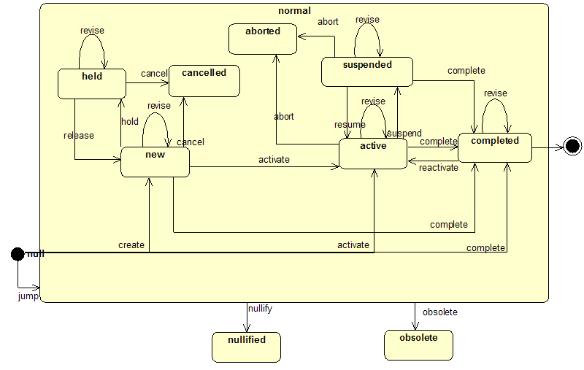

Role State Machine and Role.status values

RoleStatus
Codes representing the defined possible states of an Role, as defined by the Role class state machine.
This table controls values for structural elements of the HL7 Reference Information Model. Therefore, it is part of the Normative Ballot for the RIM.
Lvl | Type, Domain name and/or Mnemonic code | Concept ID | Mnemonic | Print Name | Definition/Description
1 | S: RoleStatusNormal (normal) | V16000 | normal | normal | The 'typical' state. Excludes "nullified" which represents the termination state of a Role instance that was created in error.
2 | L: (active) | 16001 | active | active | The state representing the fact that the Entity is currently active in the Role.
2 | L: (cancelled) | 20856 | cancelled | cancelled | The terminal state resulting from cancellation of the role prior to activation.
2 | L: (pending) | 20855 | pending | pending | The state representing that fact that the role has not yet become active.
2 | L: (suspended) | 16002 | suspended | suspended | The state that represents a suspension of the Entity playing the Role. This state is arrived at from the "active" state.
2 | L: (terminated) | 16003 | terminated | terminated | The state representing the successful termination of the Role.
1 | L: (nullified) | 16004 | nullified | nullified | The state representing the termination of a Role instance that was created in error.

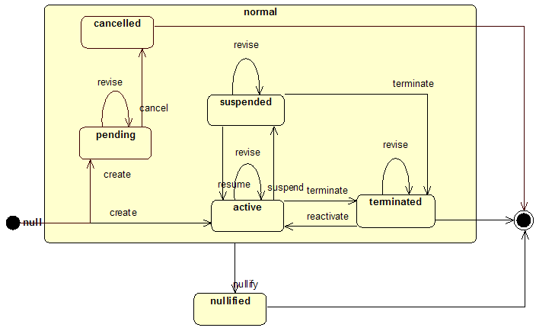

ActRelationship.typeCode

ActRelationshipType
A code specifying the meaning and purpose of every ActRelationship instance. Each of its values implies specific constraints to what kinds of Act objects can be related and in which way.
This table controls values for structural elements of the HL7 Reference Information Model. Therefore, it is part of the Normative Ballot for the RIM.
Lvl | Type, Domain name and/or Mnemonic code | Concept ID | Mnemonic | Print Name | Definition/Description
1 | A: ActRelationshipConditional | V18977 |  |  | Specifies under what circumstances (target Act) the source-Act may, must, must not or has occurred
2 | S: ActRelationshipReason (RSON) | V19376 | RSON | has reason | The reason or rationale for a service. A reason link is weaker than a trigger, it only suggests that some service may be or might have been a reason for some action, but not that this reason requires/required the action to be taken. Also, as opposed to the trigger, there is no strong timely relation between the reason and the action.  Discussion: In prior releases, the code "SUGG" (suggests) was expressed as "an inversion of the reason link." That code has been retired in favor of the inversion indicator that is an attribute of ActRelationship.
3 | L: (MITGT) | 19986 | MITGT | mitigates | The source act removes or lessens the occurrence or effect of the target act.
2 | L: (CIND) | 10323 | CIND | has contra-indication | A contraindication is just a negation of a reason, i.e. it gives a condition under which the action is not to be done. Both, source and target can be any kind of service; target service is in criterion mood. How the strength of a contraindication is expressed (e.g., relative, absolute) is left as an open issue. The priorityNumber attribute could be used.
2 | L: (PRCN) | 10319 | PRCN | has pre-condition | A requirement to be true before a service is performed. The target can be any service in criterion mood. For multiple pre-conditions a conjunction attribute (AND, OR, XOR) is applicable.
2 | L: (TRIG) | 10320 | TRIG | has trigger | A pre-condition that if true should result in the source Act being executed. The target is in typically in criterion mood. When reported after the fact (i.e. the criterion has been met) it may be in Event mood. A delay between the trigger and the triggered action can be specified.  Discussion: This includes the concept of a required act for a service or financial instrument such as an insurance plan or policy. In such cases, the trigger is the occurrence of a specific condition such as coverage limits being exceeded.
1 | S: ActRelationshipHasComponent (COMP) | V10318 | COMP | has component | A collection of sub-services as steps or subtasks performed for the source service. Services may be performed sequentially or concurrently.
2 | L: (ARR) | 17911 | ARR | arrival | The relationship that links to a Transportation Act (target) from another Act (source) indicating that the subject of the source Act entered into the source Act by means of the target Transportation act.
2 | L: (CTRLV) | 17902 | CTRLV | has control variable | A relationship from an Act to a Control Variable. For example, if a Device makes an Observation, this relates the Observation to its Control Variables documenting the device's settings that influenced the observation.
2 | L: (DEP) | 17912 | DEP | departure | The relationship that links to a Transportation Act (target) from another Act (source) indicating that the subject of the source Act departed from the source Act by means of the target Transportation act.
1 | S: ActRelationshipOutcome (OUTC) | V10324 | OUTC | has outcome | An observation that should follow or does actually follow as a result or consequence of a condition or action (sometimes called "post-conditional".) Target must be an observation as a goal, risk or any criterion. For complex outcomes a conjunction attribute (AND, OR, XOR) can be used. An outcome link is often inverted to describe an outcome assessment.
2 | A: ActRelationshipObjective | V19625 |  |  | The target act is a desired outcome of the source act. Source is any act (typically an intervention). Target must be an observation in criterion mood.
3 | L: (OBJC) | 10327 | OBJC | has continuing objective | A desired state that a service action aims to maintain. E.g., keep systolic blood pressure between 90 and 110 mm Hg. Source is an intervention service. Target must be an observation in criterion mood.
3 | L: (OBJF) | 10326 | OBJF | has final objective | A desired outcome that a service action aims to meet finally. Source is any service (typically an intervention). Target must be an observation in criterion mood.
2 | L: (GOAL) | 10325 | GOAL | has goal | A goal that one defines given a patient's health condition. Subsequently planned actions aim to meet that goal. Source is an observation or condition node, target must be an observation in goal mood.
2 | L: (RISK) | 10328 | RISK | has risk | A noteworthy undesired outcome of a patient's condition that is either likely enough to become an issue or is less likely but dangerous enough to be addressed.
1 | S: ActRelationshipPertains (PERT) | V10329 | PERT | has pertinent information | This is a very unspecific relationship from one item of clinical information to another. It does not judge about the role the pertinent information plays.
2 | A: ActRelationshipAccounting | V14900 |  |  | Codes that describe the relationship between an Act and a financial instrument such as a financial transaction, account or invoice element.
3 | A: ActRelationshipCostTracking | V19618 |  |  | Expresses values for describing the relationship relationship between an InvoiceElement or InvoiceElementGroup and a billable act.
4 | L: (CHRG) | 14904 | CHRG | has charge | A relationship that provides an ability to associate a financial transaction (target) as a charge to a clinical act (source). A clinical act may have a charge associated with the execution or delivery of the service.  The financial transaction will define the charge (bill) for delivery or performance of the service.  Charges and costs are distinct terms. A charge defines what is charged or billed to another organization or entity within an organization. The cost defines what it costs an organization to perform or deliver a service or product.
4 | L: (COST) | 14903 | COST | has cost | A relationship that provides an ability to associate a financial transaction (target) as a cost to a clinical act (source). A clinical act may have an inherit cost associated with the execution or delivery of the service.  The financial transaction will define the cost of delivery or performance of the service.  Charges and costs are distinct terms. A charge defines what is charged or billed to another organization or entity within an organization. The cost defines what it costs an organization to perform or deliver a service or product.
3 | A: ActRelationshipPosting | V19617 |  |  | Expresses values for describing the relationship between a FinancialTransaction and an Account.
4 | L: (CREDIT) | 14902 | CREDIT | has credit | A credit relationship ties a financial transaction (target) to an account (source). A credit, once applied (posted), may have either a positive or negative effect on the account balance, depending on the type of account. An asset account credit will decrease the account balance. A non-asset account credit will decrease the account balance.
4 | L: (DEBIT) | 14901 | DEBIT | has debit | A debit relationship ties a financial transaction (target) to an account (source). A debit, once applied (posted), may have either a positive or negative effect on the account balance, depending on the type of account. An asset account debit will increase the account balance. A non-asset account debit will decrease the account balance.
2 | A: TemporallyPertains | V19590
3 | L: (SAS) | 20857 | SAS | starts after start of | The source Act starts after the start of the target Act (i.e. if we say "ActOne SAS ActTwo", it means that ActOne starts after the start of ActTwo, therefore ActOne is the source and ActTwo is the target).
2 | S: hasSupport (SPRT) | V10330 | SPRT | has support | Used to indicate that an existing service is suggesting evidence for a new observation. The assumption of support is attributed to the same actor who asserts the observation. Source must be an observation, target may be any service (e.g., to indicate a status post).
3 | L: (SPRTBND) | 17899 | SPRTBND | has bounded support | A specialization of "has support" (SPRT), used to relate a secondary observation to a Region of Interest on a multidimensional observation, if the ROI specifies the true boundaries of the secondary observation as opposed to only marking the approximate area. For example, if the start and end of an ST elevation episode is visible in an EKG, this relation would indicate the ROI bounds the "ST elevation" observation -- the ROI defines the true beginning and ending of the episode. Conversely, if a ROI simply contains ST elevation, but it does not define the bounds (start and end) of the episode, the more general "has support" relation is used. Likewise, if a ROI on an image defines the true bounds of a "1st degree burn", the relation "has bounded support" is used; but if the ROI only points to the approximate area of the burn, the general "has support" relation is used.
2 | L: (AUTH) | 14019 | AUTH | authorized by | A relationship in which the target act authorizes or certifies the source act.
2 | L: (CAUS) | 10332 | CAUS | is etiology for | An assertion that a new observation was assumed to be the cause for another existing observation. The assumption is attributed to the same actor who asserts the observation. This is stronger and more specific than the support link. For example, a growth of Staphylococcus aureus may be considered the cause of an abscess. The source (cause) is typically an observation, but may be any service, while the target must be an observation.
2 | L: (COVBY) | 14894 | COVBY | covered by | A relationship in which the source act is covered by or is under the authority of a target act. A financial instrument such as an Invoice Element is covered by one or more specific instances of an Insurance Policy.
2 | L: (DRIV) | 10334 | DRIV | is derived from | Associates a derived Act with its input parameters. E.G., an anion-gap observation can be associated as being derived from given sodium-, (potassium-,), chloride-, and bicarbonate-observations. The narrative content (Act.text) of a source act is wholly machine-derived from the collection of target acts.
2 | L: (EXPL) | 10331 | EXPL | has explanation | This is the inversion of support. Used to indicate that a given observation is explained by another observation or condition.
2 | L: (ITEMSLOC) | 20841 | ITEMSLOC | ItemsLocated | Items located
2 | L: (LIMIT) | 14896 | LIMIT | limited by | A relationship that limits or restricts the source act by the elements of the target act. For example, an authorization may be limited by a financial amount (up to $500). Target Act must be in EVN.CRIT mood.
2 | L: (MFST) | 10333 | MFST | is manifestation of | An assertion that a new observation may be the manifestation of another existing observation or action. This assumption is attributed to the same actor who asserts the manifestation. This is stronger and more specific than an inverted support link. For example, an agitated appearance can be asserted to be the manifestation (effect) of a known hyperthyroxia. This expresses that one might not have realized a symptom if it would not be a common manifestation of a known condition. The target (cause) may be any service, while the source (manifestation) must be an observation.
2 | L: (NAME) | 10336 | NAME | assigns name | Used to assign a "name" to a condition thread. Source is a condition node, target can be any service.
2 | L: (PREV) | 14018 | PREV | has previous instance | A relationship in which the target act is a predecessor instance to the source act. Generally each of these instances is similar, but no identical. In healthcare coverage it is used to link a claim item to a previous claim item that might have claimed for the same set of services.
2 | L: (REFR) | 14020 | REFR | refers to | A relationship in which the target act is referred to by the source act. This permits a simple reference relationship that distinguishes between the referent and the referee.
2 | L: (REFV) | 10335 | REFV | has reference values | Reference ranges are essentially descriptors of a class of result values assumed to be "normal", "abnormal", or "critical." Those can vary by sex, age, or any other criterion. Source and target are observations, the target is in criterion mood. This link type can act as a trigger in case of alarms being triggered by critical results.
2 | L: (SUBJ) | 13971 | SUBJ | has subject | Relates an Act to its subject Act that the first Act is primarily concerned with.  Examples  - The first Act may be a ControlAct manipulating the subject Act  - The first act is a region of interest (ROI) that defines a region within the subject Act.  - The first act is a reporting or notification Act, that echos the subject Act for a specific new purpose.  Constraints  An Act may have multiple subject acts.  Rationale  The ActRelationshipType "has subject" is similar to the ParticipationType "subject", Acts that primarily operate on physical subjects use the Participation, those Acts that primarily operate on other Acts (other information) use the ActRelationship.
2 | L: (SUMM) | 15988 | SUMM | summarized by | An act that contains summary values for a list or set of subordinate acts. For example, a summary of transactions for a particular accounting period.
1 | S: ActRelationshipSequel (SEQL) | V10337 | SEQL | is sequel | An act relationship indicating that the source act follows the target act. The source act should in principle represent the same kind of act as the target. Source and target need not have the same mood code (mood will often differ). The target of a sequel is called antecedent. Examples for sequel relationships are: revision, transformation, derivation from a prototype (as a specialization is a derivation of a generalization), followup, realization, instantiation.
2 | S: ActRelationshipExcerpt (XCRPT) | V18660 | XCRPT | Excerpts | The source is an excerpt from the target.
3 | L: (VRXCRPT) | 18661 | VRXCRPT | Excerpt verbatim | The source is a direct quote from the target.
2 | S: ActRelationshipFulfills (FLFS) | V10342 | FLFS | fulfills | The source act fulfills (in whole or in part) the target act. Source act must be in a mood equal or more actual than the target act.
3 | L: (OCCR) | 11614 | OCCR | occurrence | The source act is a single occurrence of a repeatable target act. The source and target act can be in any mood on the "completion track" but the source act must be as far as or further along the track than the target act (i.e., the occurrence of an intent can be an event but not vice versa).
3 | L: (OREF) | 11628 | OREF | references order | Relates either an appointment request or an appointment to the order for the service being scheduled.
3 | L: (SCH) | 11627 | SCH | schedules request | Associates a specific time (and associated resources) with a scheduling request or other intent.
2 | S: ActRelationshipReplacement (RPLC) | V10338 | RPLC | replaces | A replacement source act replaces an existing target act. The state of the target act being replaced becomes obselete, but the act is typically still retained in the system for historical reference. The source and target must be of the same type.
3 | L: (SUCC) | 11616 | SUCC | succeeds | A new order that adds to, but does not completely replace its predecessor.
2 | L: (APND) | 10339 | APND | is appendage | An addendum (source) to an existing service object (target), containing supplemental information. The addendum is itself an original service object linked to the supplemented service object. The supplemented service object remains in place and its content and status are unaltered.
2 | L: (DOC) | 11609 | DOC | documents | The source act documents the target act.
2 | L: (ELNK) | 18865 | ELNK | episodeLink | Expresses an association that links two instances of the same act over time, indicating that the instance are part of the same episode, e.g. linking two condition nodes for episode of illness; linking two encounters for episode of encounter.
2 | L: (GEN) | 10348 | GEN | has generalization | The generalization relationship can be used to express categorical knowledge about services (e.g., amilorid, triamterene, and spironolactone have the common generalization potassium sparing diuretic).
2 | L: (GEVL) | 10346 | GEVL | evaluates (goal) | A goal-evaluation links an observation (intent or actual) to a goal to indicate that the observation evaluates the goal. Given the goal and the observation, a "goal distance" (e.g., goal to observation) can be "calculated" and need not be sent explicitly.
2 | L: (INST) | 10341 | INST | instantiates (master) | Used to capture the link between a potential service ("master" or plan) and an actual service, where the actual service instantiates the potential service. The instantiation may override the master's defaults.
2 | L: (MTCH) | 10345 | MTCH | matches (trigger) | A trigger-match links an actual service (e.g., an observation or procedure that took place) with a service in criterion mood. For example if the trigger is "observation of pain" and pain is actually observed, and if that pain-observation caused the trigger to fire, that pain-observation can be linked with the trigger.
2 | L: (OPTN) | 10347 | OPTN | has option | A relationship between a source Act that provides more detailed properties to the target Act.  The source act thus is a specialization of the target act, but instead of mentioning all the inherited properties it only mentions new property bindings or refinements.  The typical use case is to specify certain alternative variants of one kind of Act. The priorityNumber attribute is used to weigh refinements as preferred over other alternative refinements.  Example: several routing options for a drug are specified as one SubstanceAdministration for the general treatment with attached refinements for the various routing options.
2 | L: (REV) | 14898 | REV | reverses | A relationship between a source Act that seeks to reverse or undo the action of the prior target Act.  Example: A posted financial transaction (e.g., a debit transaction) was applied in error and must be reversed (e.g., by a credit transaction) the credit transaction is identified as an undo (or reversal) of the prior target transaction.  Constraints: the "completion track" mood of the target Act must be equally or more "actual" than the source act. I.e., when the target act is EVN the source act can be EVN, or any INT. If the target act is INT, the source act can be INT.
2 | L: (UPDT) | 10340 | UPDT | updates (condition) | A condition thread relationship specifically links condition nodes together to form a condition thread. The source is the new condition node and the target links to the most recent node of the existing condition thread.
2 | L: (XFRM) | 11624 | XFRM | transformation | Used when the target Act is a transformation of the source Act. (For instance, used to show that a CDA document is a transformation of a DICOM SR document.)
1 | A: x_ActRelationshipDocument | V11610 |  |  | Used to enumerate the relationships between two clinical documents for document management.
2 | L: (RPLC) | V10338 | RPLC | replaces | A replacement source act replaces an existing target act. The state of the target act being replaced becomes obselete, but the act is typically still retained in the system for historical reference. The source and target must be of the same type.
2 | L: (APND) | 10339 | APND | is appendage | An addendum (source) to an existing service object (target), containing supplemental information. The addendum is itself an original service object linked to the supplemented service object. The supplemented service object remains in place and its content and status are unaltered.
2 | L: (XFRM) | 11624 | XFRM | transformation | Used when the target Act is a transformation of the source Act. (For instance, used to show that a CDA document is a transformation of a DICOM SR document.)
1 | A: x_ActRelationshipEntry | V19446 |  |  | Used to enumerate the relationships between a CDA section and its contained entries.
2 | L: (COMP) | V10318 | COMP | has component | A collection of sub-services as steps or subtasks performed for the source service. Services may be performed sequentially or concurrently.
2 | L: (DRIV) | 10334 | DRIV | is derived from | Associates a derived Act with its input parameters. E.G., an anion-gap observation can be associated as being derived from given sodium-, (potassium-,), chloride-, and bicarbonate-observations. The narrative content (Act.text) of a source act is wholly machine-derived from the collection of target acts.
1 | A: x_ActRelationshipEntryRelationship | V19447 |  |  | Used to enumerate the relationships between two CDA entries.
2 | L: (XCRPT) | V18660 | XCRPT | Excerpts | The source is an excerpt from the target.
2 | L: (COMP) | V10318 | COMP | has component | A collection of sub-services as steps or subtasks performed for the source service. Services may be performed sequentially or concurrently.
2 | L: (RSON) | V19376 | RSON | has reason | The reason or rationale for a service. A reason link is weaker than a trigger, it only suggests that some service may be or might have been a reason for some action, but not that this reason requires/required the action to be taken. Also, as opposed to the trigger, there is no strong timely relation between the reason and the action.  Discussion: In prior releases, the code "SUGG" (suggests) was expressed as "an inversion of the reason link." That code has been retired in favor of the inversion indicator that is an attribute of ActRelationship.
2 | L: (SPRT) | V10330 | SPRT | has support | Used to indicate that an existing service is suggesting evidence for a new observation. The assumption of support is attributed to the same actor who asserts the observation. Source must be an observation, target may be any service (e.g., to indicate a status post).
2 | L: (CAUS) | 10332 | CAUS | is etiology for | An assertion that a new observation was assumed to be the cause for another existing observation. The assumption is attributed to the same actor who asserts the observation. This is stronger and more specific than the support link. For example, a growth of Staphylococcus aureus may be considered the cause of an abscess. The source (cause) is typically an observation, but may be any service, while the target must be an observation.
2 | L: (GEVL) | 10346 | GEVL | evaluates (goal) | A goal-evaluation links an observation (intent or actual) to a goal to indicate that the observation evaluates the goal. Given the goal and the observation, a "goal distance" (e.g., goal to observation) can be "calculated" and need not be sent explicitly.
2 | L: (MFST) | 10333 | MFST | is manifestation of | An assertion that a new observation may be the manifestation of another existing observation or action. This assumption is attributed to the same actor who asserts the manifestation. This is stronger and more specific than an inverted support link. For example, an agitated appearance can be asserted to be the manifestation (effect) of a known hyperthyroxia. This expresses that one might not have realized a symptom if it would not be a common manifestation of a known condition. The target (cause) may be any service, while the source (manifestation) must be an observation.
2 | L: (REFR) | 14020 | REFR | refers to | A relationship in which the target act is referred to by the source act. This permits a simple reference relationship that distinguishes between the referent and the referee.
2 | L: (SAS) | 20857 | SAS | starts after start of | The source Act starts after the start of the target Act (i.e. if we say "ActOne SAS ActTwo", it means that ActOne starts after the start of ActTwo, therefore ActOne is the source and ActTwo is the target).
2 | L: (SUBJ) | 13971 | SUBJ | has subject | Relates an Act to its subject Act that the first Act is primarily concerned with.  Examples  - The first Act may be a ControlAct manipulating the subject Act  - The first act is a region of interest (ROI) that defines a region within the subject Act.  - The first act is a reporting or notification Act, that echos the subject Act for a specific new purpose.  Constraints  An Act may have multiple subject acts.  Rationale  The ActRelationshipType "has subject" is similar to the ParticipationType "subject", Acts that primarily operate on physical subjects use the Participation, those Acts that primarily operate on other Acts (other information) use the ActRelationship.
1 | A: x_ActRelationshipExternalReference | V19000 |  |  | Used to enumerate the relationships between a CDA entry and an externally referenced act.
2 | L: (XCRPT) | V18660 | XCRPT | Excerpts | The source is an excerpt from the target.
2 | L: (RPLC) | V10338 | RPLC | replaces | A replacement source act replaces an existing target act. The state of the target act being replaced becomes obselete, but the act is typically still retained in the system for historical reference. The source and target must be of the same type.
2 | L: (SPRT) | V10330 | SPRT | has support | Used to indicate that an existing service is suggesting evidence for a new observation. The assumption of support is attributed to the same actor who asserts the observation. Source must be an observation, target may be any service (e.g., to indicate a status post).
2 | L: (ELNK) | 18865 | ELNK | episodeLink | Expresses an association that links two instances of the same act over time, indicating that the instance are part of the same episode, e.g. linking two condition nodes for episode of illness; linking two encounters for episode of encounter.
2 | L: (REFR) | 14020 | REFR | refers to | A relationship in which the target act is referred to by the source act. This permits a simple reference relationship that distinguishes between the referent and the referee.
2 | L: (SUBJ) | 13971 | SUBJ | has subject | Relates an Act to its subject Act that the first Act is primarily concerned with.  Examples  - The first Act may be a ControlAct manipulating the subject Act  - The first act is a region of interest (ROI) that defines a region within the subject Act.  - The first act is a reporting or notification Act, that echos the subject Act for a specific new purpose.  Constraints  An Act may have multiple subject acts.  Rationale  The ActRelationshipType "has subject" is similar to the ParticipationType "subject", Acts that primarily operate on physical subjects use the Participation, those Acts that primarily operate on other Acts (other information) use the ActRelationship.
1 | A: x_ActRelationshipPatientTransport | V19005
2 | L: (ARR) | 17911 | ARR | arrival | The relationship that links to a Transportation Act (target) from another Act (source) indicating that the subject of the source Act entered into the source Act by means of the target Transportation act.
2 | L: (DEP) | 17912 | DEP | departure | The relationship that links to a Transportation Act (target) from another Act (source) indicating that the subject of the source Act departed from the source Act by means of the target Transportation act.
1 | A: x_ActRelationshipPertinentInfo | V19562
2 | L: (SPRT) | V10330 | SPRT | has support | Used to indicate that an existing service is suggesting evidence for a new observation. The assumption of support is attributed to the same actor who asserts the observation. Source must be an observation, target may be any service (e.g., to indicate a status post).
2 | L: (CAUS) | 10332 | CAUS | is etiology for | An assertion that a new observation was assumed to be the cause for another existing observation. The assumption is attributed to the same actor who asserts the observation. This is stronger and more specific than the support link. For example, a growth of Staphylococcus aureus may be considered the cause of an abscess. The source (cause) is typically an observation, but may be any service, while the target must be an observation.
2 | L: (MFST) | 10333 | MFST | is manifestation of | An assertion that a new observation may be the manifestation of another existing observation or action. This assumption is attributed to the same actor who asserts the manifestation. This is stronger and more specific than an inverted support link. For example, an agitated appearance can be asserted to be the manifestation (effect) of a known hyperthyroxia. This expresses that one might not have realized a symptom if it would not be a common manifestation of a known condition. The target (cause) may be any service, while the source (manifestation) must be an observation.
2 | L: (REFR) | 14020 | REFR | refers to | A relationship in which the target act is referred to by the source act. This permits a simple reference relationship that distinguishes between the referent and the referee.
2 | L: (SUBJ) | 13971 | SUBJ | has subject | Relates an Act to its subject Act that the first Act is primarily concerned with.  Examples  - The first Act may be a ControlAct manipulating the subject Act  - The first act is a region of interest (ROI) that defines a region within the subject Act.  - The first act is a reporting or notification Act, that echos the subject Act for a specific new purpose.  Constraints  An Act may have multiple subject acts.  Rationale  The ActRelationshipType "has subject" is similar to the ParticipationType "subject", Acts that primarily operate on physical subjects use the Participation, those Acts that primarily operate on other Acts (other information) use the ActRelationship.

Act.moodCode

ActMood
A code distinguishing whether an Act is conceived of as a factual statement or in some other manner as a command, possibility, goal, etc.
Constraints: An Act-instance must have one and only one moodCode value.
The moodCode of a single Act-instance never changes. Mood is not state.
To describe the progression of a business activity from defined to planned to executed, etc. one must instantiate different Act-instances in the different moods and link them using ActRelationship of general type "sequel". (See ActRelationship.type.)
This table controls values for structural elements of the HL7 Reference Information Model. Therefore, it is part of the Normative Ballot for the RIM.
Lvl | Type, Domain name and/or Mnemonic code | Concept ID | Mnemonic | Print Name | Definition/Description
1 | A: ActMoodCompletionTrack | V10197 |  |  | These are moods describing activities as they progress in the business cycle, from defined, through planned and ordered to completed.
2 | S: ActMoodIntent (INT) | V10199 | INT | intent | An intention or plan to perform a service. Historical note: in previous RIM versions, the intent mood was captured as a separate class hierarchy, called Service_intent_or_order.
3 | L: (APT) | 11626 | APT | appointment | A planned Act for a specific time and place.
3 | L: (ARQ) | 11625 | ARQ | appointment request | A request for the booking of an appointment.
3 | L: (PRMS) | 16728 | PRMS | promise | An intent to perform a service that has the strength of a commitment, i.e., other parties may rely on the originator of such promise that said originator will see to it that the promised act will be fulfilled. A promise can be either solicited or unsolicited.
3 | L: (PRP) | 16726 | PRP | proposal | A non-mandated intent to perform an act. Used to record intents that are explicitly not Orders. Professional responsibility for the 'proposal' may or may not be present.
3 | L: (RQO) | 19973 | RQO | request | A request or order for a service is an intent directed from a placer (request author) to a fulfiller (service performer).  Rationale: The concepts of a "request" and an "order" are viewed as different, because there is an implication of a mandate associated with order. In practice, however, this distinction has no general functional value in the inter-operation of health care computing. "Orders" are commonly refused for a variety of clinical and business reasons, and the notion of a "request" obligates the recipient (the fulfiller) to respond to the sender (the author). Indeed, in many regions, including Australia and Europe, the common term used is "request."  Thus, the concept embodies both notions, as there is no useful distinction to be made. If a mandate is to be associated with a request, this will be embodied in the "local" business rules applied to the transactions. Should HL7 desire to provide a distinction between these in the future, the individual concepts could be added as specializations of this concept.  The critical distinction here, is the difference between this concept and an "intent", of which it is a specialization. An intent involves decisions by a single party, the author. A request, however, involves decisions by two parties, the author and the fulfiller, with an obligation on the part of the fulfiller to respond to the request indicating that the fulfiller will indeed fulfill the request.
3 | L: (SLOT) | 19168 | SLOT | resource slot | Periods of time on a schedule for a resource. Appointments occupy sets of one or more booked slots. A slot that is open for appointments is considered available and a slot that is held back for administrative purposes is considered blocked. A Resource slot that is "tentatively" booked is referred to as reserved.
2 | L: (DEF) | 10198 | DEF | definition | A definition of a service (master).  Historical note: in previous RIM versions, the definition mood was captured as a separate class hierarchy, called Master_service.
2 | L: (EVN) | 10201 | EVN | event (occurrence) | A service that actually happens, may be an ongoing service or a documentation of a past service.  Historical note: in previous RIM versions, the event mood was captured as a separate class hierarchy, called Patient_service_event, and later Service_event.
1 | A: ActMoodPredicate | V10202 |  |  | Any of the above service moods (e.g., event, intent, or goal) can be turned into a predicate used as a criterion to express conditionals (or queries.) However, currently we allow only criteria on service events.
2 | L: (EVN.CRT) | 10203 | EVN.CRT | event criterion | A criterion or condition over service events that must apply for an associated service to be considered.
2 | L: (GOL) | 18864 | GOL | Goal | Expectation to make a specific observation with a desired value at a predefined future time
2 | L: (OPT) | 10204 | OPT | option | An option is an alternative set of property-value bindings. Options specify alternative sets of values, typically used in definitions or orders to describe alternatives. An option can only be used as a group, that is, all assigned values must be used together.  Historical note: in HL7 v2.x option existed in the special case for alternative medication routes (RXR segment).
2 | L: (PERM) | 20916 | PERM | permission | A kind of service which is authorized to be performed.
2 | L: (PERMRQ) | 20917 | PERMRQ | permission request | A request for authorization to perform a kind of service.  Discussion: This is distinct from RQO which is a request for an actual act. PERMRQ is merely a request for permission to perform an act.
1 | A: x_ActMoodDefEvn | V19375 |  |  | A grouping of Definition, Event. These specific moods are used in control wrapper override acts. The domain is restricted to acts that are possible to occur or have already occurred.
2 | L: (DEF) | 10198 | DEF | definition | A definition of a service (master).  Historical note: in previous RIM versions, the definition mood was captured as a separate class hierarchy, called Master_service.
2 | L: (EVN) | 10201 | EVN | event (occurrence) | A service that actually happens, may be an ongoing service or a documentation of a past service.  Historical note: in previous RIM versions, the event mood was captured as a separate class hierarchy, called Patient_service_event, and later Service_event.
1 | A: x_ActMoodDefEvnRqoPrmsPrp | V19371
2 | L: (DEF) | 10198 | DEF | definition | A definition of a service (master).  Historical note: in previous RIM versions, the definition mood was captured as a separate class hierarchy, called Master_service.
2 | L: (EVN) | 10201 | EVN | event (occurrence) | A service that actually happens, may be an ongoing service or a documentation of a past service.  Historical note: in previous RIM versions, the event mood was captured as a separate class hierarchy, called Patient_service_event, and later Service_event.
2 | L: (PRMS) | 16728 | PRMS | promise | An intent to perform a service that has the strength of a commitment, i.e., other parties may rely on the originator of such promise that said originator will see to it that the promised act will be fulfilled. A promise can be either solicited or unsolicited.
2 | L: (PRP) | 16726 | PRP | proposal | A non-mandated intent to perform an act. Used to record intents that are explicitly not Orders. Professional responsibility for the 'proposal' may or may not be present.
2 | L: (RQO) | 19973 | RQO | request | A request or order for a service is an intent directed from a placer (request author) to a fulfiller (service performer).  Rationale: The concepts of a "request" and an "order" are viewed as different, because there is an implication of a mandate associated with order. In practice, however, this distinction has no general functional value in the inter-operation of health care computing. "Orders" are commonly refused for a variety of clinical and business reasons, and the notion of a "request" obligates the recipient (the fulfiller) to respond to the sender (the author). Indeed, in many regions, including Australia and Europe, the common term used is "request."  Thus, the concept embodies both notions, as there is no useful distinction to be made. If a mandate is to be associated with a request, this will be embodied in the "local" business rules applied to the transactions. Should HL7 desire to provide a distinction between these in the future, the individual concepts could be added as specializations of this concept.  The critical distinction here, is the difference between this concept and an "intent", of which it is a specialization. An intent involves decisions by a single party, the author. A request, however, involves decisions by two parties, the author and the fulfiller, with an obligation on the part of the fulfiller to respond to the request indicating that the fulfiller will indeed fulfill the request.
1 | A: x_ActMoodDocumentObservation | V18943 |  |  | Used to enumerate the moods that an observation can take within the body of a clinical document.
2 | L: (INT) | V10199 | INT | intent | An intention or plan to perform a service. Historical note: in previous RIM versions, the intent mood was captured as a separate class hierarchy, called Service_intent_or_order.
2 | L: (DEF) | 10198 | DEF | definition | A definition of a service (master).  Historical note: in previous RIM versions, the definition mood was captured as a separate class hierarchy, called Master_service.
2 | L: (EVN) | 10201 | EVN | event (occurrence) | A service that actually happens, may be an ongoing service or a documentation of a past service.  Historical note: in previous RIM versions, the event mood was captured as a separate class hierarchy, called Patient_service_event, and later Service_event.
2 | L: (GOL) | 18864 | GOL | Goal | Expectation to make a specific observation with a desired value at a predefined future time
2 | L: (PRMS) | 16728 | PRMS | promise | An intent to perform a service that has the strength of a commitment, i.e., other parties may rely on the originator of such promise that said originator will see to it that the promised act will be fulfilled. A promise can be either solicited or unsolicited.
2 | L: (PRP) | 16726 | PRP | proposal | A non-mandated intent to perform an act. Used to record intents that are explicitly not Orders. Professional responsibility for the 'proposal' may or may not be present.
2 | L: (RQO) | 19973 | RQO | request | A request or order for a service is an intent directed from a placer (request author) to a fulfiller (service performer).  Rationale: The concepts of a "request" and an "order" are viewed as different, because there is an implication of a mandate associated with order. In practice, however, this distinction has no general functional value in the inter-operation of health care computing. "Orders" are commonly refused for a variety of clinical and business reasons, and the notion of a "request" obligates the recipient (the fulfiller) to respond to the sender (the author). Indeed, in many regions, including Australia and Europe, the common term used is "request."  Thus, the concept embodies both notions, as there is no useful distinction to be made. If a mandate is to be associated with a request, this will be embodied in the "local" business rules applied to the transactions. Should HL7 desire to provide a distinction between these in the future, the individual concepts could be added as specializations of this concept.  The critical distinction here, is the difference between this concept and an "intent", of which it is a specialization. An intent involves decisions by a single party, the author. A request, however, involves decisions by two parties, the author and the fulfiller, with an obligation on the part of the fulfiller to respond to the request indicating that the fulfiller will indeed fulfill the request.
1 | A: x_ActMoodEvnOrdPrmsPrp | V18965
2 | L: (EVN) | 10201 | EVN | event (occurrence) | A service that actually happens, may be an ongoing service or a documentation of a past service.  Historical note: in previous RIM versions, the event mood was captured as a separate class hierarchy, called Patient_service_event, and later Service_event.
2 | L: (PRMS) | 16728 | PRMS | promise | An intent to perform a service that has the strength of a commitment, i.e., other parties may rely on the originator of such promise that said originator will see to it that the promised act will be fulfilled. A promise can be either solicited or unsolicited.
2 | L: (PRP) | 16726 | PRP | proposal | A non-mandated intent to perform an act. Used to record intents that are explicitly not Orders. Professional responsibility for the 'proposal' may or may not be present.
2 | L: (RQO) | 19973 | RQO | request | A request or order for a service is an intent directed from a placer (request author) to a fulfiller (service performer).  Rationale: The concepts of a "request" and an "order" are viewed as different, because there is an implication of a mandate associated with order. In practice, however, this distinction has no general functional value in the inter-operation of health care computing. "Orders" are commonly refused for a variety of clinical and business reasons, and the notion of a "request" obligates the recipient (the fulfiller) to respond to the sender (the author). Indeed, in many regions, including Australia and Europe, the common term used is "request."  Thus, the concept embodies both notions, as there is no useful distinction to be made. If a mandate is to be associated with a request, this will be embodied in the "local" business rules applied to the transactions. Should HL7 desire to provide a distinction between these in the future, the individual concepts could be added as specializations of this concept.  The critical distinction here, is the difference between this concept and an "intent", of which it is a specialization. An intent involves decisions by a single party, the author. A request, however, involves decisions by two parties, the author and the fulfiller, with an obligation on the part of the fulfiller to respond to the request indicating that the fulfiller will indeed fulfill the request.
1 | A: x_ActMoodIntentEvent | V16742 |  |  | A constraint domain for RMIM design.
2 | S: ActMoodIntent (INT) | V10199 | INT | intent | An intention or plan to perform a service. Historical note: in previous RIM versions, the intent mood was captured as a separate class hierarchy, called Service_intent_or_order.
3 | L: (APT) | 11626 | APT | appointment | A planned Act for a specific time and place.
3 | L: (ARQ) | 11625 | ARQ | appointment request | A request for the booking of an appointment.
3 | L: (PRMS) | 16728 | PRMS | promise | An intent to perform a service that has the strength of a commitment, i.e., other parties may rely on the originator of such promise that said originator will see to it that the promised act will be fulfilled. A promise can be either solicited or unsolicited.
3 | L: (PRP) | 16726 | PRP | proposal | A non-mandated intent to perform an act. Used to record intents that are explicitly not Orders. Professional responsibility for the 'proposal' may or may not be present.
3 | L: (RQO) | 19973 | RQO | request | A request or order for a service is an intent directed from a placer (request author) to a fulfiller (service performer).  Rationale: The concepts of a "request" and an "order" are viewed as different, because there is an implication of a mandate associated with order. In practice, however, this distinction has no general functional value in the inter-operation of health care computing. "Orders" are commonly refused for a variety of clinical and business reasons, and the notion of a "request" obligates the recipient (the fulfiller) to respond to the sender (the author). Indeed, in many regions, including Australia and Europe, the common term used is "request."  Thus, the concept embodies both notions, as there is no useful distinction to be made. If a mandate is to be associated with a request, this will be embodied in the "local" business rules applied to the transactions. Should HL7 desire to provide a distinction between these in the future, the individual concepts could be added as specializations of this concept.  The critical distinction here, is the difference between this concept and an "intent", of which it is a specialization. An intent involves decisions by a single party, the author. A request, however, involves decisions by two parties, the author and the fulfiller, with an obligation on the part of the fulfiller to respond to the request indicating that the fulfiller will indeed fulfill the request.
3 | L: (SLOT) | 19168 | SLOT | resource slot | Periods of time on a schedule for a resource. Appointments occupy sets of one or more booked slots. A slot that is open for appointments is considered available and a slot that is held back for administrative purposes is considered blocked. A Resource slot that is "tentatively" booked is referred to as reserved.
2 | L: (EVN) | 10201 | EVN | event (occurrence) | A service that actually happens, may be an ongoing service or a documentation of a past service.  Historical note: in previous RIM versions, the event mood was captured as a separate class hierarchy, called Patient_service_event, and later Service_event.
1 | A: x_ActMoodOrdPrms | V16735 |  |  | A grouping of Order, Promise. These specific moods are used in orders.
2 | L: (PRMS) | 16728 | PRMS | promise | An intent to perform a service that has the strength of a commitment, i.e., other parties may rely on the originator of such promise that said originator will see to it that the promised act will be fulfilled. A promise can be either solicited or unsolicited.
2 | L: (RQO) | 19973 | RQO | request | A request or order for a service is an intent directed from a placer (request author) to a fulfiller (service performer).  Rationale: The concepts of a "request" and an "order" are viewed as different, because there is an implication of a mandate associated with order. In practice, however, this distinction has no general functional value in the inter-operation of health care computing. "Orders" are commonly refused for a variety of clinical and business reasons, and the notion of a "request" obligates the recipient (the fulfiller) to respond to the sender (the author). Indeed, in many regions, including Australia and Europe, the common term used is "request."  Thus, the concept embodies both notions, as there is no useful distinction to be made. If a mandate is to be associated with a request, this will be embodied in the "local" business rules applied to the transactions. Should HL7 desire to provide a distinction between these in the future, the individual concepts could be added as specializations of this concept.  The critical distinction here, is the difference between this concept and an "intent", of which it is a specialization. An intent involves decisions by a single party, the author. A request, however, involves decisions by two parties, the author and the fulfiller, with an obligation on the part of the fulfiller to respond to the request indicating that the fulfiller will indeed fulfill the request.
1 | A: x_ActMoodOrdPrmsEvn | V16730 |  |  | A grouping of Order, Promise and Event moods.
2 | L: (EVN) | 10201 | EVN | event (occurrence) | A service that actually happens, may be an ongoing service or a documentation of a past service.  Historical note: in previous RIM versions, the event mood was captured as a separate class hierarchy, called Patient_service_event, and later Service_event.
2 | L: (PRMS) | 16728 | PRMS | promise | An intent to perform a service that has the strength of a commitment, i.e., other parties may rely on the originator of such promise that said originator will see to it that the promised act will be fulfilled. A promise can be either solicited or unsolicited.
2 | L: (RQO) | 19973 | RQO | request | A request or order for a service is an intent directed from a placer (request author) to a fulfiller (service performer).  Rationale: The concepts of a "request" and an "order" are viewed as different, because there is an implication of a mandate associated with order. In practice, however, this distinction has no general functional value in the inter-operation of health care computing. "Orders" are commonly refused for a variety of clinical and business reasons, and the notion of a "request" obligates the recipient (the fulfiller) to respond to the sender (the author). Indeed, in many regions, including Australia and Europe, the common term used is "request."  Thus, the concept embodies both notions, as there is no useful distinction to be made. If a mandate is to be associated with a request, this will be embodied in the "local" business rules applied to the transactions. Should HL7 desire to provide a distinction between these in the future, the individual concepts could be added as specializations of this concept.  The critical distinction here, is the difference between this concept and an "intent", of which it is a specialization. An intent involves decisions by a single party, the author. A request, however, involves decisions by two parties, the author and the fulfiller, with an obligation on the part of the fulfiller to respond to the request indicating that the fulfiller will indeed fulfill the request.
1 | A: x_ActMoodRqoPrpAptArq | V19372
2 | L: (APT) | 11626 | APT | appointment | A planned Act for a specific time and place.
2 | L: (ARQ) | 11625 | ARQ | appointment request | A request for the booking of an appointment.
2 | L: (PRP) | 16726 | PRP | proposal | A non-mandated intent to perform an act. Used to record intents that are explicitly not Orders. Professional responsibility for the 'proposal' may or may not be present.
2 | L: (RQO) | 19973 | RQO | request | A request or order for a service is an intent directed from a placer (request author) to a fulfiller (service performer).  Rationale: The concepts of a "request" and an "order" are viewed as different, because there is an implication of a mandate associated with order. In practice, however, this distinction has no general functional value in the inter-operation of health care computing. "Orders" are commonly refused for a variety of clinical and business reasons, and the notion of a "request" obligates the recipient (the fulfiller) to respond to the sender (the author). Indeed, in many regions, including Australia and Europe, the common term used is "request."  Thus, the concept embodies both notions, as there is no useful distinction to be made. If a mandate is to be associated with a request, this will be embodied in the "local" business rules applied to the transactions. Should HL7 desire to provide a distinction between these in the future, the individual concepts could be added as specializations of this concept.  The critical distinction here, is the difference between this concept and an "intent", of which it is a specialization. An intent involves decisions by a single party, the author. A request, however, involves decisions by two parties, the author and the fulfiller, with an obligation on the part of the fulfiller to respond to the request indicating that the fulfiller will indeed fulfill the request.
1 | A: x_DocumentActMood | V19458 |  |  | Used to enumerate the moods that an act can take within the body of a clinical document.
2 | L: (INT) | V10199 | INT | intent | An intention or plan to perform a service. Historical note: in previous RIM versions, the intent mood was captured as a separate class hierarchy, called Service_intent_or_order.
2 | L: (APT) | 11626 | APT | appointment | A planned Act for a specific time and place.
2 | L: (ARQ) | 11625 | ARQ | appointment request | A request for the booking of an appointment.
2 | L: (DEF) | 10198 | DEF | definition | A definition of a service (master).  Historical note: in previous RIM versions, the definition mood was captured as a separate class hierarchy, called Master_service.
2 | L: (EVN) | 10201 | EVN | event (occurrence) | A service that actually happens, may be an ongoing service or a documentation of a past service.  Historical note: in previous RIM versions, the event mood was captured as a separate class hierarchy, called Patient_service_event, and later Service_event.
2 | L: (PRMS) | 16728 | PRMS | promise | An intent to perform a service that has the strength of a commitment, i.e., other parties may rely on the originator of such promise that said originator will see to it that the promised act will be fulfilled. A promise can be either solicited or unsolicited.
2 | L: (PRP) | 16726 | PRP | proposal | A non-mandated intent to perform an act. Used to record intents that are explicitly not Orders. Professional responsibility for the 'proposal' may or may not be present.
2 | L: (RQO) | 19973 | RQO | request | A request or order for a service is an intent directed from a placer (request author) to a fulfiller (service performer).  Rationale: The concepts of a "request" and an "order" are viewed as different, because there is an implication of a mandate associated with order. In practice, however, this distinction has no general functional value in the inter-operation of health care computing. "Orders" are commonly refused for a variety of clinical and business reasons, and the notion of a "request" obligates the recipient (the fulfiller) to respond to the sender (the author). Indeed, in many regions, including Australia and Europe, the common term used is "request."  Thus, the concept embodies both notions, as there is no useful distinction to be made. If a mandate is to be associated with a request, this will be embodied in the "local" business rules applied to the transactions. Should HL7 desire to provide a distinction between these in the future, the individual concepts could be added as specializations of this concept.  The critical distinction here, is the difference between this concept and an "intent", of which it is a specialization. An intent involves decisions by a single party, the author. A request, however, involves decisions by two parties, the author and the fulfiller, with an obligation on the part of the fulfiller to respond to the request indicating that the fulfiller will indeed fulfill the request.
1 | A: x_DocumentEncounterMood | V19459 |  |  | Used to enumerate the moods that an encounter can take within the body of a clinical document.
2 | L: (INT) | V10199 | INT | intent | An intention or plan to perform a service. Historical note: in previous RIM versions, the intent mood was captured as a separate class hierarchy, called Service_intent_or_order.
2 | L: (APT) | 11626 | APT | appointment | A planned Act for a specific time and place.
2 | L: (ARQ) | 11625 | ARQ | appointment request | A request for the booking of an appointment.
2 | L: (EVN) | 10201 | EVN | event (occurrence) | A service that actually happens, may be an ongoing service or a documentation of a past service.  Historical note: in previous RIM versions, the event mood was captured as a separate class hierarchy, called Patient_service_event, and later Service_event.
2 | L: (PRMS) | 16728 | PRMS | promise | An intent to perform a service that has the strength of a commitment, i.e., other parties may rely on the originator of such promise that said originator will see to it that the promised act will be fulfilled. A promise can be either solicited or unsolicited.
2 | L: (PRP) | 16726 | PRP | proposal | A non-mandated intent to perform an act. Used to record intents that are explicitly not Orders. Professional responsibility for the 'proposal' may or may not be present.
2 | L: (RQO) | 19973 | RQO | request | A request or order for a service is an intent directed from a placer (request author) to a fulfiller (service performer).  Rationale: The concepts of a "request" and an "order" are viewed as different, because there is an implication of a mandate associated with order. In practice, however, this distinction has no general functional value in the inter-operation of health care computing. "Orders" are commonly refused for a variety of clinical and business reasons, and the notion of a "request" obligates the recipient (the fulfiller) to respond to the sender (the author). Indeed, in many regions, including Australia and Europe, the common term used is "request."  Thus, the concept embodies both notions, as there is no useful distinction to be made. If a mandate is to be associated with a request, this will be embodied in the "local" business rules applied to the transactions. Should HL7 desire to provide a distinction between these in the future, the individual concepts could be added as specializations of this concept.  The critical distinction here, is the difference between this concept and an "intent", of which it is a specialization. An intent involves decisions by a single party, the author. A request, however, involves decisions by two parties, the author and the fulfiller, with an obligation on the part of the fulfiller to respond to the request indicating that the fulfiller will indeed fulfill the request.
1 | A: x_DocumentProcedureMood | V19460 |  |  | Used to enumerate the moods that a procedure can take within the body of a clinical document.
2 | L: (INT) | V10199 | INT | intent | An intention or plan to perform a service. Historical note: in previous RIM versions, the intent mood was captured as a separate class hierarchy, called Service_intent_or_order.
2 | L: (APT) | 11626 | APT | appointment | A planned Act for a specific time and place.
2 | L: (ARQ) | 11625 | ARQ | appointment request | A request for the booking of an appointment.
2 | L: (DEF) | 10198 | DEF | definition | A definition of a service (master).  Historical note: in previous RIM versions, the definition mood was captured as a separate class hierarchy, called Master_service.
2 | L: (EVN) | 10201 | EVN | event (occurrence) | A service that actually happens, may be an ongoing service or a documentation of a past service.  Historical note: in previous RIM versions, the event mood was captured as a separate class hierarchy, called Patient_service_event, and later Service_event.
2 | L: (PRMS) | 16728 | PRMS | promise | An intent to perform a service that has the strength of a commitment, i.e., other parties may rely on the originator of such promise that said originator will see to it that the promised act will be fulfilled. A promise can be either solicited or unsolicited.
2 | L: (PRP) | 16726 | PRP | proposal | A non-mandated intent to perform an act. Used to record intents that are explicitly not Orders. Professional responsibility for the 'proposal' may or may not be present.
2 | L: (RQO) | 19973 | RQO | request | A request or order for a service is an intent directed from a placer (request author) to a fulfiller (service performer).  Rationale: The concepts of a "request" and an "order" are viewed as different, because there is an implication of a mandate associated with order. In practice, however, this distinction has no general functional value in the inter-operation of health care computing. "Orders" are commonly refused for a variety of clinical and business reasons, and the notion of a "request" obligates the recipient (the fulfiller) to respond to the sender (the author). Indeed, in many regions, including Australia and Europe, the common term used is "request."  Thus, the concept embodies both notions, as there is no useful distinction to be made. If a mandate is to be associated with a request, this will be embodied in the "local" business rules applied to the transactions. Should HL7 desire to provide a distinction between these in the future, the individual concepts could be added as specializations of this concept.  The critical distinction here, is the difference between this concept and an "intent", of which it is a specialization. An intent involves decisions by a single party, the author. A request, however, involves decisions by two parties, the author and the fulfiller, with an obligation on the part of the fulfiller to respond to the request indicating that the fulfiller will indeed fulfill the request.
1 | A: x_DocumentSubstanceMood | V19461 |  |  | Used to enumerate the moods that a substance administration can take within the body of a clinical document.
2 | L: (INT) | V10199 | INT | intent | An intention or plan to perform a service. Historical note: in previous RIM versions, the intent mood was captured as a separate class hierarchy, called Service_intent_or_order.
2 | L: (EVN) | 10201 | EVN | event (occurrence) | A service that actually happens, may be an ongoing service or a documentation of a past service.  Historical note: in previous RIM versions, the event mood was captured as a separate class hierarchy, called Patient_service_event, and later Service_event.
2 | L: (PRMS) | 16728 | PRMS | promise | An intent to perform a service that has the strength of a commitment, i.e., other parties may rely on the originator of such promise that said originator will see to it that the promised act will be fulfilled. A promise can be either solicited or unsolicited.
2 | L: (PRP) | 16726 | PRP | proposal | A non-mandated intent to perform an act. Used to record intents that are explicitly not Orders. Professional responsibility for the 'proposal' may or may not be present.
2 | L: (RQO) | 19973 | RQO | request | A request or order for a service is an intent directed from a placer (request author) to a fulfiller (service performer).  Rationale: The concepts of a "request" and an "order" are viewed as different, because there is an implication of a mandate associated with order. In practice, however, this distinction has no general functional value in the inter-operation of health care computing. "Orders" are commonly refused for a variety of clinical and business reasons, and the notion of a "request" obligates the recipient (the fulfiller) to respond to the sender (the author). Indeed, in many regions, including Australia and Europe, the common term used is "request."  Thus, the concept embodies both notions, as there is no useful distinction to be made. If a mandate is to be associated with a request, this will be embodied in the "local" business rules applied to the transactions. Should HL7 desire to provide a distinction between these in the future, the individual concepts could be added as specializations of this concept.  The critical distinction here, is the difference between this concept and an "intent", of which it is a specialization. An intent involves decisions by a single party, the author. A request, however, involves decisions by two parties, the author and the fulfiller, with an obligation on the part of the fulfiller to respond to the request indicating that the fulfiller will indeed fulfill the request.

